**FLEET MANAGEMENT SYSTEM Version 5.0.2**

FLEET USER MANUAL

(As of March 15, 2021)

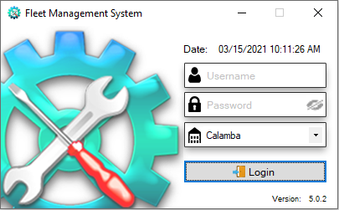

# **GENERAL MENU**

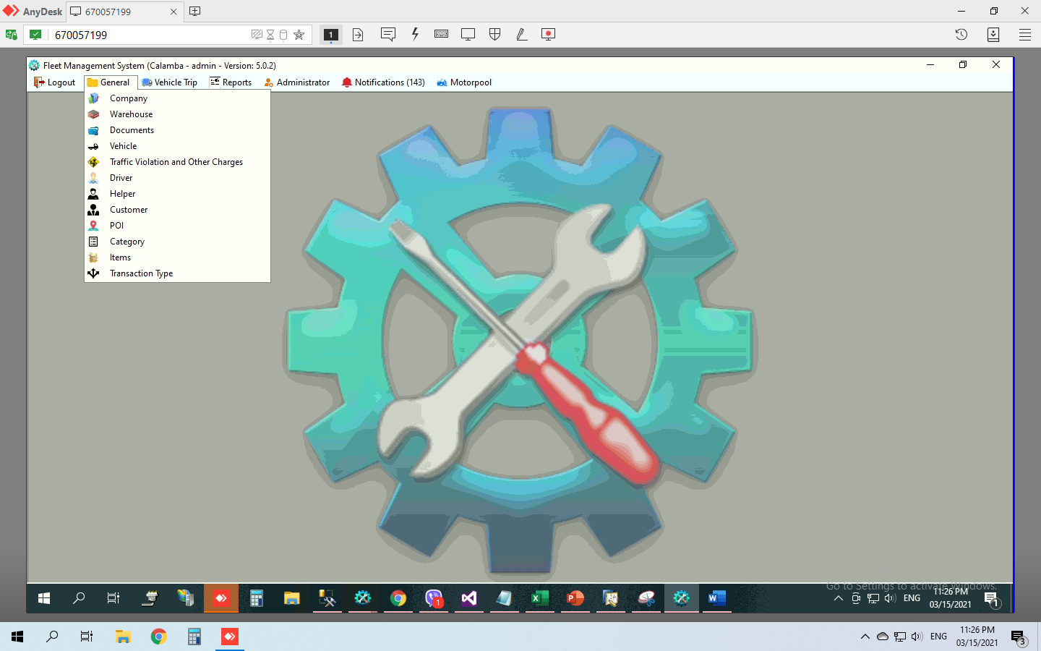

1. Company
2. Warehouse
3. Documents
4. Vehicle
5. Traffic Violation and Other Charges
6. Driver
7. Helper
8. Customer
9. POI
10. Category
11. Items
12. Transaction Type

## Company

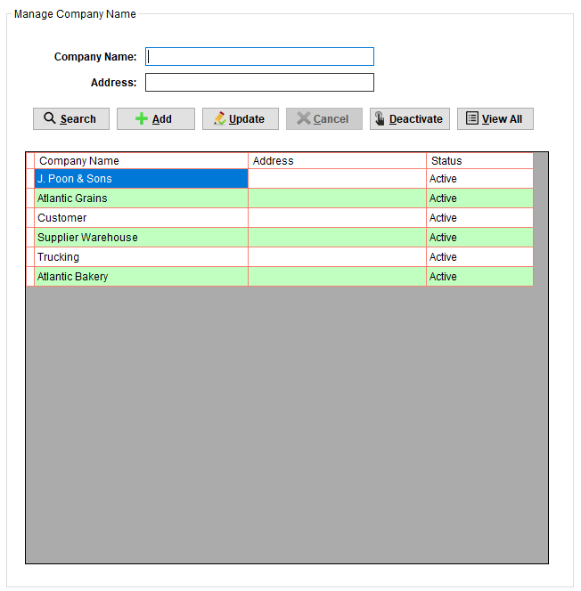

## Warehouse

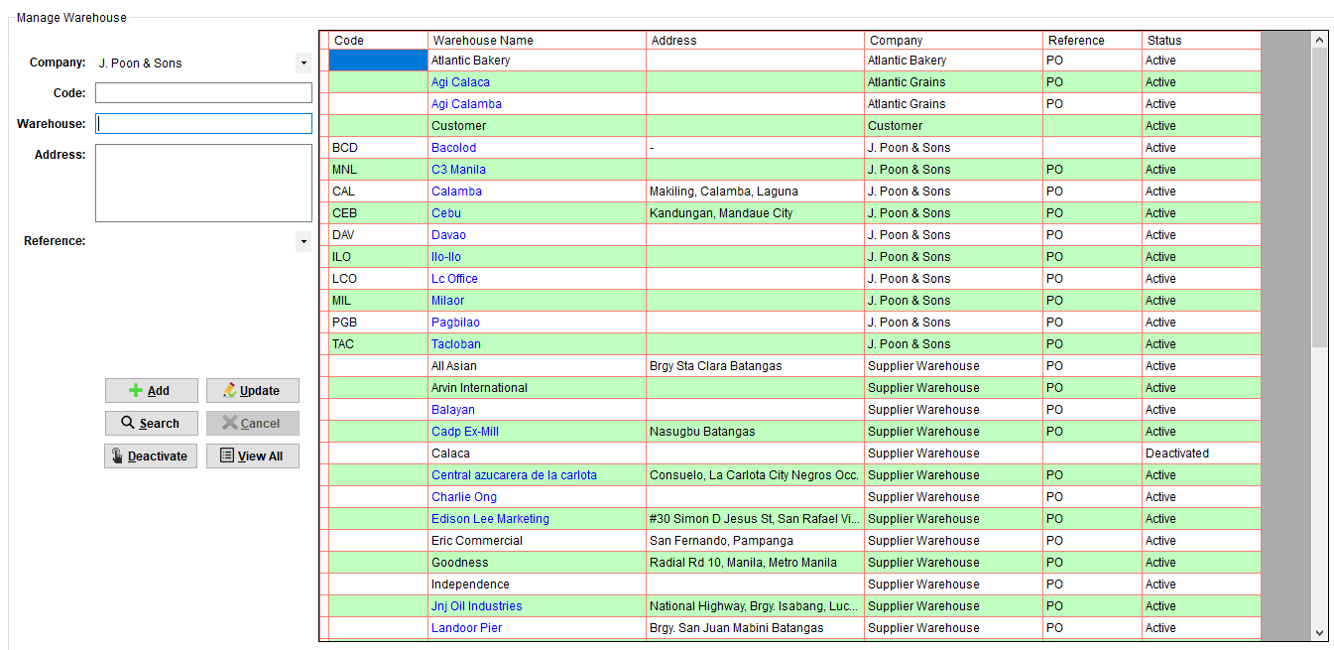

## Documents

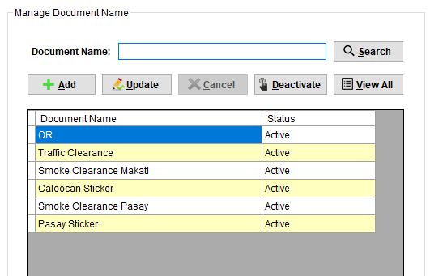

## Vehicle

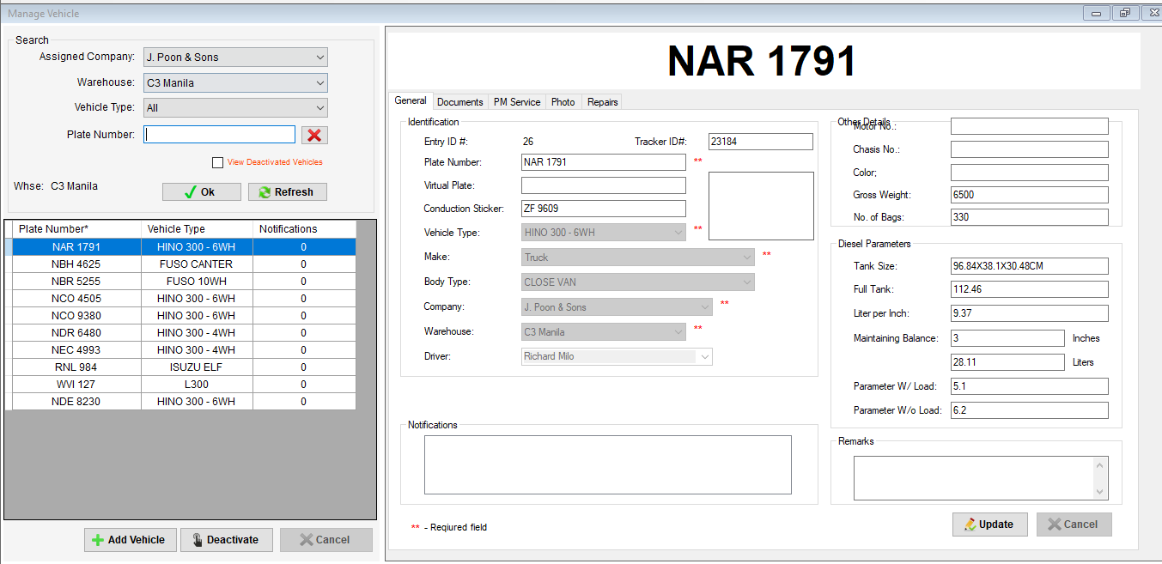

## Traffic Violations and Other Charges

## POI

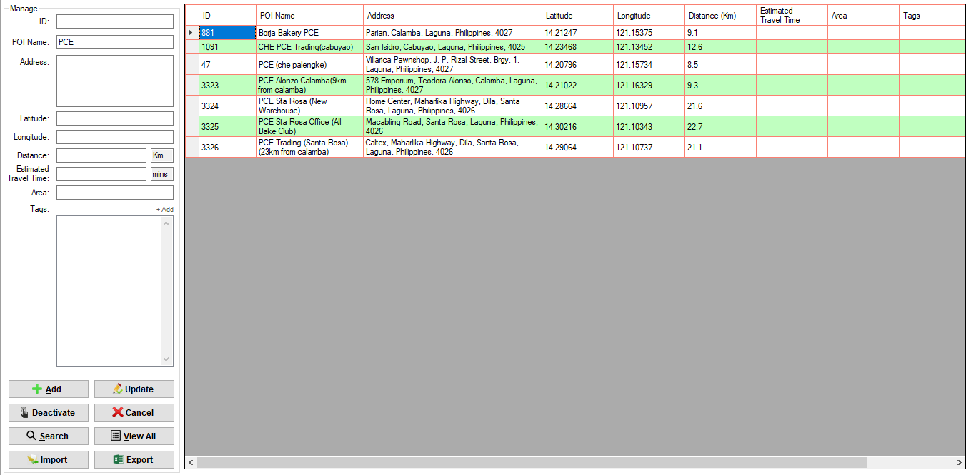

## Category

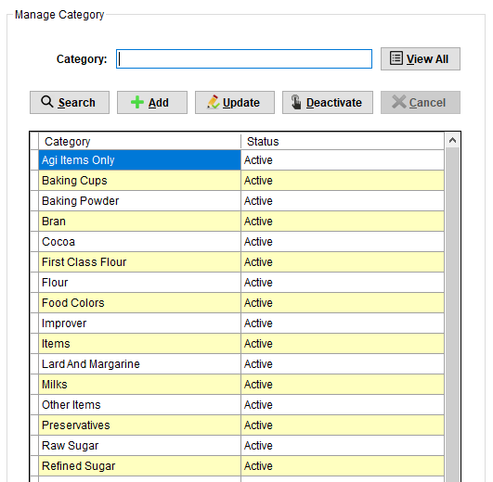

## Items

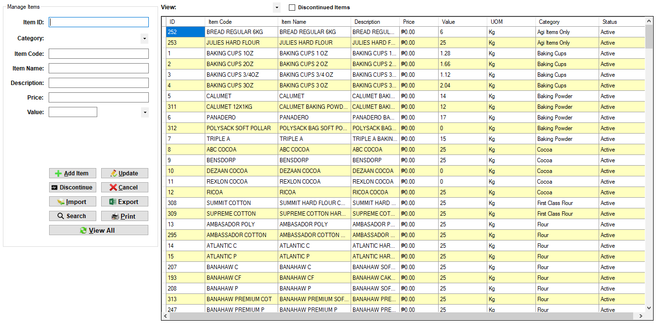

## Transaction Type

# **VEHICLE TRIP MENU**

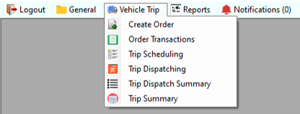

1. Create Order
2. Order Transactions
3. Trip Scheduling
4. Trip Dispatching
5. [Step 1 (Pre-Inspection)](#_STEP_1_(PRE-INSPECTION))
6. [Step 2 (Diesel)](#_STEP_2_(DIESEL))
7. [Step 3 (Loading)](#_STEP_3_(LOADING))
8. [Step 4 (Release Documents)](#_STEP_4_(RELEASE)
9. [Step 5 (Release Petty Cash)](#_STEP_5_(RELEASE)
10. [Step 6 (Exit / Delivery / Return)](#_STEP_6_(GUARD)
11. [Step 7 (Return Documents)](#_STEP_7_(RETURN)
12. [Step 8 (Post-Inspection)](#_STEP_8_(POST-INSPECTION))
13. [Step 9 (Recording)](#_STEP_9_(RECORDING))
14. Trip Dispatching Summary
15. Trip Summary

## **Create Order**

|  |  |  |
| --- | --- | --- |
| 1 | Draft Transaction# |  |
| 2 | Recipient | List from dbo.tblcustomers.customer (Active only) |
| 3 | Order list | Description from dbo.tbloritems.itemcode (Active only), Qty up to 3 Decimal places |
| 4 | GPS POI | Drop off and Address |
| 5 | Date Booked | If connected in SAP, initial value is DocDate |
| Expected Delivery Date | If connected in SAP, initial value is DocDueDate |
| 6 | Transaction Type | List from dbo.tbltranstype.transtype (Active only) |
| Pick up from | List from dbo.tblwhse.company<>’ J. Poon & Sons’ |
| Pick up Address | From dbo.tblwhsepoi.poiid |
| 7 | SO# |  |
| 8 | Attachments for SO# |  |
| 9 | PO# or ITR# |  |
| 10 | Attachments for PO# or ITR# |  |
| 11 | Buttons for Attachments |  |
| 12 | SAP WHSE | If connected in SAP with SO#, SAP Whse = WhsCode |
| If connected in SAP with PO#, SAP Whse = CardCode |
| If connected in SAP with ITR#, SAP Whse = FromWhse |
| If not connected in SAP or without ref#, SAP Whse = "" |
| No SO Direct DR only |  |
| No PO |  |
| 13 | Container Stuffing |  |
| 14 | Priority |  |
| 15 | Notes |  |
| 16 | Clear Items | To clear order list |
| 17 | OK | To confirm create order |

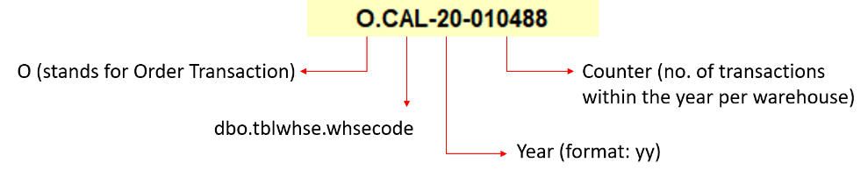**Generate Transaction#**

**Database**

* Add Transaction to **dbo.tblortrans**
* dbo.tblortrans.transyear – Year
* dbo.tblortrans.transnum - Transaction#
* dbo.tblortrans.refnum – If one reference# (REF#1)

- If two reference# (REF#1 / REF#2)

* dbo.tblortrans.sonum – SO#
* dbo.tblortrans.ponum – PO#
* dbo.tblortrans.itrnum – ITR#
* dbo.tblortrans.datebooked – Date booked
* dbo.tblortrans.dateexpected – Expected Delivery Date
* dbo.tblortrans.customer – Recipient
* dbo.tblortrans.poiid – Drop off POI ID (dbo.tblpoi.poiid)
* dbo.tblortrans.trid – Transaction Type ID (dbo.tbltranstype.trid)
* dbo.tblortrans.pupid – Pick up Warehouse ID (dbo.tblwhse.whseid)
* dbo.tblortrans.pup_poiid – Pick up POI ID (dbo.tblpoi.poiid)
* any Stock Transfer (except pickup frm AGI)
* dbo.tblortrans.arnum – ’N/A’
* dbo.tblortrans.rdrnum – ’’
* dbo.tblortrans.drnum – ’N/A’
* dbo.tblortrans.itrnum – ’’
* dbo.tblortrans.dnnum – ’N/A’
* dbo.tblortrans.itnum – ’’
* dbo.tblortrans.grponum – ’’
* Stock Transfer pickup frm AGI
* dbo.tblortrans.arnum – ’N/A’
* dbo.tblortrans.rdrnum – ’’
* dbo.tblortrans.drnum – ’N/A’
* dbo.tblortrans.itrnum – ’’
* dbo.tblortrans.dnnum – ’’
* dbo.tblortrans.itnum – ’’
* dbo.tblortrans.grponum – ’N/A’
* any Sales Transaction (except pickup frm AGI)
* dbo.tblortrans.arnum – ’’
* dbo.tblortrans.rdrnum – ’’
* dbo.tblortrans.drnum – ’’
* dbo.tblortrans.itrnum – ’N/A’
* dbo.tblortrans.dnnum – ’N/A’
* dbo.tblortrans.itnum – ’N/A’
* dbo.tblortrans.grponum – ’N/A’
* Sales Transaction pickup frm AGI
* dbo.tblortrans.arnum – ’’
* dbo.tblortrans.rdrnum – ’’
* dbo.tblortrans.drnum – ’’
* dbo.tblortrans.itrnum – ’N/A’
* dbo.tblortrans.dnnum – ’’
* dbo.tblortrans.itnum – ’N/A’
* dbo.tblortrans.grponum – ’N/A’
* dbo.tblortrans.notes – Notes
* dbo.tblortrans.cancel – 0
* dbo.tblortrans.whsename – Login Warehouse
* dbo.tblortrans.chktype
* 4 – Trucking only for Monde Customers
* 3 – Trucking only for Oro Allado Customers
* 2 – No SO Direct DR only
* 1 – Trucking only for AGI Customers
* 0 – Default
* dbo.tblortrans.datecreated – GetDate()
* dbo.tblortrans.createdby – Login User
* dbo.tblortrans.status – 1
* dbo.tblortrans.priority
* 1 – Priority
* 0 – Not Priority
* dbo.tblortrans.stuffing
* 1 – Delivery via Shipping Lines
* 0 – Not Delivery via Shipping Lines
* dbo.tblortrans.sapwhse
* If SO – from SAP (WhsCode)
* If PO – from SAP (CardCode)
* If ITR – from SAP (FromWhse)
* dbo.tblortrans.sap
* 1 – Order Details from SAP
* 0 – Manual Create Order
* dbo.tblortrans.edited
* 0 – Not Edited
* Add items to **dbo.tblorder**
* dbo.tblorder.transnum – Transaction#
* dbo.tblorder.itemcode – Item code
* dbo.tblorder.qty – qty
* dbo.tlorder.status – 1
* Add Photos to **dbo.tblorimage**
* dbo.tblorimage.transnum – Transaction#
* dbo.tblorimage.name – Image Name
* dbo.tblorimage.img - Image

### **TRANSACTION TYPES**

|  |  |  |
| --- | --- | --- |
| TRANSACTION TYPE | DESCRIPTION | REFERENCE# |
| 1. JPSC STOCK TRANSFER PICKUP | - pickup stocks from supplier warehouse, deliver to jpoon warehouse | *** |
| 2. JPSC STOCK TRANSFER WHSE TO WHSE | - stocks from jpoon warehouse, deliver to another jpoon warehouse | ITR |
| 3. JPSC SALES TRANSACTION | - stocks from jpoon warehouse, deliver to customer | SO |
| 4. JPSC SALES TRANSACTION PICKUP | - direct pickup stocks from supplier warehouse, deliver to customer | SO and PO - (if pickup from any AGI) |
| SO - (if pickup from any other supplier) |
| 5. JPSC TRUCKING FOR OTHERS PICKUP | - pickup stocks from others like AGI / ORO ALLADO / MONDE, deliver to their customers | SO |
| 6. JPSC TAXI | - does not involve any items for sale | NONE |
| 7. CUSTOMER SALES TRANSACTION WHSE | - direct pickup stocks from jpoon warehouse | SO |
| 8. CUSTOMER SALES TRANSACTION PICKUP | - direct pickup stocks from supplier warehouse | SO and PO - (if pickup from any AGI) |
| SO - (if pickup from any other supplier) |
| 9. TRUCKING STOCK TRANSFER PICKUP | - pickup stocks from supplier warehouse, deliver to jpoon warehouse | *** |
| 10. TRUCKING STOCK TRANSFER WHSE TO WHSE | - stocks from jpoon warehouse, deliver to another jpoon warehouse | ITR |
| 11. TRUCKING SALES TRANSACTION WHSE | - direct pickup stocks from jpoon warehouse, deliver to customer | SO |
| 12. TRUCKING SALES TRANSACTION PICKUP | - direct pickup stocks from supplier warehouse, deliver to customer | SO and PO - (if pickup from any AGI) |
| SO - (if pickup from any other supplier) |

Note:

*** - reference# depends on the selected warehouse. You can get the reference# from tblwhse

=all the transaction types that starts with JPSC are for JPSC trucks (trucks under "J. Poon & Sons" company)

=all the transaction types that starts with CUSTOMER are for CUSTOMER pickup trucks (trucks under "Customer" company)

=all the transaction types that starts with TRUCKING are for Third party trucks like LALAMOVE and other Trucking companies (trucks under "Trucking" company)

### **How to Create an Order**

#### **JPSC STOCK TRANSFER PICKUP**

* 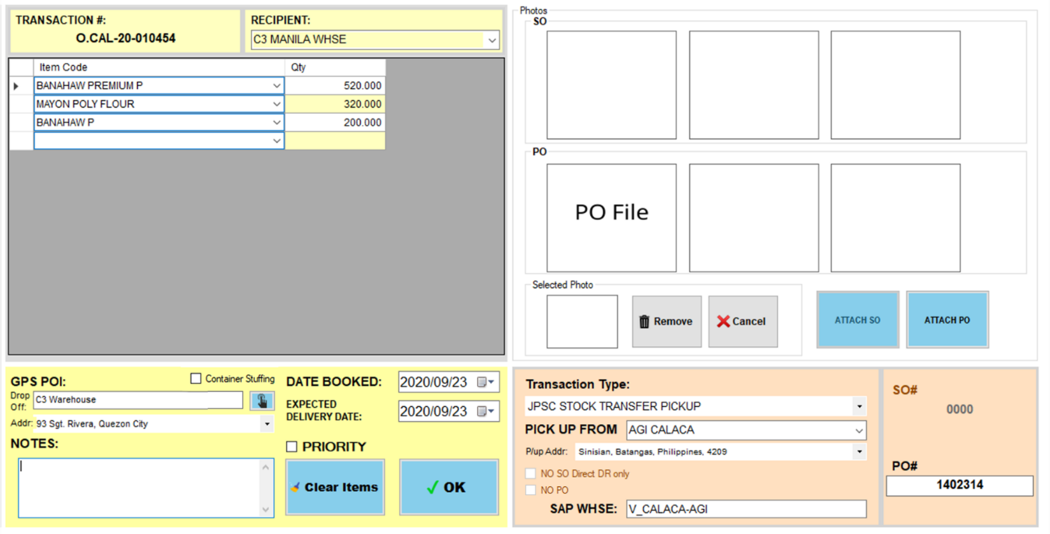Pickup from supplier warehouse (Reference# is PO)

Complete the fields

1. Select Transaction Type
2. Select Pick up from
3. Select P/up Address
4. Input PO#
5. Attach PO – required for Manual Create Order only
6. Input SAP Whse – automatic if connected in SAP
7. Input Recipient
8. Input Items – automatic if connected in SAP
9. Select Drop off
10. Select Drop off Address
11. Select Date Booked – DocDate from SAP if connected in SAP
12. Set Expected Delivery Date – Initially DocDueDate from SAP if connected in SAP
13. Set if Priority (Optional)
14. Check Container Stuffing if delivery via shipping lines
15. Input Notes – required if reference number is TO FOLLOW

Click OK button

* 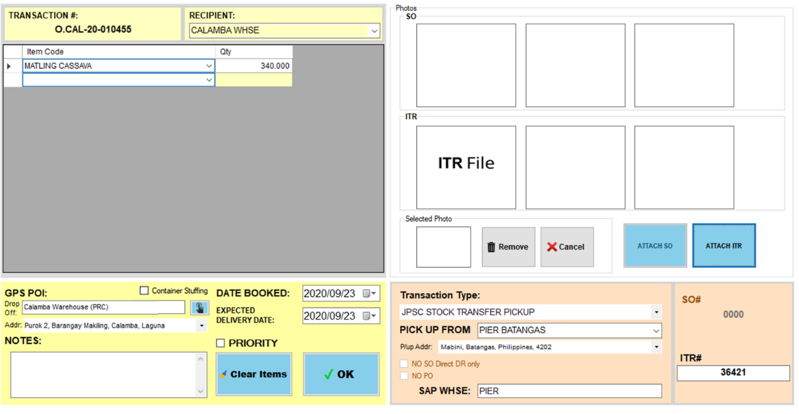Pickup from supplier warehouse (Reference# is ITR)

Complete the fields

1. Select Transaction Type
2. Select Pick up from
3. Select P/up Address
4. Input ITR#
5. Attach ITR – required for Manual Create Order only
6. Input SAP Whse – automatic if connected in SAP
7. Input Recipient
8. Input Items – automatic if connected in SAP
9. Select Drop off
10. Select Drop off Address
11. Select Date Booked – DocDate from SAP if connected in SAP
12. Set Expected Delivery Date – Initially DocDueDate from SAP if connected in SAP
13. Set if Priority (Optional)
14. Check Container Stuffing if delivery via shipping lines
15. Input Notes – required if reference number is TO FOLLOW

Click OK button

#### **JPSC STOCK TRANSFER WHSE TO WHSE**

Complete the fields

1. Select Transaction Type
2. Input ITR#
3. Attach ITR – required for Manual Create Order only
4. Input SAP Whse – automatic if connected in SAP
5. Input Recipient
6. Input Items – automatic if connected in SAP
7. Select Drop off
8. Select Drop off Address
9. Select Date Booked – DocDate from SAP if connected in SAP
10. Set Expected Delivery Date – Initially DocDueDate from SAP if connected in SAP
11. Set if Priority (Optional)
12. Check Container Stuffing if delivery via shipping lines
13. Input Notes – required if reference number is TO FOLLOW

Click OK button

#### **JPSC SALES TRANSACTION**

Complete the fields

1. Select Transaction Type
2. Input SO#
3. Attach SO – required for Manual Create Order only
4. Input SAP Whse – automatic if connected in SAP
5. Input Recipient – automatic if connected in SAP
6. Input Items – automatic if connected in SAP
7. Select Drop off
8. Select Drop off Address
9. Select Date Booked – DocDate from SAP if connected in SAP
10. Set Expected Delivery Date – Initially DocDueDate from SAP if connected in SAP
11. Set if Priority (Optional)
12. Check Container Stuffing if delivery via shipping lines
13. Input Notes – required if reference number is TO FOLLOW

Click OK button

#### **JPSC SALES TRANSACTION PICKUP**

* 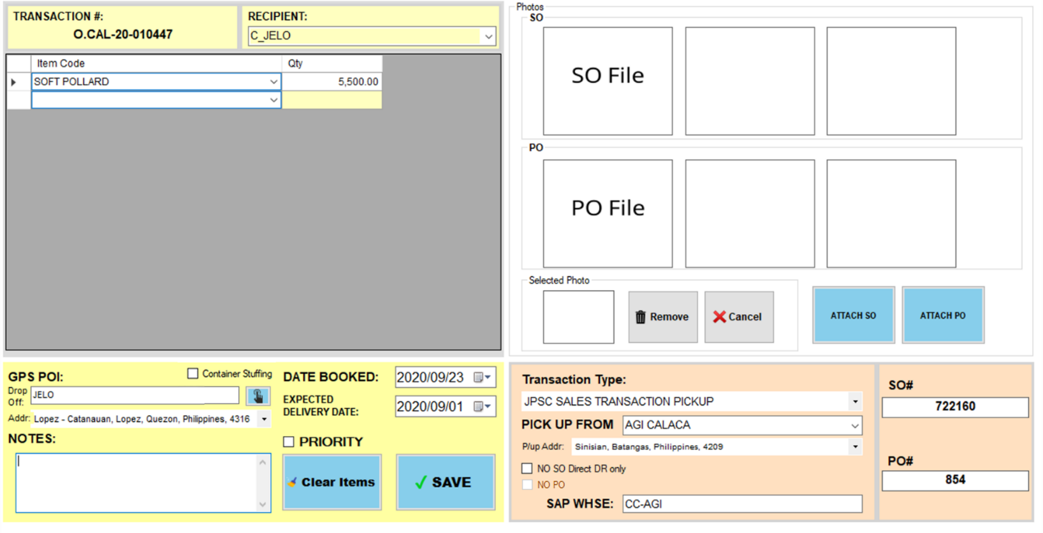Pickup from any AGI

Complete the fields

1. Select Transaction Type
2. Select Pick up from any AGI
3. Select P/up Address
4. Input SO#
5. Attach SO – required for Manual Create Order only
6. Input PO#
7. Attach PO – required for Manual Create Order only
8. Input SAP Whse – automatic if connected in SAP
9. Input Recipient – automatic if connected in SAP
10. Input Items – automatic if connected in SAP
11. Select Drop off
12. Select Drop off Address
13. Select Date Booked – DocDate from SAP if connected in SAP
14. Set Expected Delivery Date – Initially DocDueDate from SAP if connected in SAP
15. Set if Priority (Optional)
16. Check Container Stuffing if delivery via shipping lines
17. Input Notes – required if reference number is TO FOLLOW

Click OK button

* 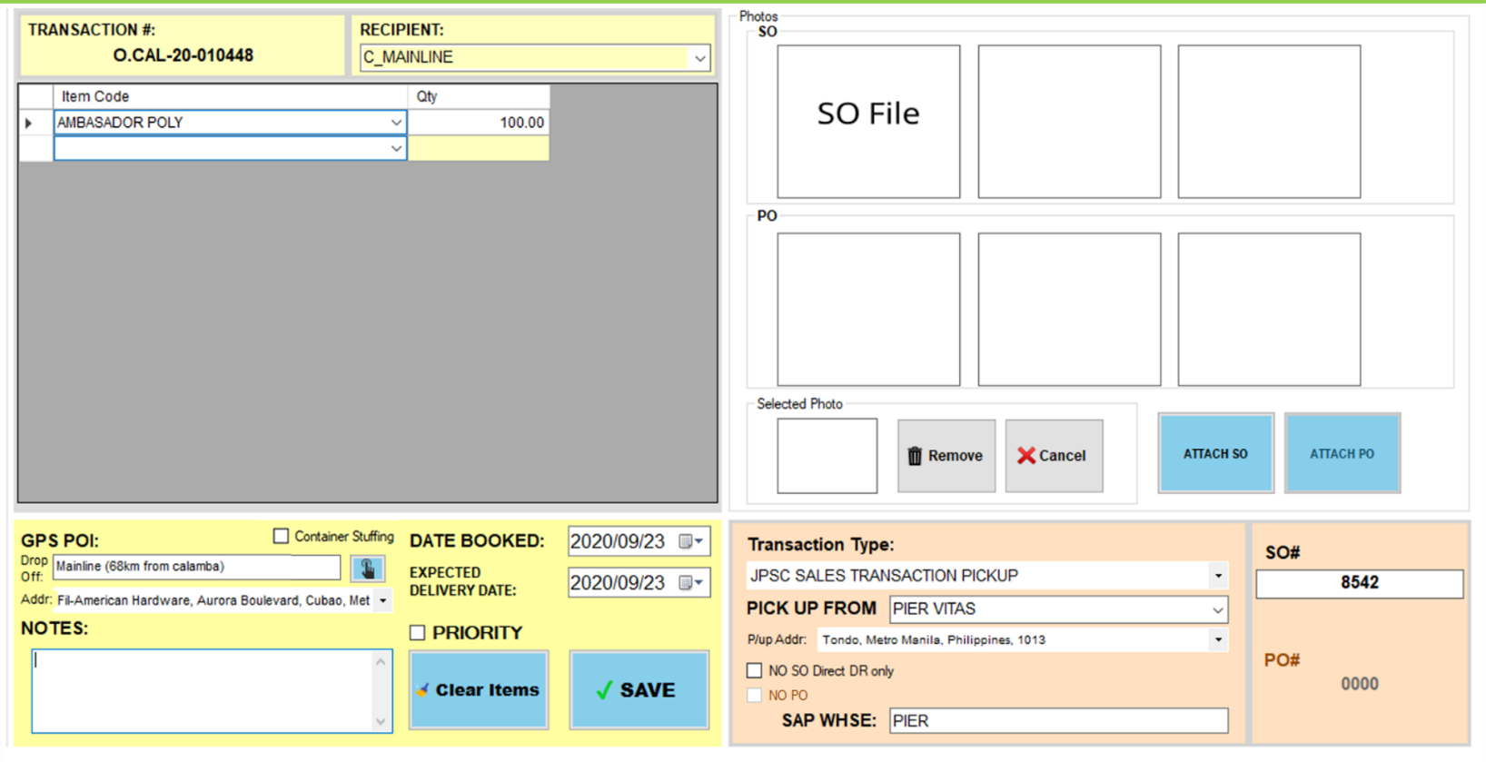Pickup from any supplier warehouse except AGI

Complete the fields

1. Select Transaction Type
2. Select Pick up from any supplier warehouse except AGI
3. Select P/up Address
4. Input SO#
5. Attach SO – required for Manual Create Order only
6. Input SAP Whse – automatic if connected in SAP
7. Input Recipient – automatic if connected in SAP
8. Input Items – automatic if connected in SAP
9. Select Drop off
10. Select Drop off Address
11. Select Date Booked – DocDate from SAP if connected in SAP
12. Set Expected Delivery Date – Initially DocDueDate from SAP if connected in SAP
13. Set if Priority (Optional)
14. Check Container Stuffing if delivery via shipping lines
15. Input Notes – required if reference number is TO FOLLOW

Click OK button

#### **JPSC TRUCKING FOR OTHERS PICKUP**

Complete the fields

1. Select Transaction Type
2. Select Pick up from
3. Select P/up Address
4. Input SO#
5. Attach SO – required for Manual Create Order only
6. Input SAP Whse – automatic if connected in SAP
7. Input Recipient – automatic if connected in SAP
8. Input Items – automatic if connected in SAP
9. Select Drop off
10. Select Drop off Address
11. Select Date Booked – DocDate from SAP if connected in SAP
12. Set Expected Delivery Date – Initially DocDueDate from SAP if connected in SAP
13. Set if Priority (Optional)
14. Check Container Stuffing if delivery via shipping lines
15. Input Notes – required if reference number is TO FOLLOW

Click OK button

#### **JPSC TAXI**

Complete the fields

1. Select Transaction Type
2. Input Recipient – Destination
3. Select Drop off
4. Select Drop off Address
5. Set Expected Delivery Date – Expected Arrival date at destination
6. Set if Priority (Optional)
7. Input Notes (Optional)

Click OK button

#### **CUSTOMER SALES TRANSACTION WHSE**

Complete the fields

1. Select Transaction Type
2. Input SO#
3. Attach SO – required for Manual Create Order only
4. Input SAP Whse – automatic if connected in SAP
5. Input Recipient – automatic if connected in SAP
6. Input Items – automatic if connected in SAP
7. Select Date Booked – DocDate from SAP if connected in SAP
8. Set Expected Delivery Date – Initially DocDueDate from SAP if connected in SAP
9. Set if Priority (Optional)
10. Input Notes – required if reference number is TO FOLLOW

Click OK button

#### **CUSTOMER SALES TRANSACTION PICKUP**

* 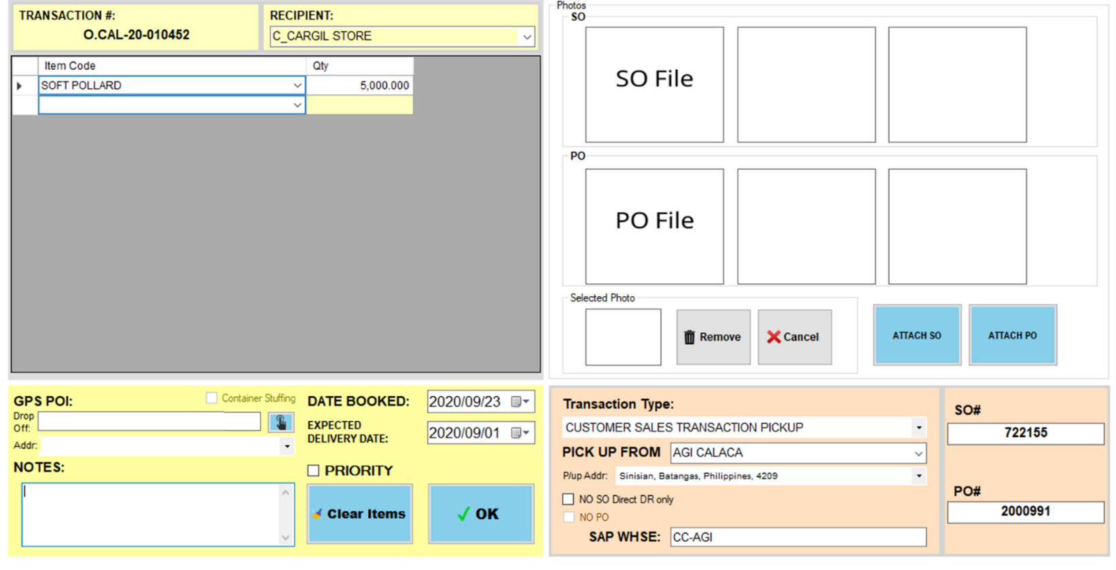Pickup from any AGI

Complete the fields

1. Select Transaction Type
2. Select Pick up from any AGI
3. Select P/up Address
4. Input SO#
5. Attach SO – required for Manual Create Order only
6. Input PO#
7. Attach PO – required for Manual Create Order only
8. Input SAP Whse – automatic if connected in SAP
9. Input Recipient – automatic if connected in SAP
10. Input Items – automatic if connected in SAP
11. Select Date Booked – DocDate from SAP if connected in SAP
12. Set Expected Delivery Date – Initially DocDueDate from SAP if connected in SAP
13. Set if Priority (Optional)
14. Input Notes – required if reference number is TO FOLLOW

Click OK button

* 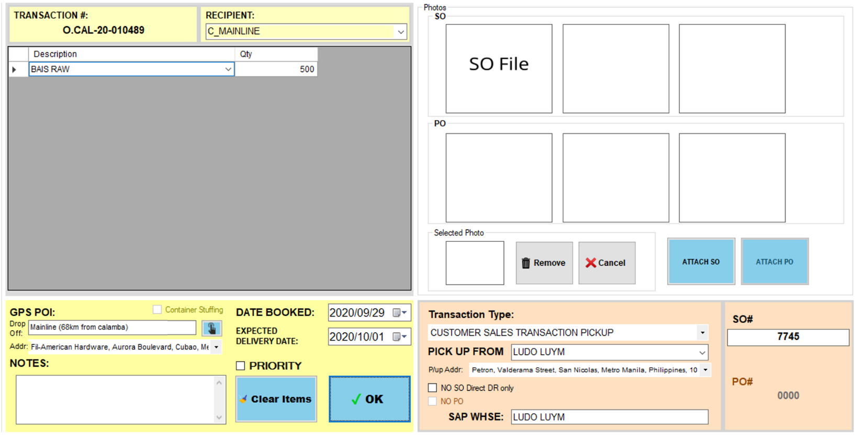Pickup from any supplier warehouse except AGI

Complete the fields

1. Select Transaction Type
2. Select Pick up from any supplier warehouse except AGI
3. Select P/up Address
4. Input SO#
5. Attach SO – required for Manual Create Order only
6. Input SAP Whse – automatic if connected in SAP
7. Input Recipient – automatic if connected in SAP
8. Input Items – automatic if connected in SAP
9. Select Date Booked – DocDate from SAP if connected in SAP
10. Set Expected Delivery Date – Initially DocDueDate from SAP if connected in SAP
11. Set if Priority (Optional)
12. Input Notes – required if reference number is TO FOLLOW

Click OK button

#### **TRUCKING STOCK TRANSFER PICKUP**

* 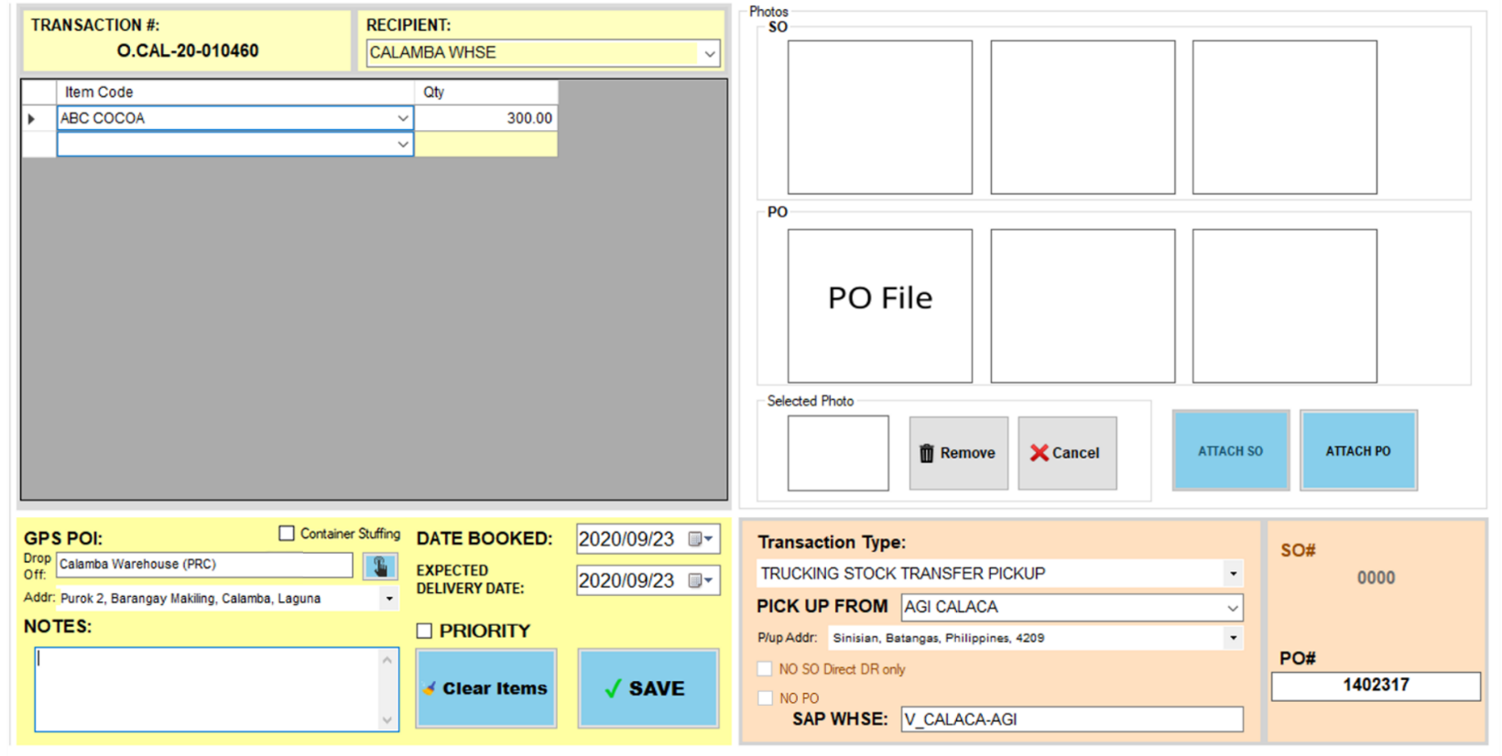Pickup from supplier warehouse (Reference# is PO)

Complete the fields

1. Select Transaction Type
2. Select Pick up from
3. Select P/up Address
4. Input PO#
5. Attach PO – required for Manual Create Order only
6. Input SAP Whse – automatic if connected in SAP
7. Input Recipient
8. Input Items – automatic if connected in SAP
9. Select Drop off
10. Select Drop off Address
11. Select Date Booked – DocDate from SAP if connected in SAP
12. Set Expected Delivery Date – Initially DocDueDate from SAP if connected in SAP
13. Set if Priority (Optional)
14. Check Container Stuffing if delivery via shipping lines
15. Input Notes – required if reference number is TO FOLLOW

Click OK button

* 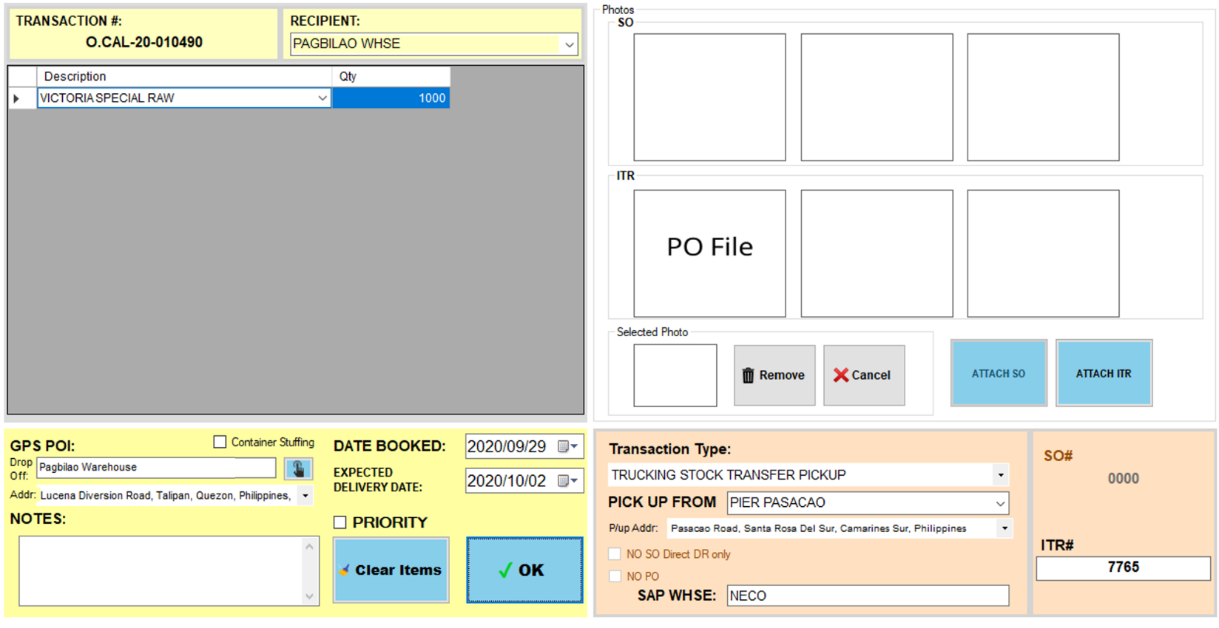Pickup from supplier warehouse (Reference# is ITR)

Complete the fields

1. Select Transaction Type
2. Select Pick up from
3. Select P/up Address
4. Input ITR#
5. Attach ITR – required for Manual Create Order only
6. Input SAP Whse – automatic if connected in SAP
7. Input Recipient
8. Input Items – automatic if connected in SAP
9. Select Drop off
10. Select Drop off Address
11. Select Date Booked – DocDate from SAP if connected in SAP
12. Set Expected Delivery Date – Initially DocDueDate from SAP if connected in SAP
13. Set if Priority (Optional)
14. Check Container Stuffing if delivery via shipping lines
15. Input Notes – required if reference number is TO FOLLOW

Click OK button

#### **TRUCKING STOCK TRANSFER WHSE TO WHSE**

Complete the fields

1. Select Transaction Type
2. Input ITR#
3. Attach ITR – required for Manual Create Order only
4. Input SAP Whse – automatic if connected in SAP
5. Input Recipient
6. Input Items – automatic if connected in SAP
7. Select Drop off
8. Select Drop off Address
9. Select Date Booked – DocDate from SAP if connected in SAP
10. Set Expected Delivery Date – Initially DocDueDate from SAP if connected in SAP
11. Set if Priority (Optional)
12. Check Container Stuffing if delivery via shipping lines
13. Input Notes – required if reference number is TO FOLLOW

Click OK button

#### **TRUCKING SALES TRANSACTION WHSE**

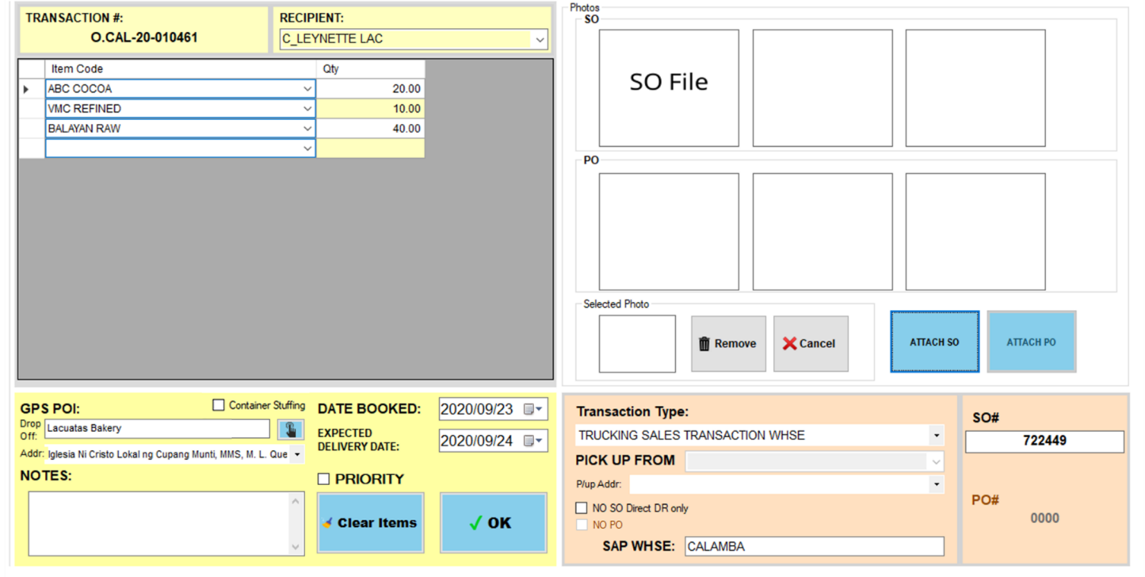

Complete the fields

1. Select Transaction Type
2. Input SO#
3. Attach SO – required for Manual Create Order only
4. Input SAP Whse – automatic if connected in SAP
5. Input Recipient – automatic if connected in SAP
6. Input Items – automatic if connected in SAP
7. Select Drop off
8. Select Drop off Address
9. Select Date Booked – DocDate from SAP if connected in SAP
10. Set Expected Delivery Date – Initially DocDueDate from SAP if connected in SAP
11. Set if Priority (Optional)
12. Check Container Stuffing if delivery via shipping lines
13. Input Notes – required if reference number is TO FOLLOW

Click OK button

#### **TRUCKING SALES TRANSACTION PICKUP**

* Pickup from any AGI

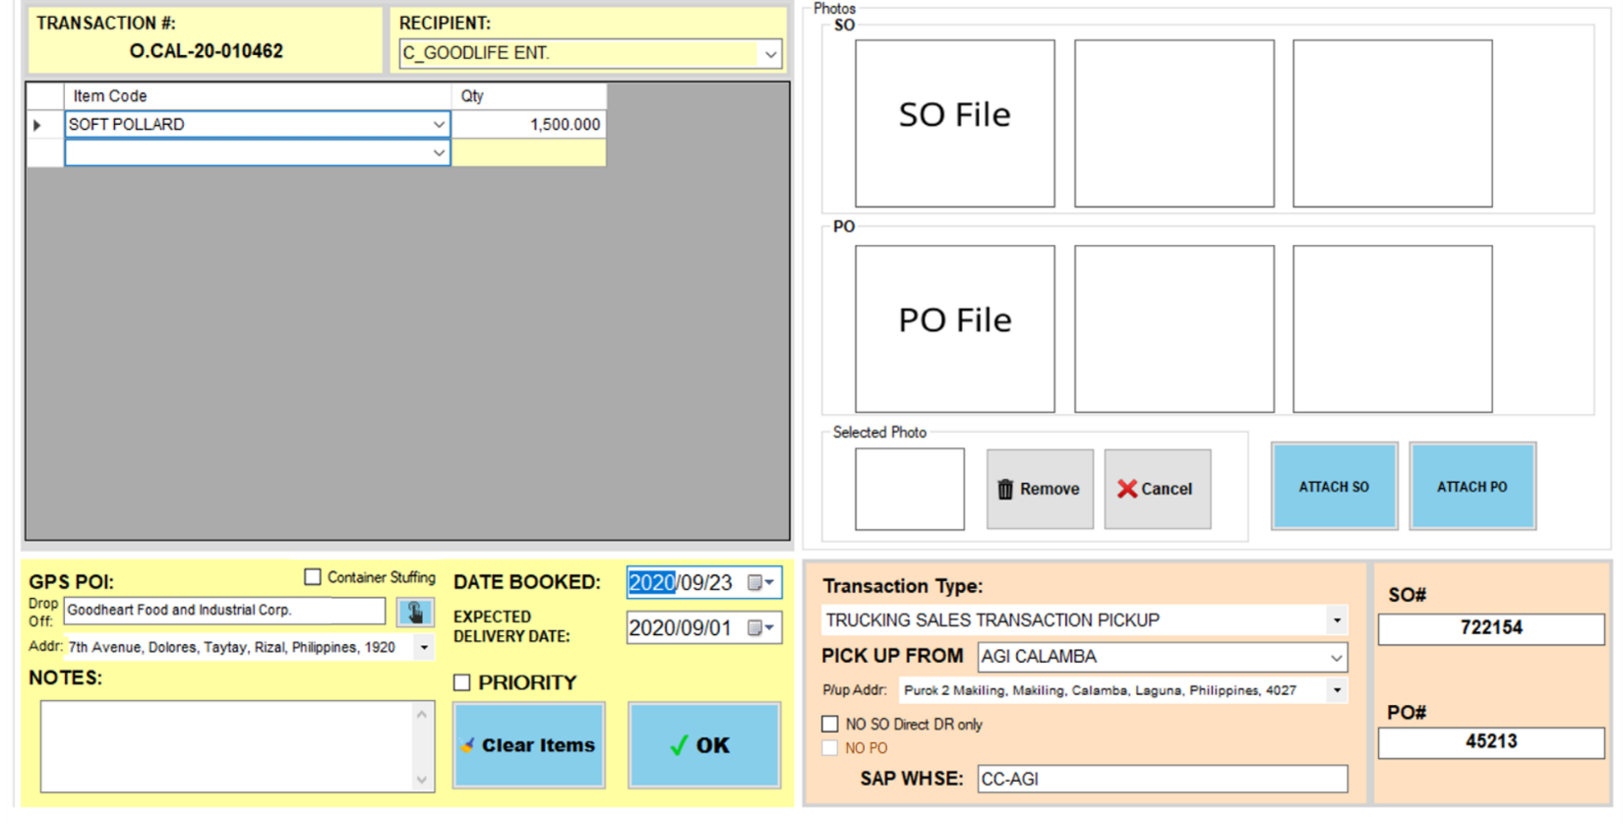

Complete the fields

1. Select Transaction Type
2. Select Pick up from any AGI
3. Select P/up Address
4. Input SO#
5. Attach SO – required for Manual Create Order only
6. Input PO#
7. Attach PO – required for Manual Create Order only
8. Input SAP Whse – automatic if connected in SAP
9. Input Recipient – automatic if connected in SAP
10. Input Items – automatic if connected in SAP
11. Select Drop off
12. Select Drop off Address
13. Select Date Booked – DocDate from SAP if connected in SAP
14. Set Expected Delivery Date – Initially DocDueDate from SAP if connected in SAP
15. Set if Priority (Optional)
16. Check Container Stuffing if delivery via shipping lines
17. Input Notes – required if reference number is TO FOLLOW

Click OK button

* 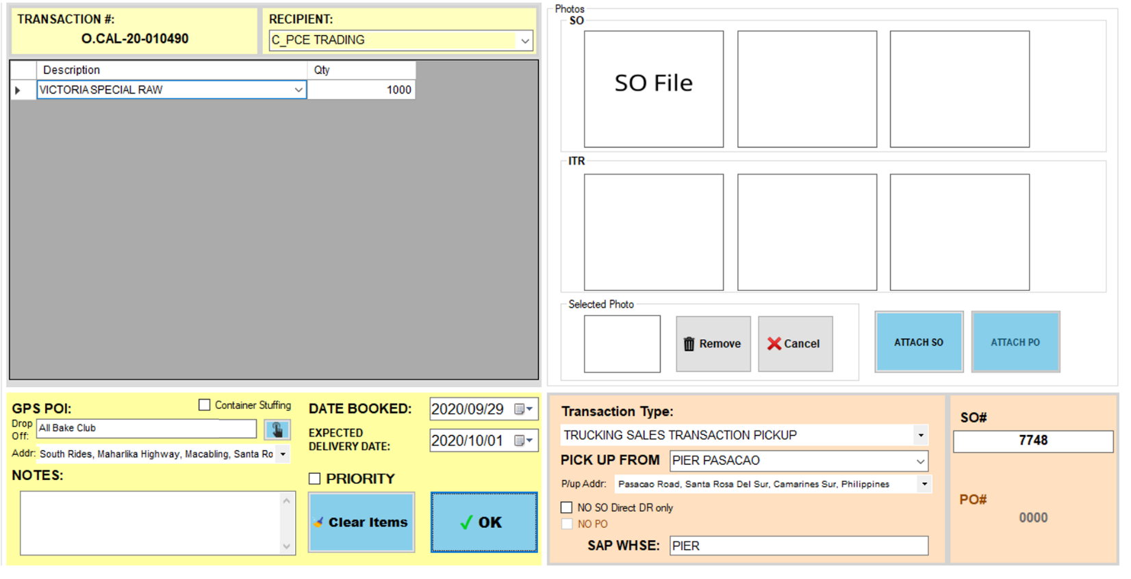Pickup from any supplier warehouse except AGI

Complete the fields

1. Select Transaction Type
2. Select Pick up from any supplier warehouse except AGI
3. Select P/up Address
4. Input SO#
5. Attach SO – required for Manual Create Order only
6. Input SAP Whse – automatic if connected in SAP
7. Input Recipient – automatic if connected in SAP
8. Input Items – automatic if connected in SAP
9. Select Drop off
10. Select Drop off Address
11. Select Date Booked – DocDate from SAP if connected in SAP
12. Set Expected Delivery Date – Initially DocDueDate from SAP if connected in SAP
13. Set if Priority (Optional)
14. Check Container Stuffing if delivery via shipping lines
15. Input Notes – required if reference number is TO FOLLOW

Click OK button

## **Order Transactions**

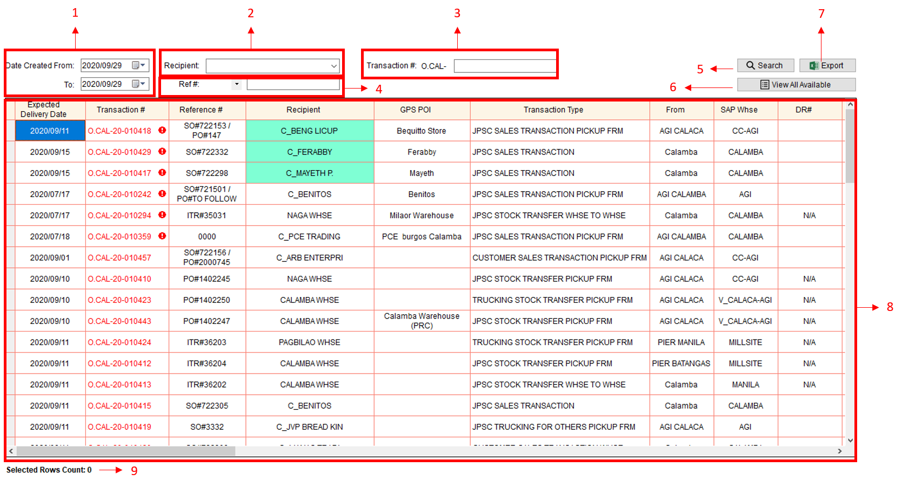

1. Date Range
2. Recipient – from dbo.tblortrans.customer
3. Transaction#
4. Reference#
5. Search Button
6. View All Available Button – dbo.tblortrans.status=1
7. Export Button
8. List or Order Transactions – order by priority and expected delivery date
9. No. of Selected Rows

### **How to Edit Order Transaction**

Notes:

* For Manager account only
* Cannot edit order transaction if Step 4 is already confirmed.
* Cannot edit transaction type if transaction is already added to a trip.
* You can edit order details in Order Transactions and Trip Scheduling module.
* You can edit items in Trip Dispatching - Step 4. See How to edit Items (Item name or Qty).

1. 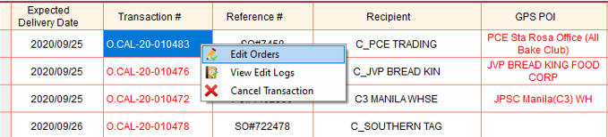Right click order transaction you want to edit.
2. 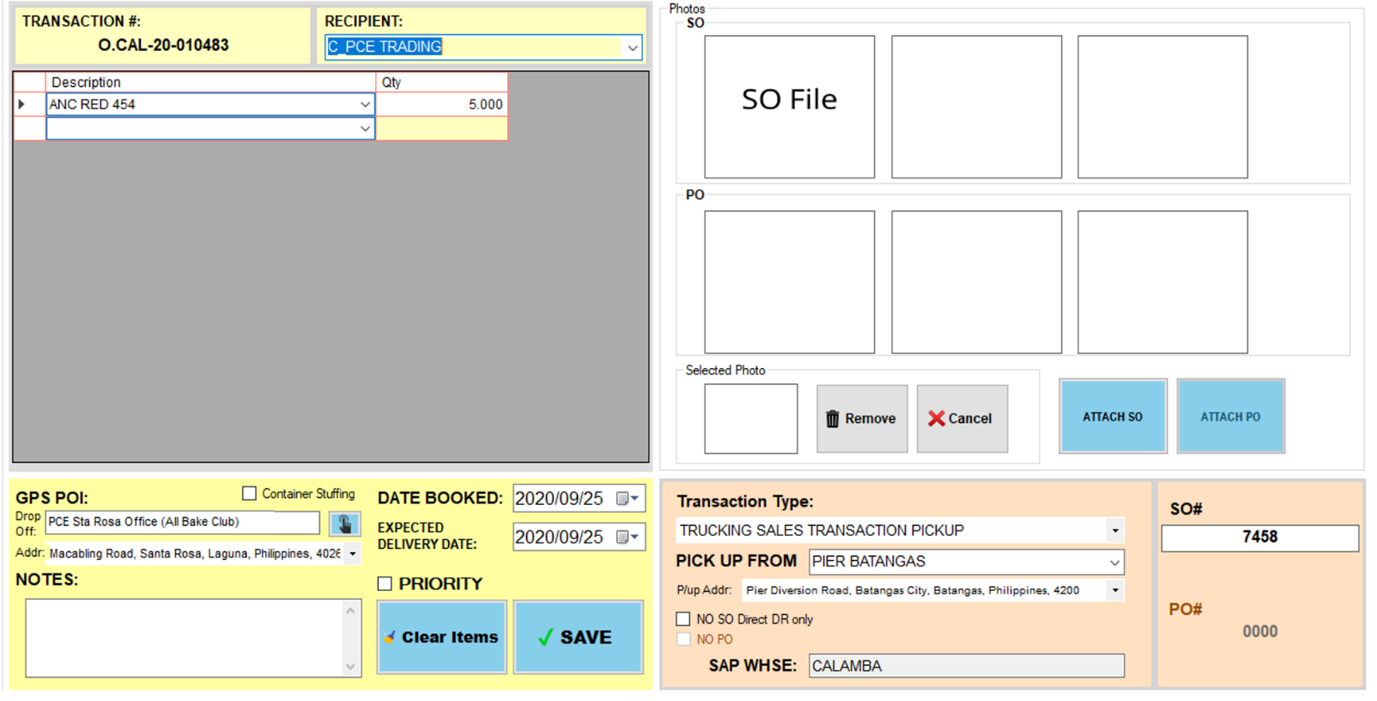Select Edit Orders
3. Edit details.
4. Then, click Save button.

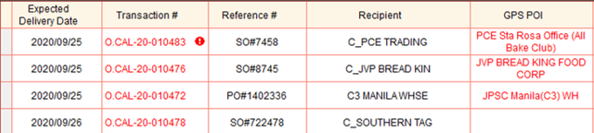

Edited Order Transaction

* Update Transaction to dbo.tblortrans
* dbo.tblortrans.edited – 1
* Update Items to dbo.tblorder
* Update Photos to dbo.tblorimage
* Insert edit logs to dbo.tblorderedit
* dbo.tblorderedit.transnum – Transaction#
* dbo.tblorderedit.dateedited – Date and Time
* dbo.tblorderedit.editedby – Login User
* dbo.tblorderedit.frm – module

### **How to View Edit Logs**

1. 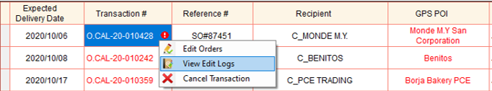Right click order transaction you want to view edit logs.
2. Select View Edit Logs

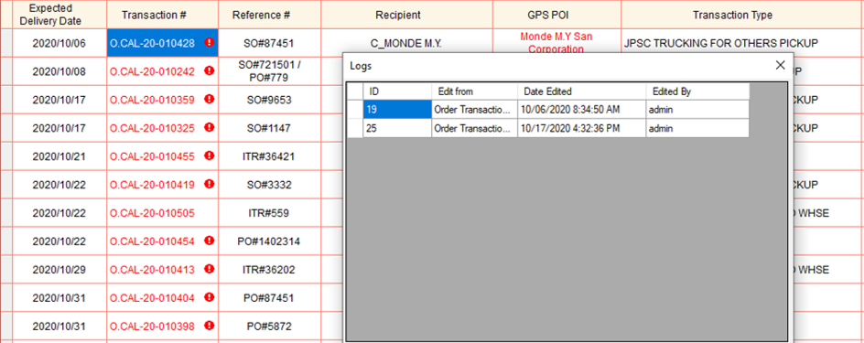

### **How to Cancel Order Transaction**

Notes:

* For Manager account only
* Cannot cancel order transaction in Order Transactions module, if the transaction status is in process.
* Cannot cancel order transaction if it is already completed.

1. Right click order transaction you want to cancel.

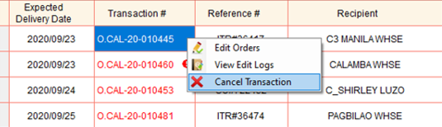

1. 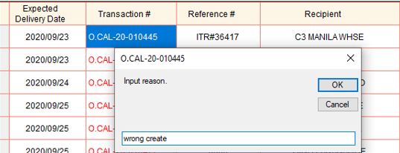Select Cancel Transaction
2. 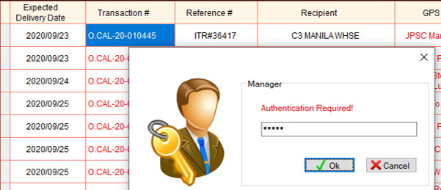Input reason why do you want to cancel the transaction. Then, click OK button.
3. Input password.
4. Then, click Ok button



* Update dbo.tblortrans
* dbo.tblortrans.cancel – 1
* dbo.tblortrans.datecancelled – Date and Time
* dbo.tblortrans.cancelledby – Login User

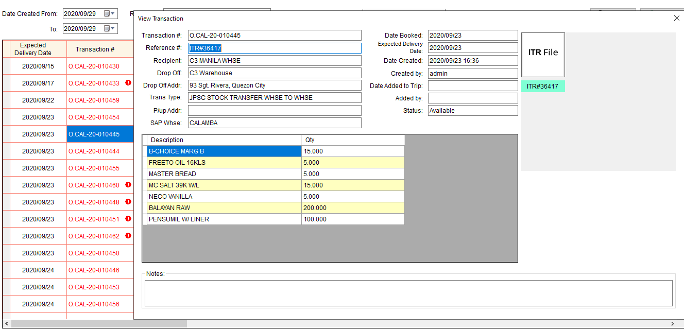**Click Transaction# to view Order Transaction Details**

## **Trip Scheduling**

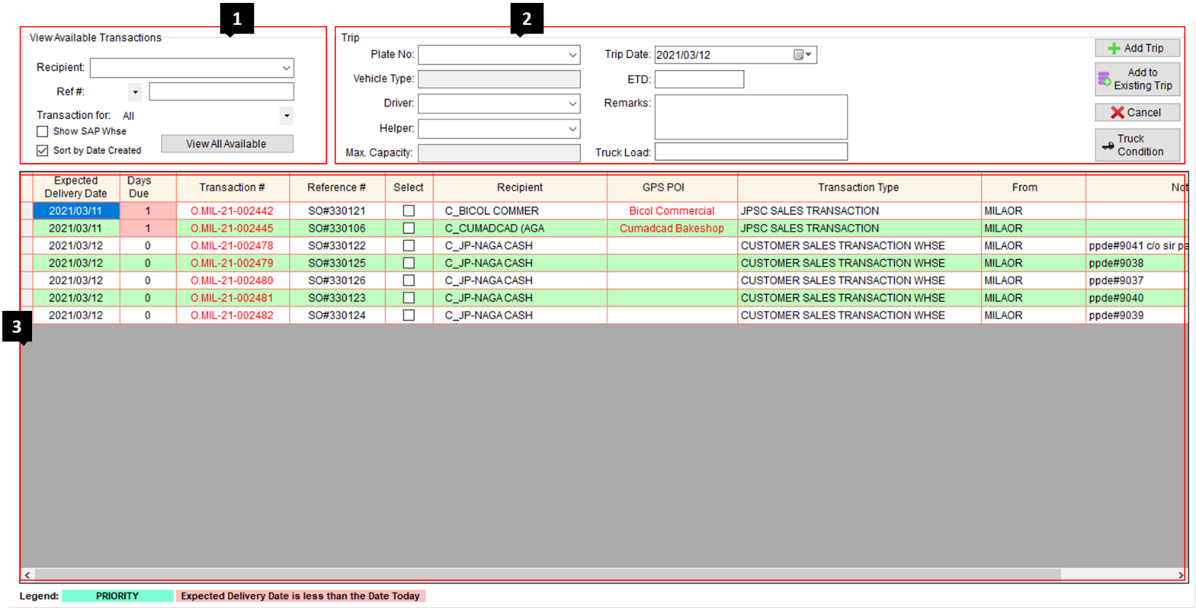

1. Filter Available Transactions – available transactions for scheduling

* Recipient
* Reference #
* Transaction for (JPSC TRUCK, CUSTOMER TRUCK, TRUCKING TRUCK)

1. Trip General Information

* Plate No. – from dbo.tblgeneral.platenum (Active only)
* Vehicle Type – Vehicle Type of the selected plate#, automatic from database dbo.tblgeneral.vtype
* Driver – from dbo.tbldriver.driver (Active only)
* Helper – from dbo.tblhelper.helper (Active only)
* Trip Date
* ETD (Estimated Time of Departure)
* Remarks
* Max. Capacity – (No. of Bags / Capacity in Kg), automatic from database dbo.tblgeneral.bags

Capacity in Kg = (No. of Bags) * 25

* Truck load
* No Truck Load computation for CUSTOMER TRUCK AND TRUCKING TRUCK
* Truck Load = Total Weight of the items (tblorder.qty * tbloritems.value)
* Add Trip button – create new trip schedule
* Add to Existing Trip button – add another transaction to an existing trip
* Cancel button
* Truck Condition button – check motorpool inspection status

1. List of Available Order Transactions – order by priority and expected delivery date

Notes:

* Type the Plate No. of a JPSC Truck if:
* JPSC Truck will pick up the items and/or deliver it to the recipient.
* Transaction type under this plate no. should start with the word *JPSC*.
* Type the Plate No. of a JPSC Service Vehicle if:
* JPSC Service Vehicle will pick up the items and/or deliver it to the recipient. (Not c/o by a sales agent)
* Transaction type under this plate no. should start with the word *JPSC*.
* Type the Plate No. of a Customer truck if:
* The truck of the customer will pick up the items.
* Transaction type under this plate no. should start with the word *CUSTOMER*.
* Type **PPDE** in the Plate No. if:
* A sales agent will pick up the items and deliver it to customers. All of the transactions are PPDE transactions.
* Plate no. **PPDE** Is under CUSTOMER TRUCK.
* Transaction type under this plate no. should start with the word *CUSTOMER*.
* Type **EMPLOYEE** in the Plate No. if:
* AR is charge to employee(s).
* Plate no. **EMPLOYEE** Is under CUSTOMER TRUCK.
* Transaction type under this plate no. should start with the word *CUSTOMER*.
* Type **WALK IN** in the Plate No. if:
* Walk in customer or the vehicle has no plate# such as padyak or tricycle
* Plate no. **WALK IN** Is under CUSTOMER TRUCK.
* Transaction type under this plate no. should start with the word *CUSTOMER*.
* Type the Plate No. of a Third-party truck if:
* A truck from a third-party trucking company will pick up the items and deliver it to the recipient.
* Transaction type under this plate no. should start with the word *TRUCKING*.

### **TRANSACTION TYPE AND STEPS TABLE**

* 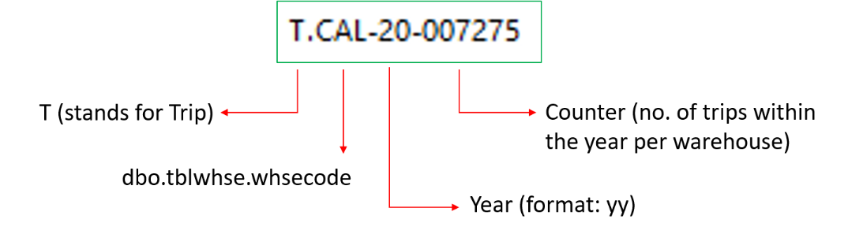Generate Trip#

**Database**

* Add trip to dbo.tbltripsum
* dbo.tbltripsum.tripyear – Year
* dbo.tbltripsum.tripnum – Trip#
* dbo.tbltripsum.platenum – Plate#
* dbo.tbltripsum.driver – Driver
* dbo.tbltripsum.helper – Helper
* dbo.tbltripsum.datepick – Trip date
* dbo.tbltripsum.etd - ETD
* dbo.tbltripsum.remarks – Remarks
* dbo.tbltripsum.odostart – 0
* dbo.tbltripsum.odoactual – 0
* dbo.tbltripsum.odoend – 0
* dbo.tbltripsum.diswith – 0
* dbo.tbltripsum.diswout – 0
* dbo.tbltripsum.dshould – 0
* dbo.tbltripsum.dieselbeg – 0
* dbo.tbltripsum.dieselactual – 0
* dbo.tbltripsum.podiesel – 0
* dbo.tbltripsum.addpo – 0
* dbo.tbltripsum.postaddpo – 0
* dbo.tbltripsum.dieselend – 0
* dbo.tbltripsum.loadscale – 0
* dbo.tbltripsum.rescue – ‘-‘
* dbo.tbltripsum.repair – 0
* dbo.tbltripsum.taxi – 0
* dbo.tbltripsum.assigned – tblgeneral.whsename
* dbo.tbltripsum.whsename – Login Warehouse
* dbo.tbltripsum.datecreated – GetDate()
* dbo.tbltripsum.createdby – Login Username
* dbo.tbltripsum.status – 1
* Add to dbo.tbldispatchsum
* dbo.tbldispatchsum.tripnum – dbo.tbltripsum.tripnum
* dbo.tbldispatchsum.rescue – ‘’
* dbo.tbldispatchsum.complete – 0
* dbo.tbldispatchsum.remarks – ‘’
* dbo.tbldispatchsum.whsename9 – Login warehouse
* if all Steps are open
  + dbo.tbldispatchsum.step1 – 0
  + dbo.tbldispatchsum.namestp1 – ‘’
  + dbo.tbldispatchsum.step2 – 0
  + dbo.tbldispatchsum.namestp2 – ‘’
  + dbo.tbldispatchsum.step3 – 0
  + dbo.tbldispatchsum.namestp3 – ‘’
  + dbo.tbldispatchsum.step4 – 0
  + dbo.tbldispatchsum.namestp4 – ‘’
  + dbo.tbldispatchsum.step5 – 0
  + dbo.tbldispatchsum.namestp5 – ‘’
  + dbo.tbldispatchsum.step6 – 0
  + dbo.tbldispatchsum.namestp6 – ‘’
  + dbo.tbldispatchsum.step7 – 0
  + dbo.tbldispatchsum.namestp7 – ‘’
  + dbo.tbldispatchsum.step8 – 0
  + dbo.tbldispatchsum.namestp8 – ‘’
  + dbo.tbldispatchsum.step9 – 0
  + dbo.tbldispatchsum.namestp9 – ‘’
* If skipped step (ex. Step 1)
* dbo.tbldispatchsum.step1 – 1
* dbo.tbldispatchsum.namestp1 – ‘’
* dbo.tbldispatchsum.steady
* 0 – Not Steady (Open Step 3)
* 1 – Steady Items (Skipped Step 3)
* 2 – Taxi (Skipped Step 3)
* Add to dbo.tbltripitems
* dbo.tbltripitems.tripnum – dbo.tbltripsum.tripnum
* dbo.tbltripitems.transnum – dbo.tblortrans.transnum
* dbo.tbltripitems.datecreated – GetDate()
* dbo.tbltripitems.createdby – Login Username
* dbo.tbltripitems.alreadydisp – 0
* dbo.tbltripitems.status – 1
* dbo.tbltripitems.cusodo
* 0 – If Vehicle Type is Customer Truck or Trucking Truck
* 0 – If Service Vehicle
* Null – Default
* dbo.tbltripitems.steady
* 0 – Not Steady Items
* 1 – Steady Items
* Update status of Order transactions
* dbo.tblortrans.status – 0

### **Add Trip**

#### **JPSC TAXI**

* cannot combine to other transaction type
* 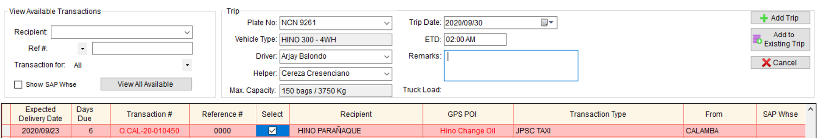It does not involve any items for sale (ex. Change oil of trucks, deliver items for construction to another warehouse, going to another warehouse without load)

1. Complete the following fields.

* Plate no.
* Trip Date
* ETD
* Driver
* Helper (Optional)
* 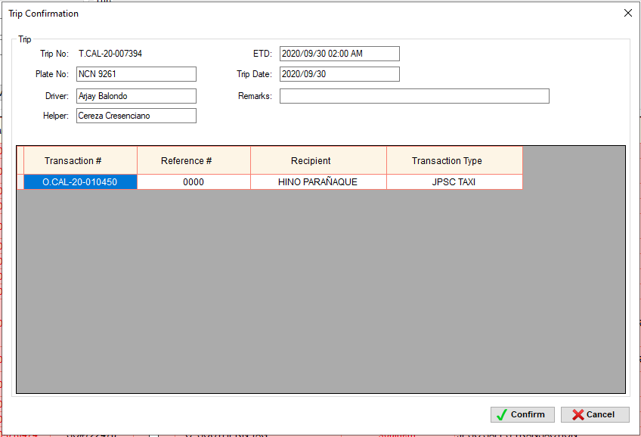Remarks (Optional)

1. Select order transaction
2. Click Add Trip button
3. Trip Confirmation window will appear
4. Click Confirm button.

JPSC TAXI – STEPS

#### **JPSC – ONE DROP-OFF WITHOUT PICK UP**

* 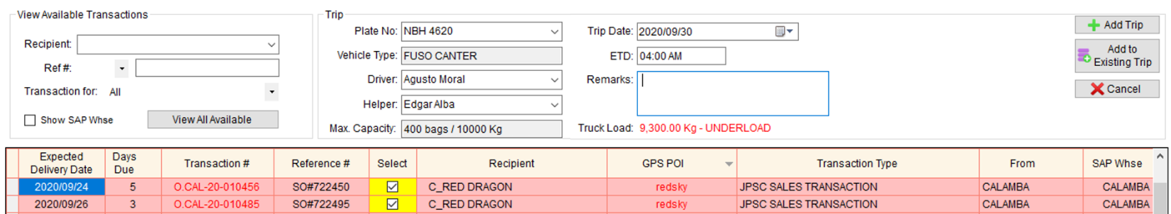It can be a one or more than one order transaction as long as one drop-off point only.

1. Complete the following fields.

* Plate no.
* Trip Date
* ETD
* Driver
* Helper (Optional)
* Remarks (Optional)

1. Select order transaction(s)
2. 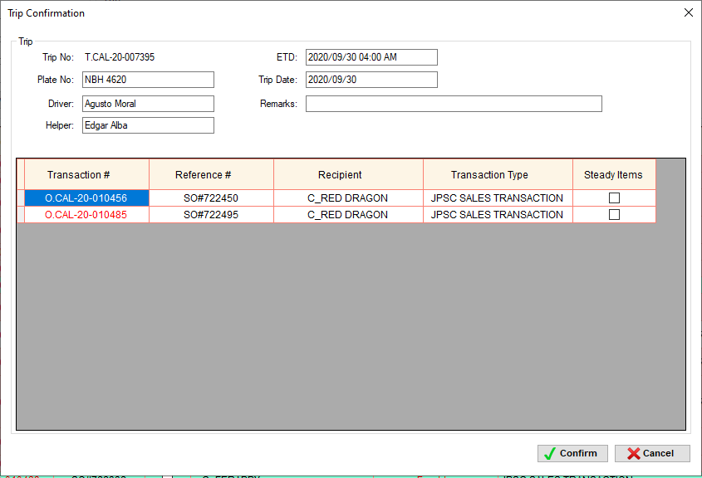Click Add Trip button
3. Trip Confirmation window will appear
4. Click Confirm button

STEPS – it depends on the transaction types. See TRANSACTION TYPE AND STEPS TABLE



#### **JPSC – ONE DROP-OFF WITH PICK UP**

* 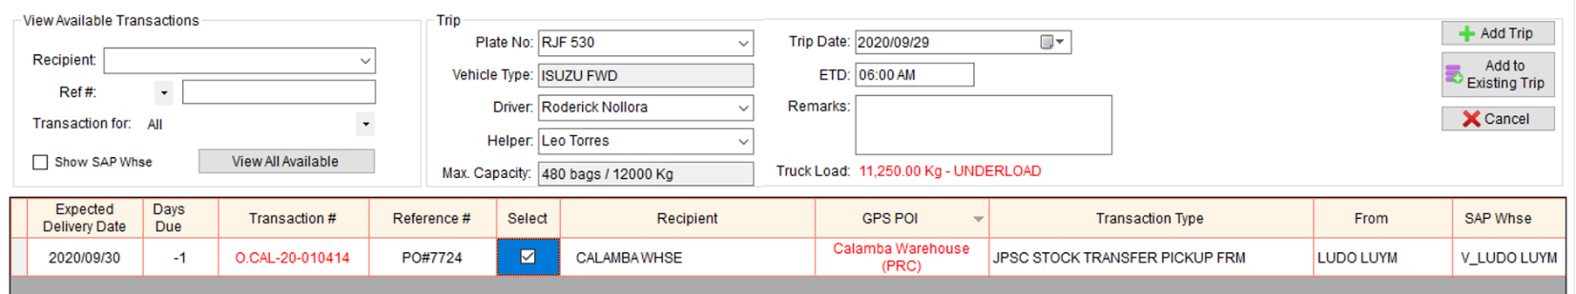It can be a one or more than one order transaction as long as one drop-off point only.

1. Complete the following fields.

* Plate no.
* Trip Date
* ETD
* Driver
* Helper (Optional)
* Remarks (Optional)

1. 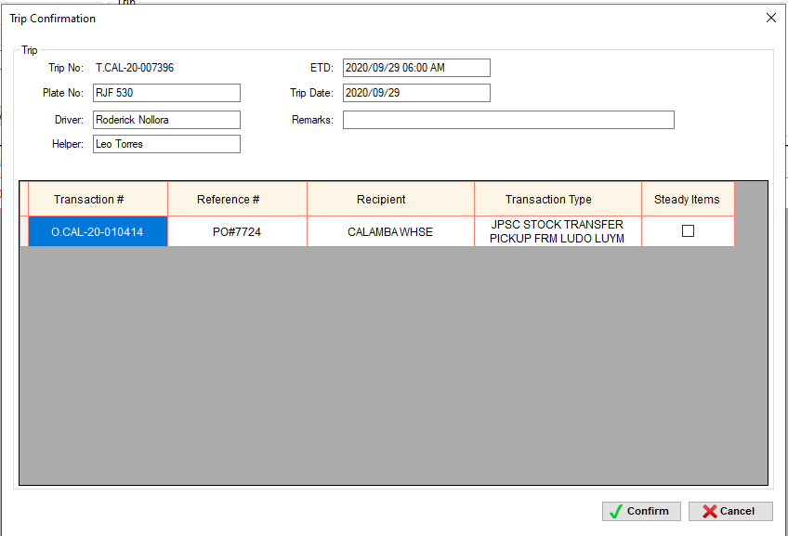Select order transaction(s)
2. Click Add Trip button
3. Trip Confirmation window will appear
4. Click Confirm button

STEPS – it depends on the transaction types. See TRANSACTION TYPE AND STEPS TABLE

#### **JPSC – MULTIPLE DROP-OFF WITHOUT PICK UP**

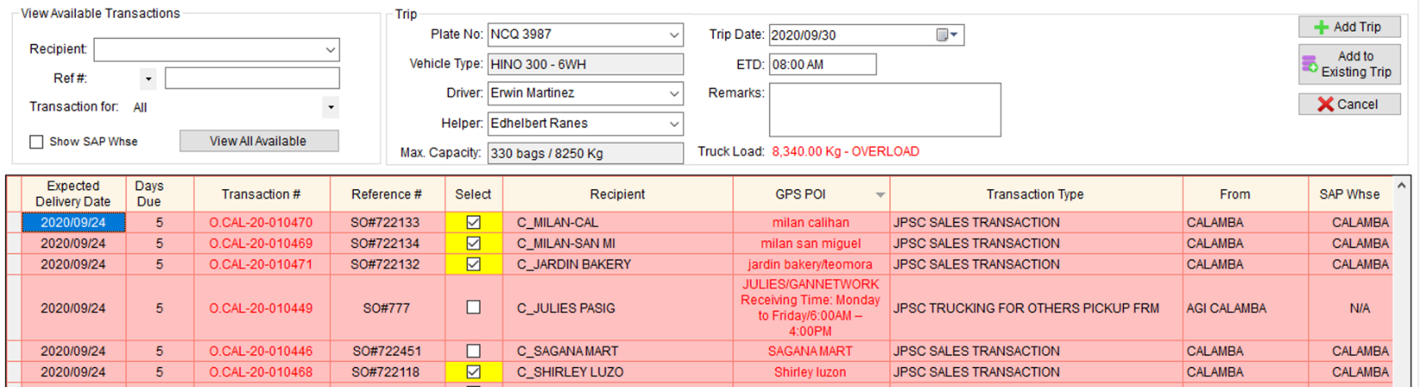

1. Complete the following fields.

* Plate no.
* Trip Date
* ETD
* Driver
* Helper (Optional)
* 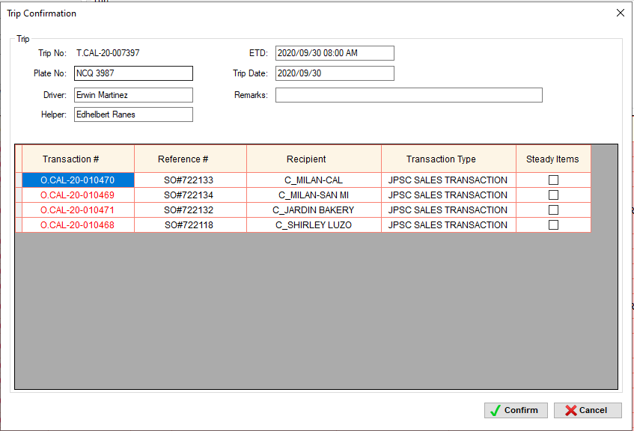Remarks (Optional)

1. Select order transaction(s)
2. Click Add Trip button
3. Trip Confirmation window will appear
4. Click Confirm button

STEPS – it depends on the transaction types. See TRANSACTION TYPE AND STEPS TABLE

#### **JPSC – MULTIPLE DROP-OFF WITH PICK UP**

1. Complete the following fields.

* Plate no.
* Trip Date
* ETD
* Driver
* Helper (Optional)
* Remarks (Optional)

1. 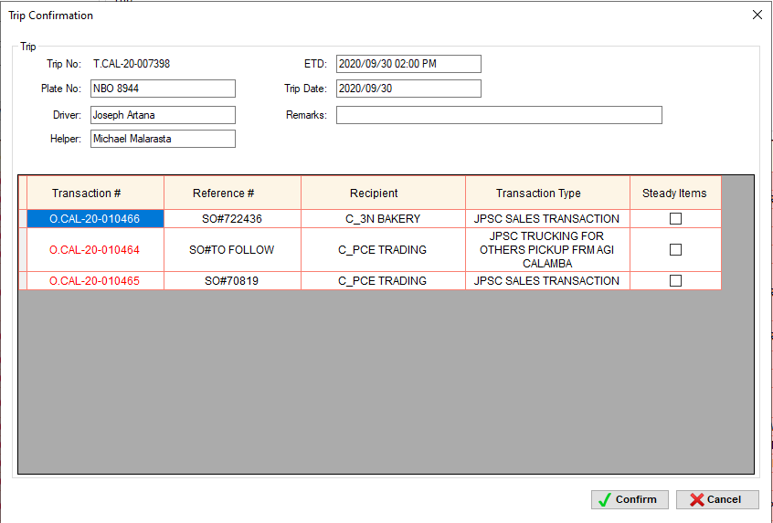Select order transaction(s)
2. Click Add Trip button
3. Trip Confirmation window will appear
4. Click Confirm button

STEPS – it depends on the transaction types. See TRANSACTION TYPE AND STEPS TABLE

#### **JPSC – SOME TRANSACTIONS ARE STEADY ITEMS AND SOME ARE NOT**

* 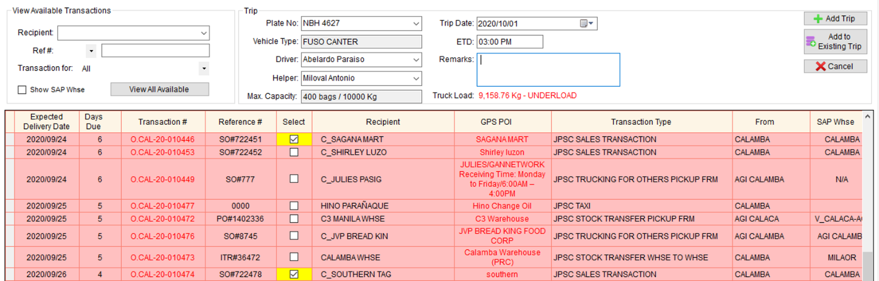Step 3 is open

1. Complete the following fields.

* Plate no.
* Trip Date
* ETD
* Driver
* Helper (Optional)
* Remarks (Optional)

1. Select order transaction(s)
2. Click Add Trip button
3. Trip Confirmation window will appear

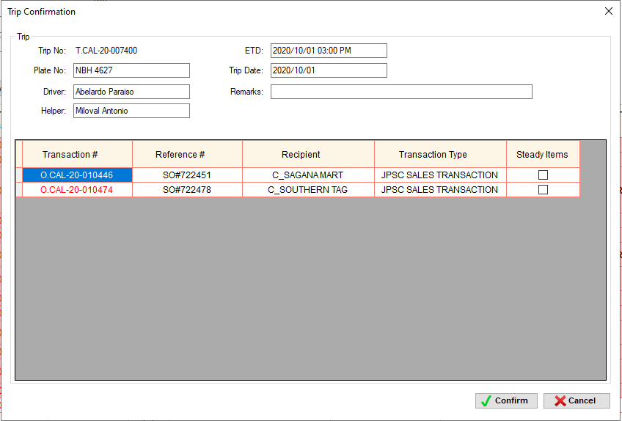

1. Check the Steady Items column of the corresponding transaction.
2. There is a confirmation message box

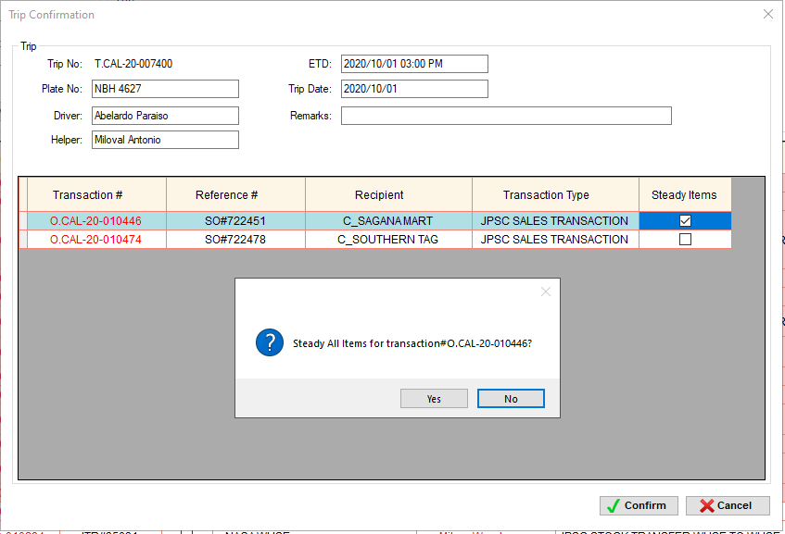

1. Click Yes to proceed. The transaction is highlighted in blue.

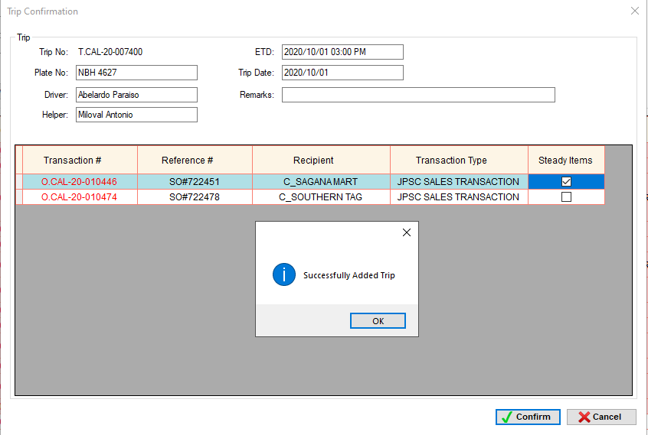

1. Click Confirm button

STEPS – it depends on the transaction types. See TRANSACTION TYPE AND STEPS TABLE

#### **JPSC – ALL TRANSACTIONS ARE STEADY ITEMS**

* It can be one or more than one order transaction, just set all transactions to steady items
* 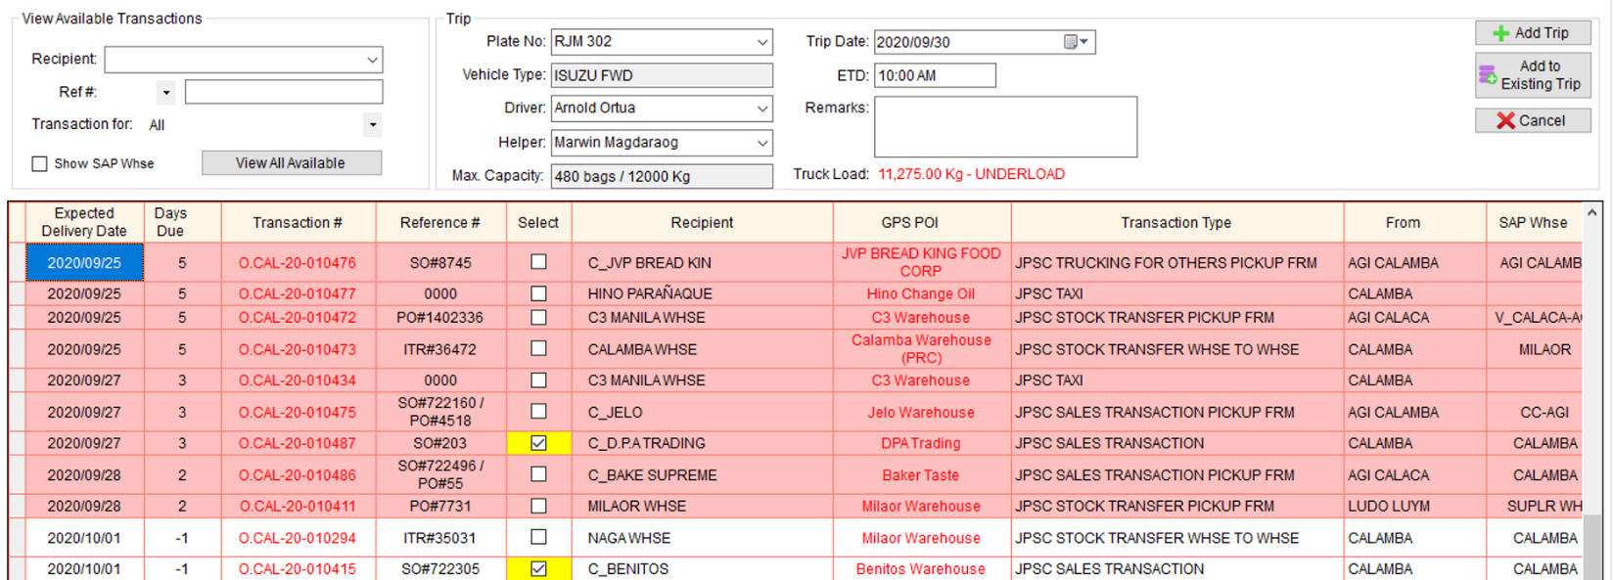Step 3 is skipped

1. Complete the following fields.

* Plate no.
* Trip Date
* ETD
* Driver
* Helper (Optional)
* Remarks (Optional)

1. Select order transaction(s)
2. 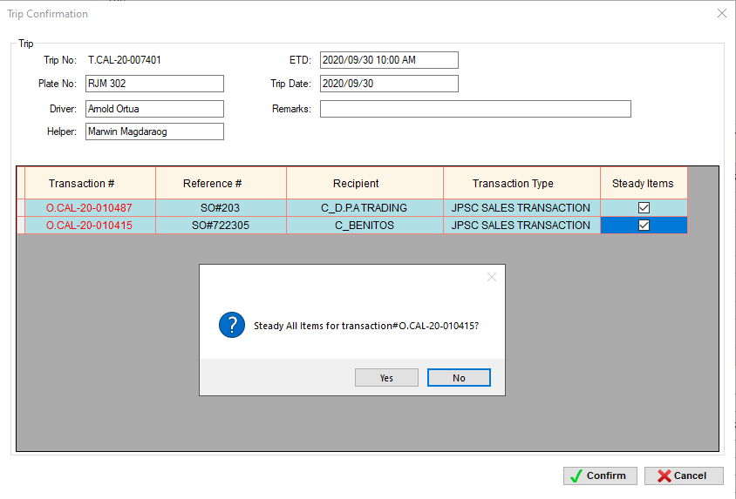Click Add Trip button
3. Trip Confirmation window will appear
4. Check the Steady Items column of the transactions.
5. There is a confirmation message box
6. Click Yes to proceed. The transactions are highlighted in blue.
7. 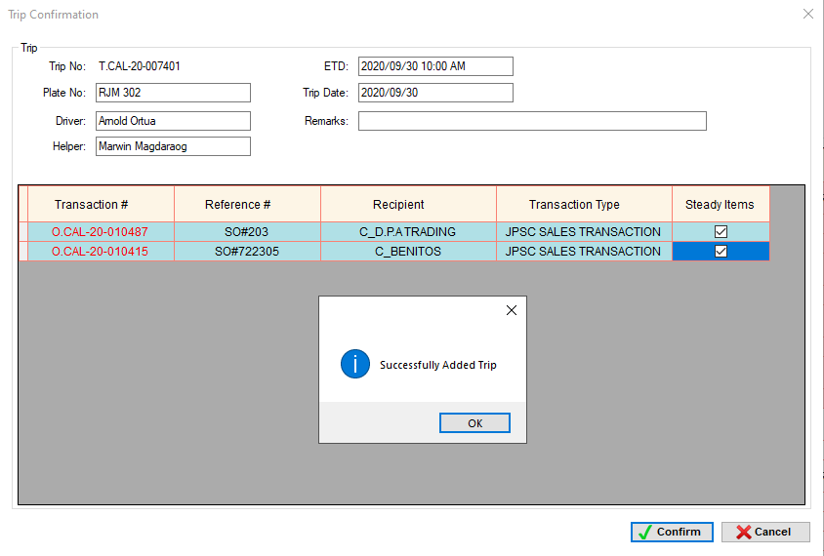Click Confirm button.

STEPS – it depends on the transaction types. See TRANSACTION TYPE AND STEPS TABLE



STEADY ALL ITEMS



#### **JPSC – SERVICE VEHICLE**

* 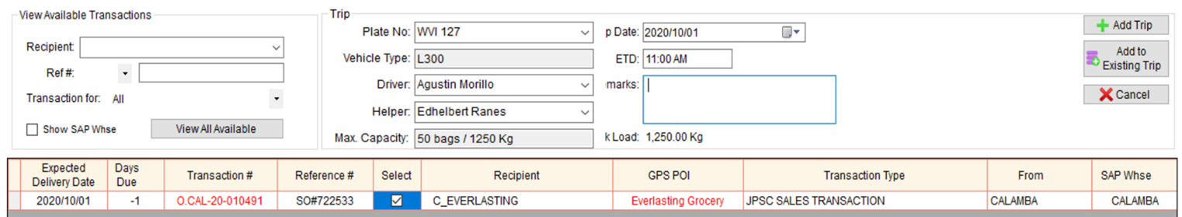No STEADY ITEMS option

1. Complete the following fields.

* Plate no.
* Trip Date
* ETD
* Driver
* Helper (Optional)
* Remarks (Optional)

1. Select order transaction(s)
2. 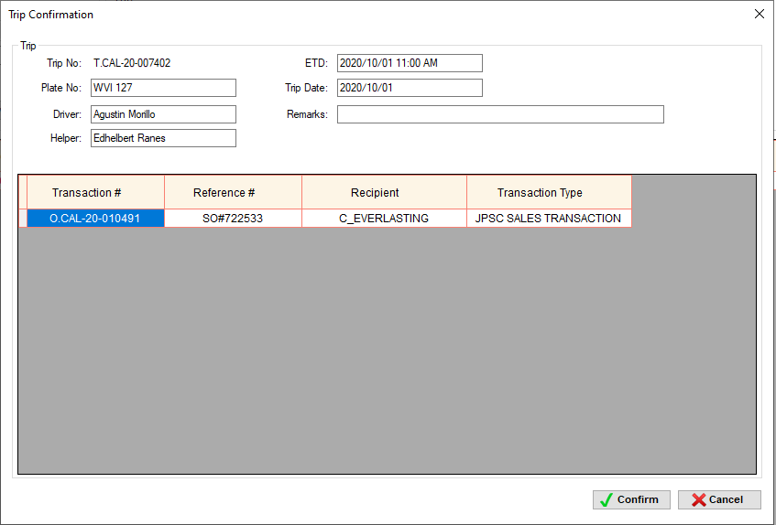Click Add Trip button
3. Trip Confirmation window will appear
4. Click Confirm button

STEPS – it depends on the transaction types. See TRANSACTION TYPE AND STEPS TABLE



#### **JPSC – WITH DELIVERY VIA SHIPPING LINES**

* It can be one or more than one order transaction.
* JPSC Truck will deliver the items in PIER only, and then, the shipping line will deliver the items either to warehouse or direct to customer. Usually the truck is from C3 warehouse or Calamba warehouse and the items are for Cebu, Davao, Bacolod, Tacloban, Ilo-Ilo warehouse and customers.

##### One transaction type only

* **CREATE ORDER** – same on how to create a JPSC STOCK TRANSFER PICKUP, but in terms of choosing GPS POI (for computing the distance and diesel of the truck), choose PIER.

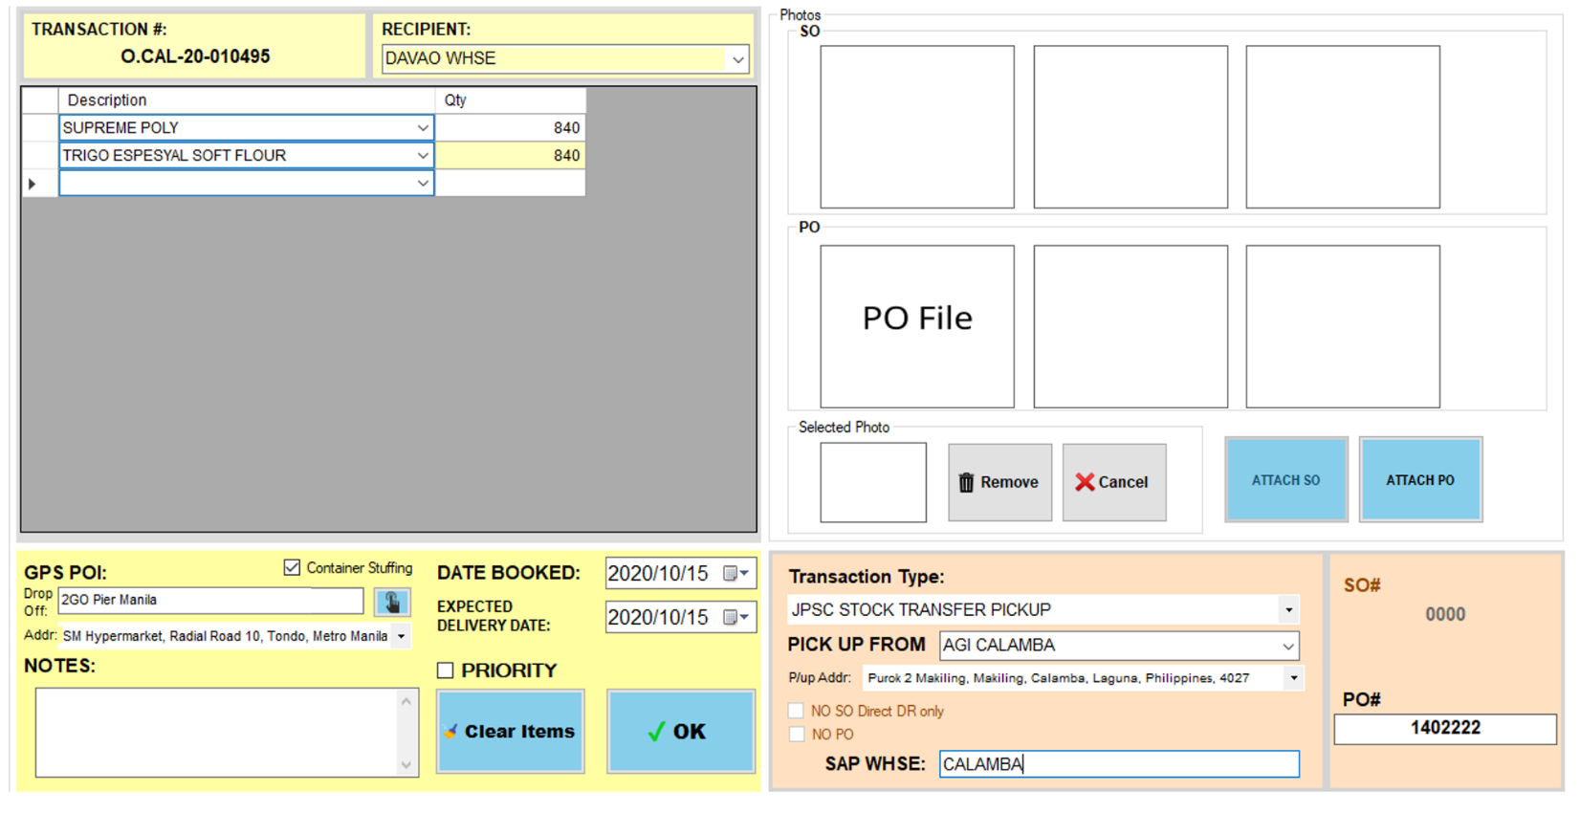

* 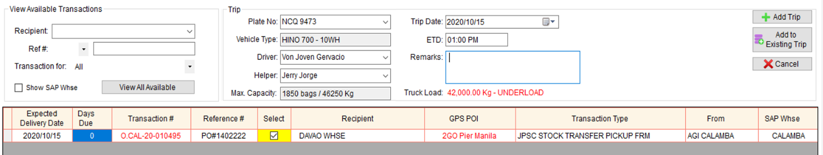**TRIP SCHEDULING** – same on how to schedule a JPSC – ONE DROP-OFF WITH PICK UP

STEPS



* **TAGGING** – the administrator or supervisor accounts will tag the trip as **W/ DELIVERY VIA SHIPPING LINES.** This includes adding of Bill of Lading Document details such as BL# and Date of stuffing.

1. Once Mam Flor send the BL Document and details via viber, we will search for the trip# based on the reference#.

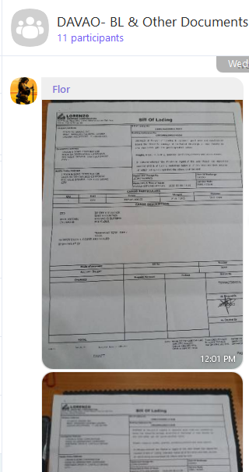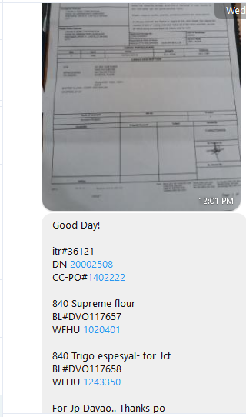

1. From this example, we can use DN#, ITR# or PO# as reference#.
2. In Trip Dispatch Summary, search Trip# based on DN#.

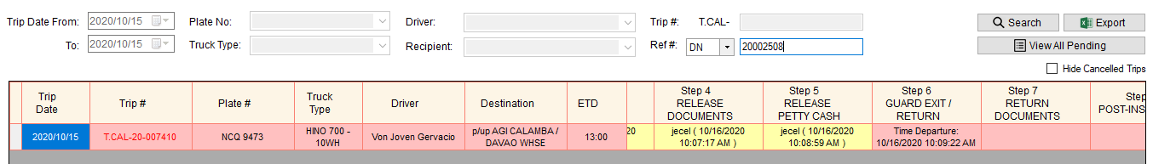

1. Right click the trip# and select **W/ Delivery via Shipping Lines**

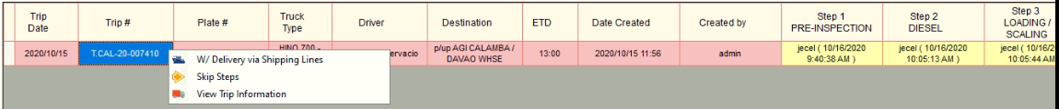

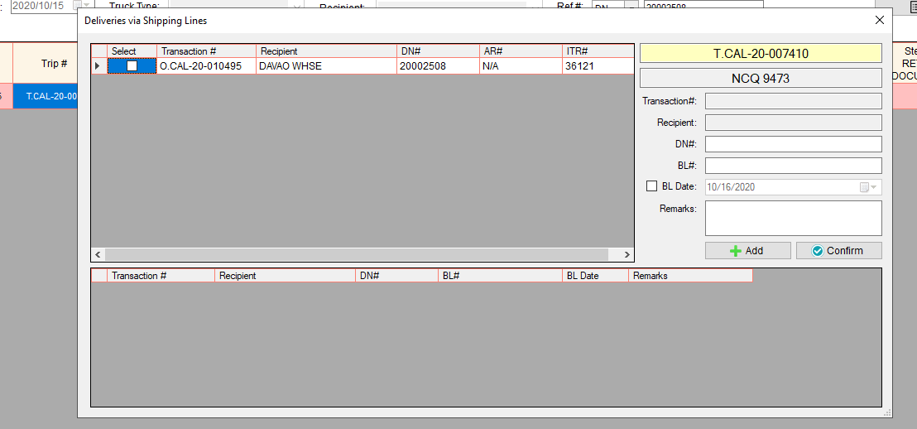

1. 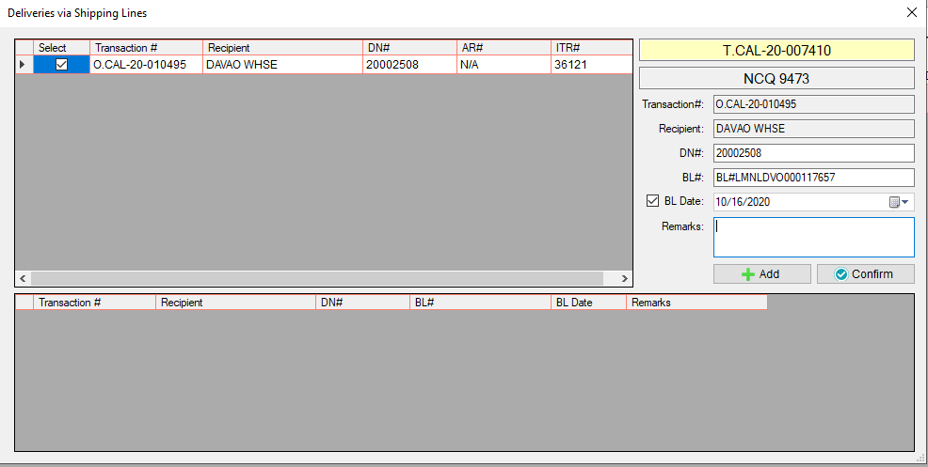Select Transaction# and input the BL# and its BL Date (Date of Stuffing).
2. 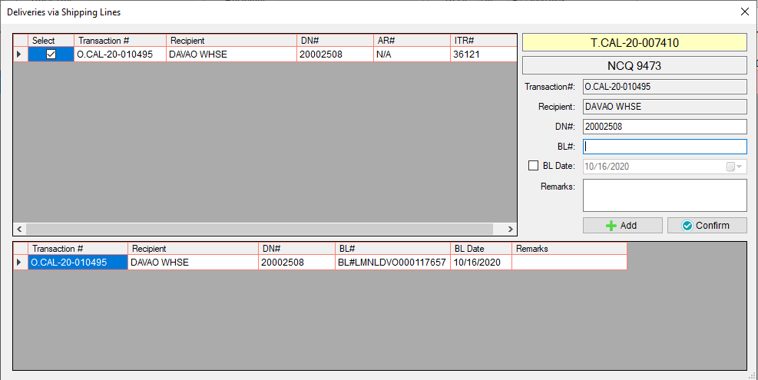Click Add button.
3. Since there are two Bill of Lading Document in one order transaction, select again the transaction and input the other BL# and its BL Date.

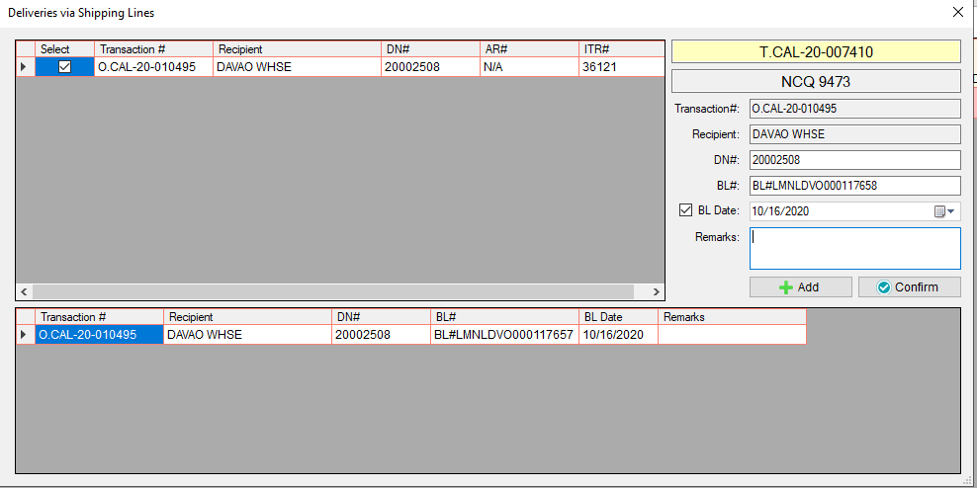

1. Click Add button

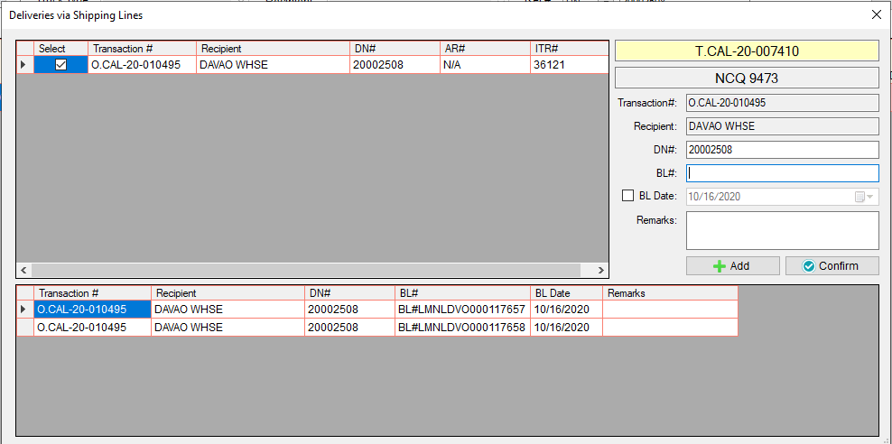

1. Click confirm button.

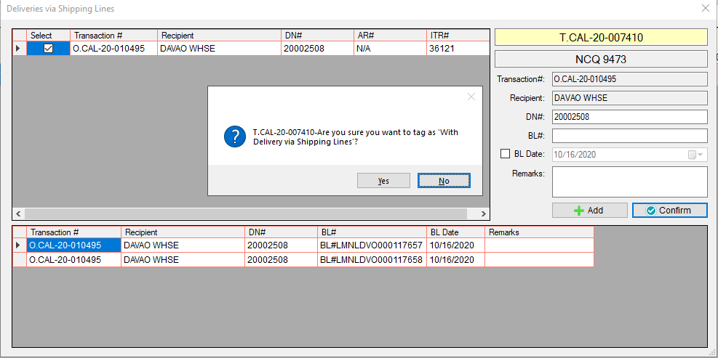

1. Click Yes button.

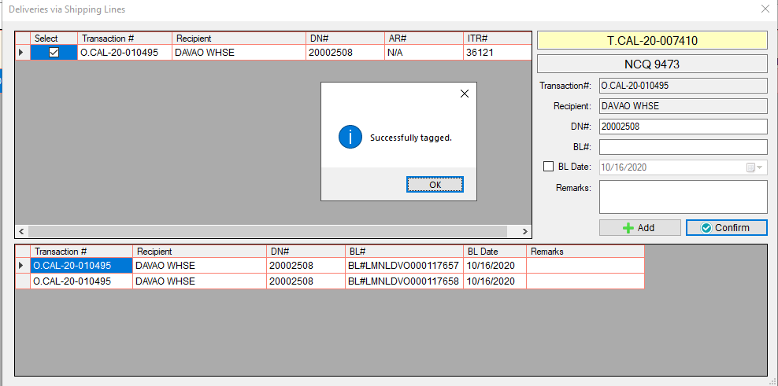

1. Click Ok button.

* In Trip Dispatch Summary, if the trip is tagged as **W/ Delivery via Shipping Lines,** an icon will appear beside the destination.



W/ Delivery via Shipping Lines

* To monitor if the items is already received by the recipient, go to **Trip via Shipping Lines (Pending)**

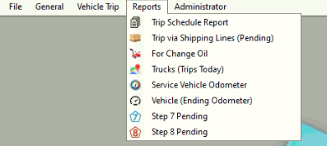

* 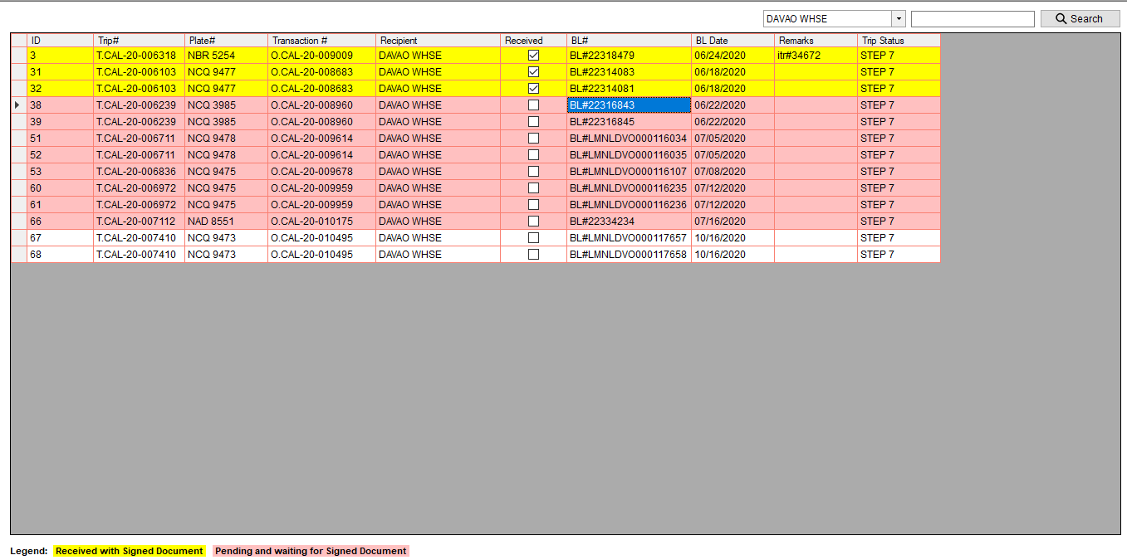This will show the list of all the BL numbers that are not yet received and all the bl numbers that are received but the step 7 is still open.
* Transactions that are highlighted in yellow – signed Document is already sent thru viber (indicates also that the items are received)
* Transactions that are highlighted in red – waiting for signed Document
* Transactions that are highlighted in white – added today

##### Multiple transaction type

* All orders will deliver via shipping lines – Two transaction type in one bill of lading document

(Ex. JPSC STOCK TRANSFER PICKUP and JPSC STOCK TRANSFER WHSE TO WHSE)

* **CREATE ORDER** – same on how to create a JPSC STOCK TRANSFER PICKUP, but in terms of choosing GPS POI (for computing the distance and diesel of the truck), choose PIER.

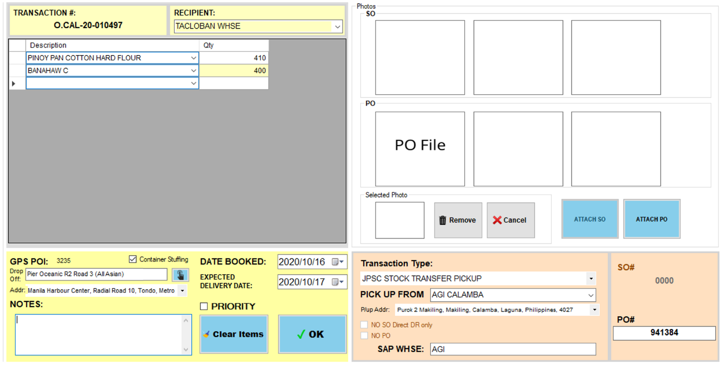

* **CREATE ORDER** – same on how to create a JPSC STOCK TRANSFER WHSE TO WHSE, but in terms of choosing GPS POI (for computing the distance and diesel of the truck), choose PIER.

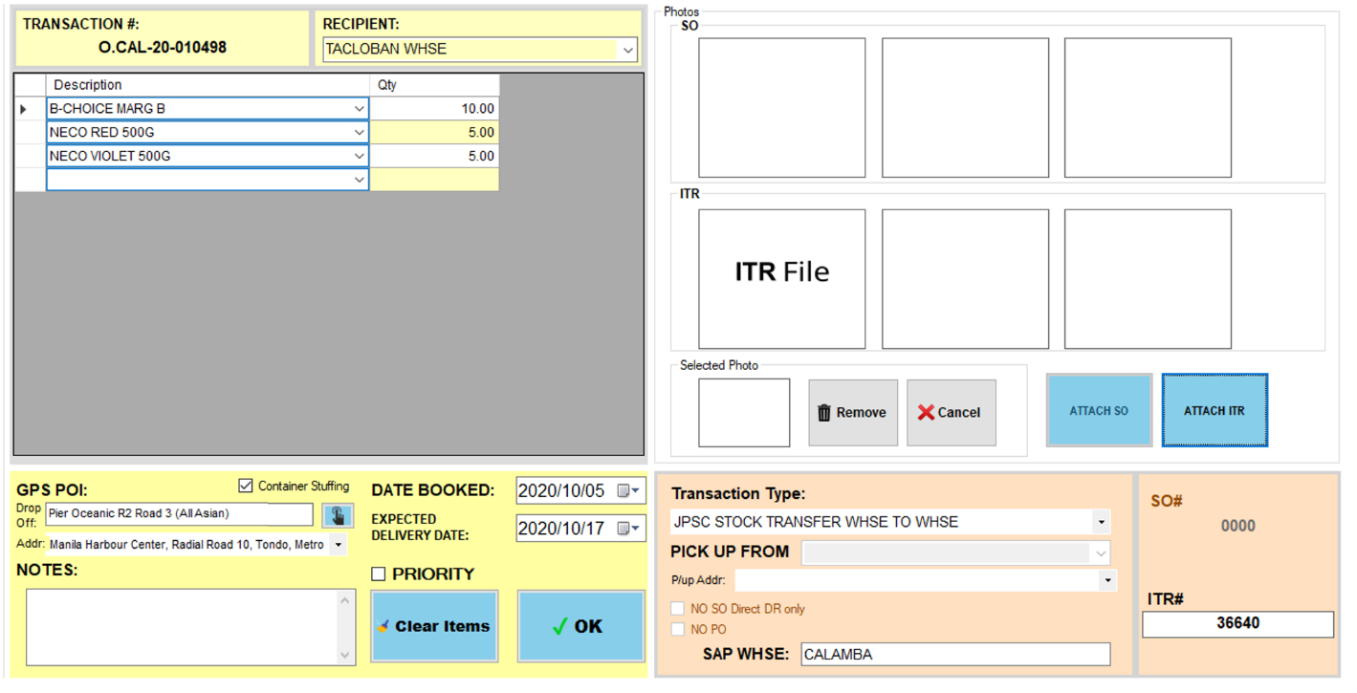

* 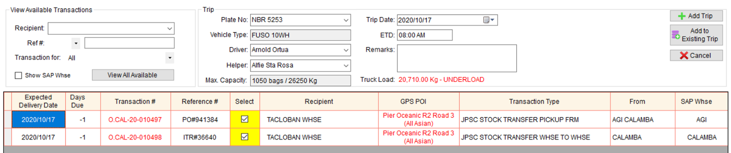**TRIP SCHEDULING** – same on how to schedule a JPSC – ONE DROP-OFF WITH PICK UP

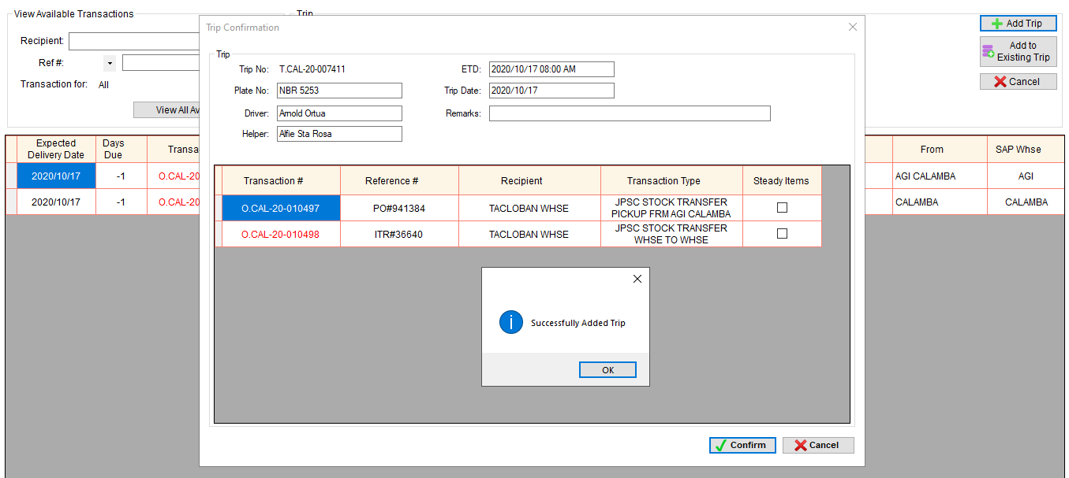

STEPS



* **TAGGING** – the administrator or supervisor accounts will tag the trip as **W/ DELIVERY VIA SHIPPING LINES.** This includes adding of Bill of Lading Document details such as BL# and Date of stuffing.

1. Once Mam Flor send the BL Document and details via viber, we will search for the trip# based on the reference#.

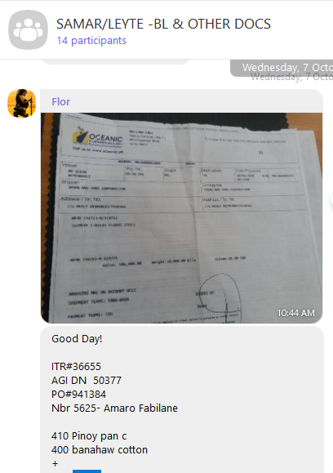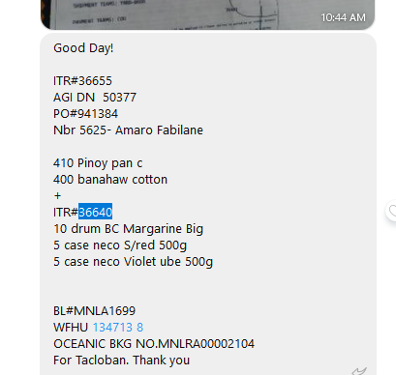

1. From this example, we can use DN#, ITR# or PO# as reference#.
2. 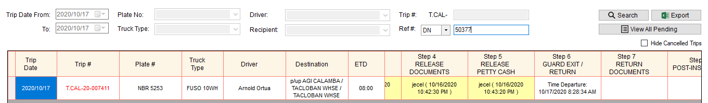In Trip Dispatch Summary, search Trip# based on DN#.
3. Right click the trip# and select **W/ Delivery via Shipping Lines**

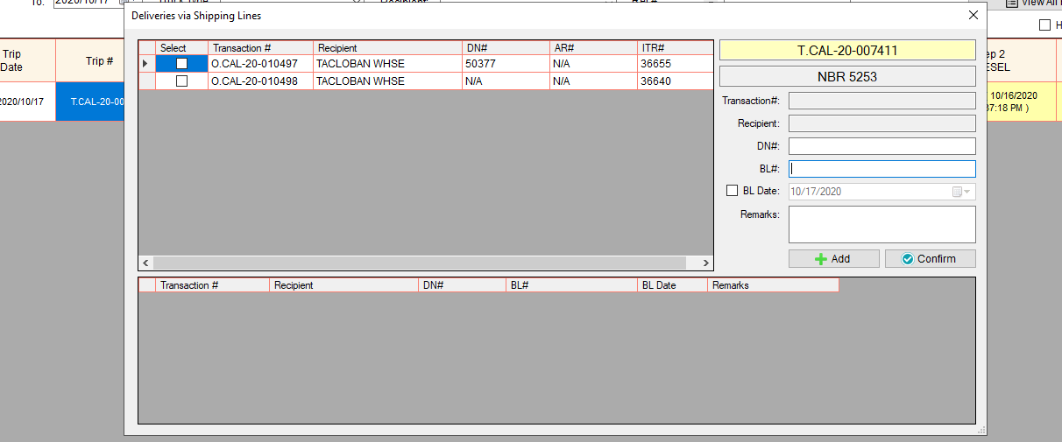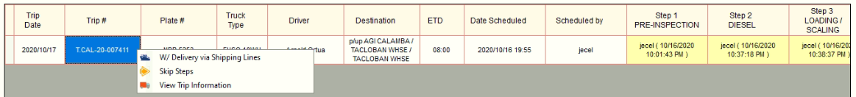

1. 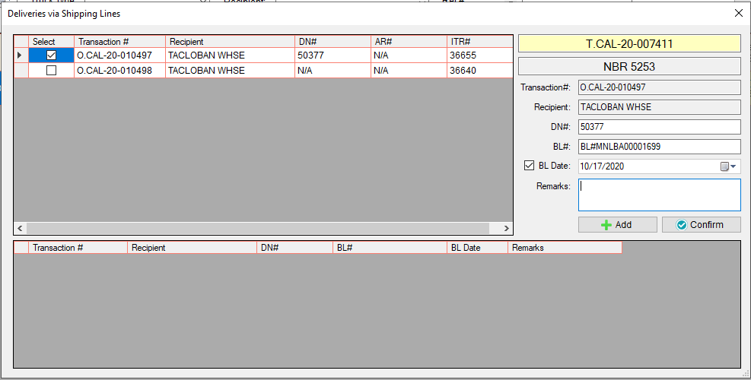Select Transaction# and input the BL# and its BL Date (Date of Stuffing).
2. Click Add button.
3. 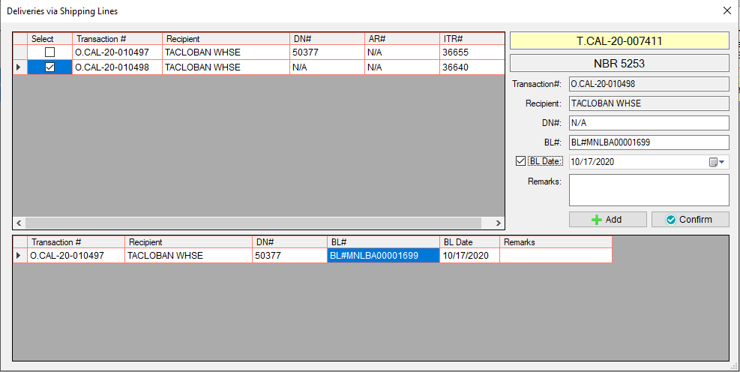Since there are one Bill of Lading Document in two order transactions, select the other transaction and input again the BL# and its BL Date.
4. Click Add button

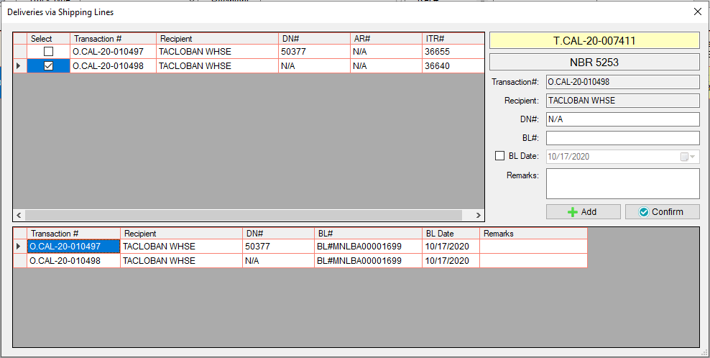

1. 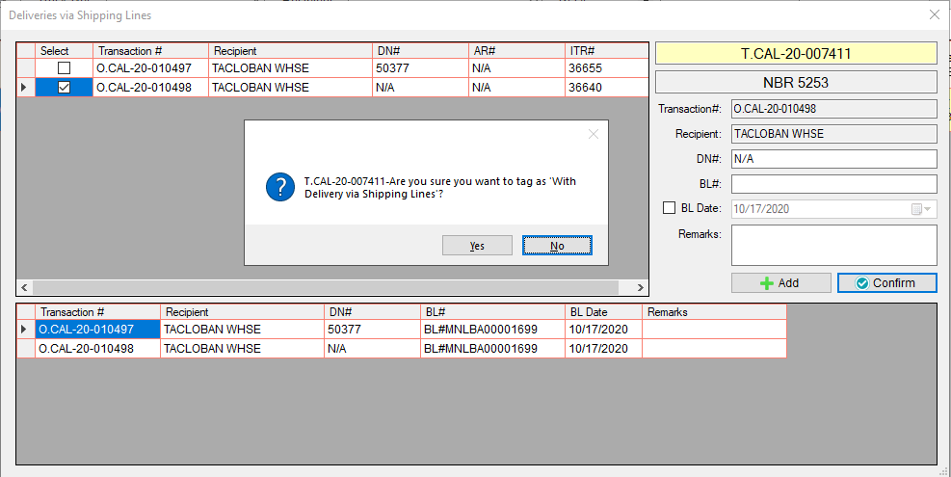Click confirm button.
2. Click Yes button.

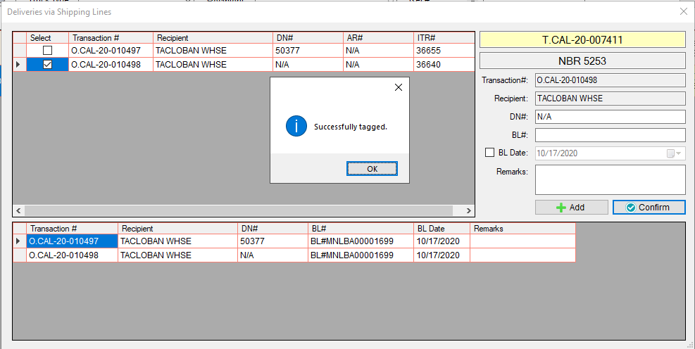

1. Click Ok button.

* In Trip Dispatch Summary, if the trip is tagged as **W/ Delivery via Shipping Lines,** an icon will appear beside the destination.



W/ Delivery via Shipping Lines

* To monitor if the items is already received by the recipient, go to **Trip via Shipping Lines (Pending)**



* This will show the list of all the BL numbers that are not yet received and all the bl numbers that are received but the step 7 is still open.
* Transactions that are highlighted in yellow – signed Document is already sent thru viber (indicates also that the items are received)
* Transactions that are highlighted in red – waiting for signed Document
* Transactions that are highlighted in white – added today
* All orders will deliver via shipping lines – Two transaction type with one bill of lading document each

(Ex. JPSC STOCK TRANSFER PICKUP and JPSC SALES TRANSACTION PICKUP)

* **CREATE ORDER** – same on how to create a JPSC STOCK TRANSFER PICKUP, but in terms of choosing GPS POI (for computing the distance and diesel of the truck), choose PIER.

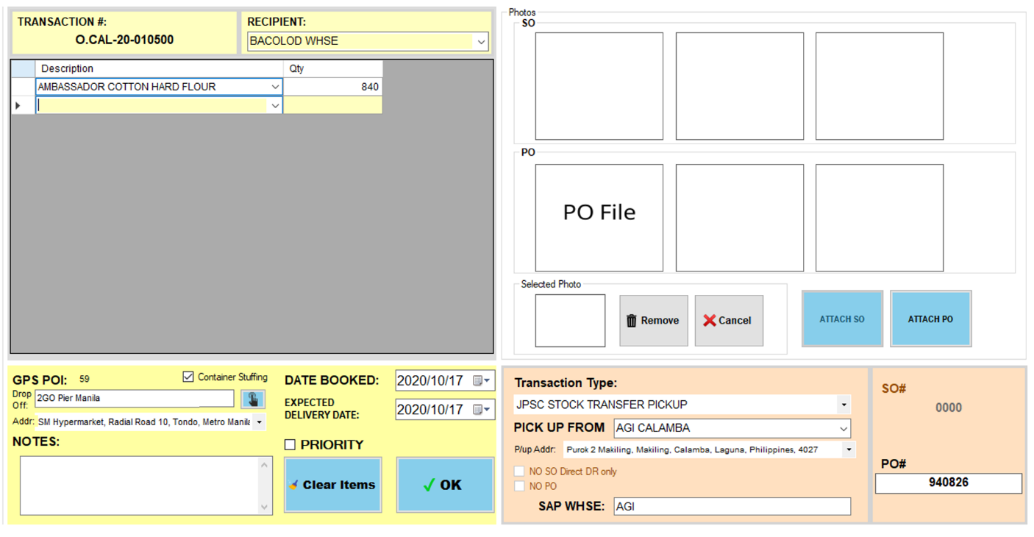

* **CREATE ORDER** – same on how to create a JPSC SALES TRANSACTION PICKUP, but in terms of choosing GPS POI (for computing the distance and diesel of the truck), choose PIER.

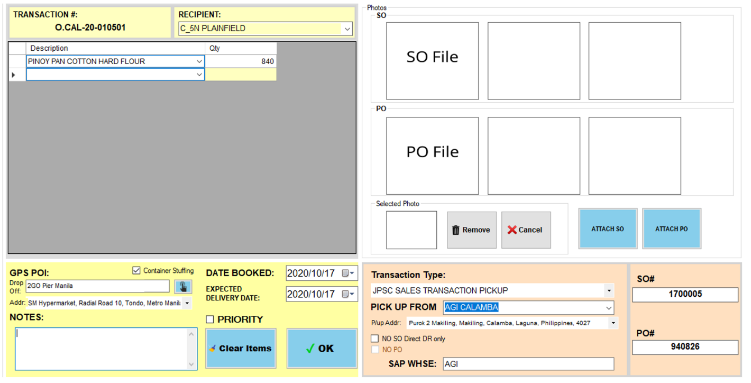

* 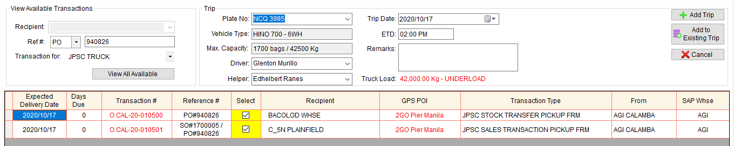**TRIP SCHEDULING** – same on how to schedule a JPSC – ONE DROP-OFF WITH PICK UP

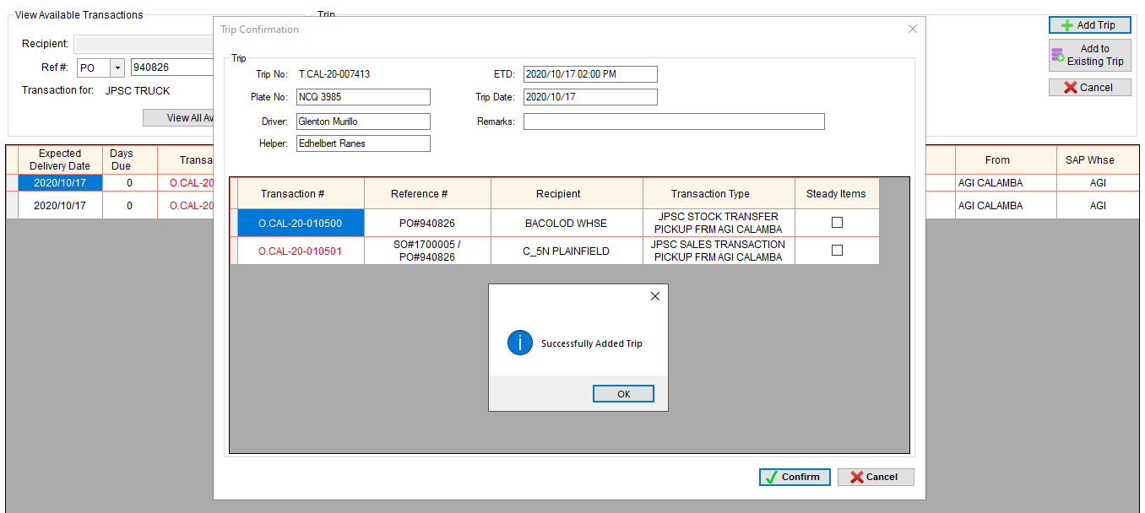

STEPS



* **TAGGING** – the administrator or supervisor accounts will tag the trip as **W/ DELIVERY VIA SHIPPING LINES.** This includes adding of Bill of Lading Document details such as BL# and Date of stuffing.

1. Once Mam Flor send the BL Document and details via viber, we will search for the trip# based on the reference#.

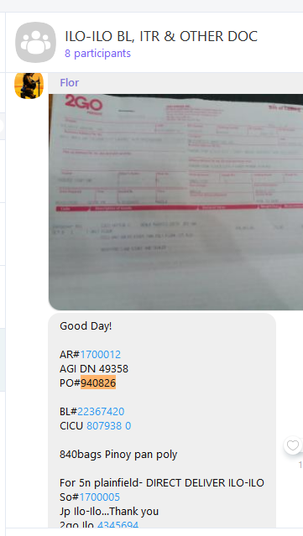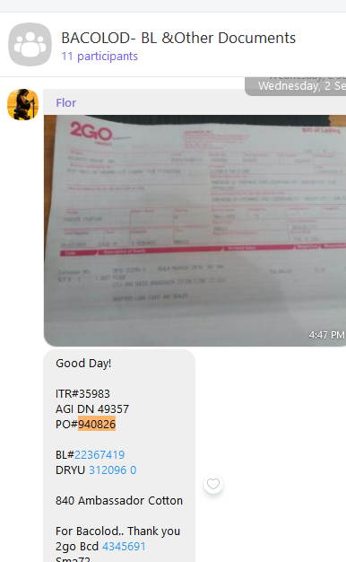

1. From this example, we can use DN#, ITR# or PO# as reference#.
2. 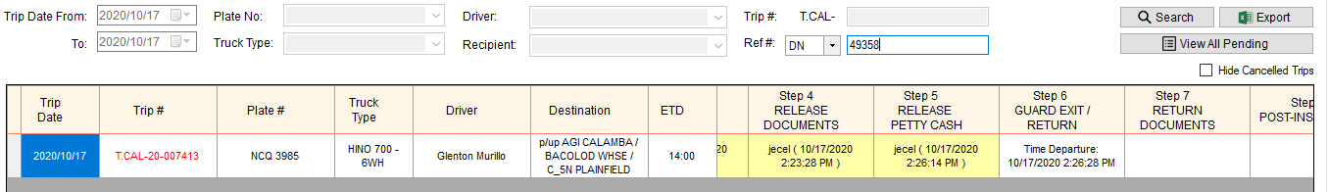In Trip Dispatch Summary, search Trip# based on DN#.
3. Right click the trip# and select **W/ Delivery via Shipping Lines**

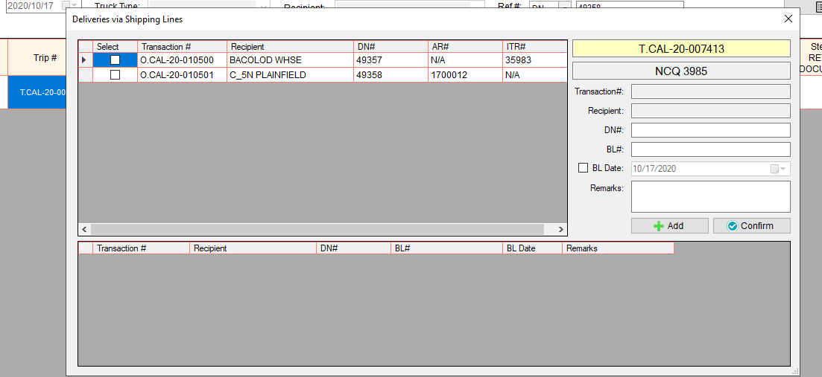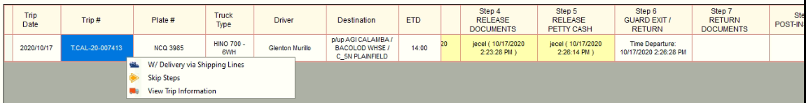

1. Select Transaction# and input the BL# and its BL Date (Date of Stuffing).

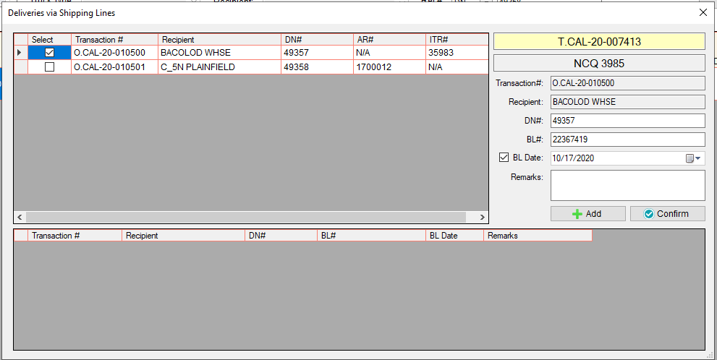

1. 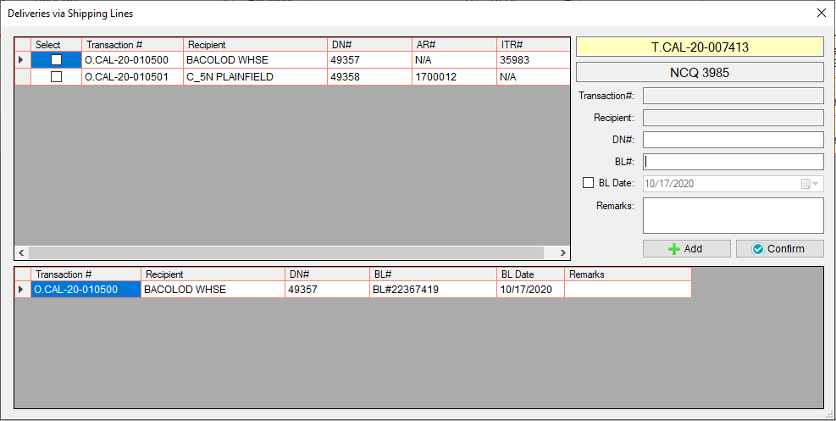Click Add button.
2. Select the other transaction and input the BL# and its BL Date.

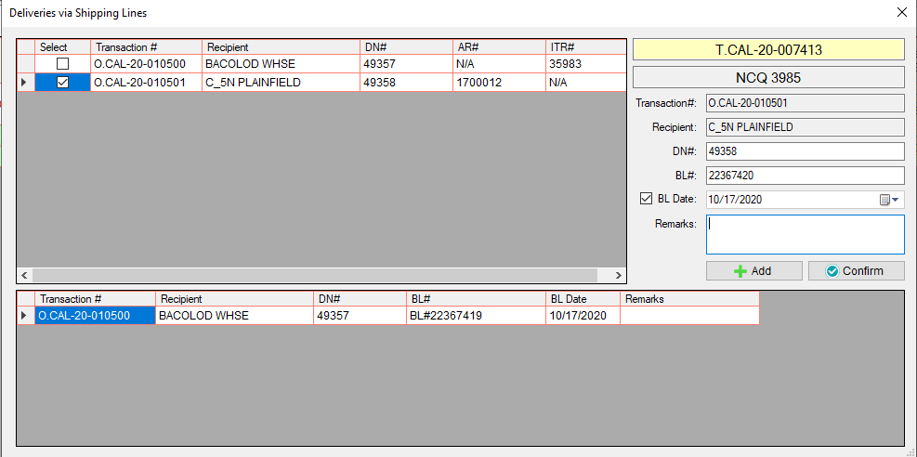

1. Click Add button

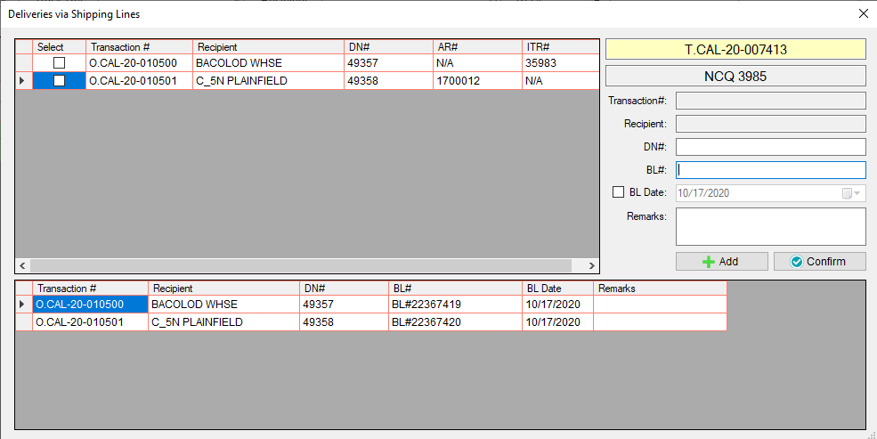

1. 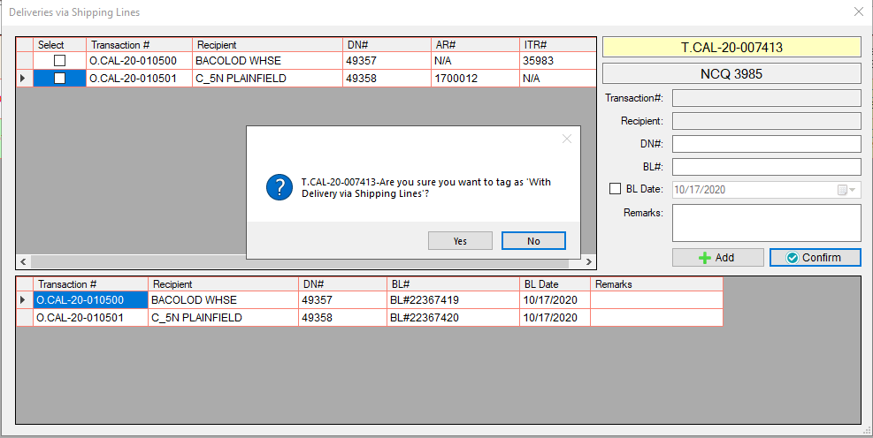Click confirm button.
2. Click Yes button.

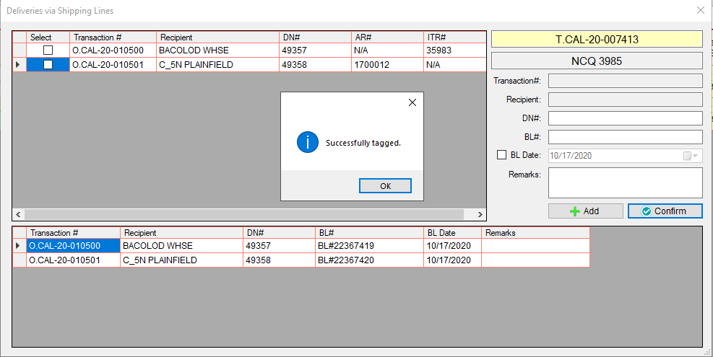

1. Click Ok button.

* In Trip Dispatch Summary, if the trip is tagged as **W/ Delivery via Shipping Lines,** an icon will appear beside the destination.



W/ Delivery via Shipping Lines

* To monitor if the items is already received by the recipient, go to **Trip via Shipping Lines (Pending)**



* This will show the list of all the BL numbers that are not yet received and all the bl numbers that are received but the step 7 is still open.
* Transactions that are highlighted in yellow – signed Document is already sent thru viber (indicates also that the items are received)
* Transactions that are highlighted in red – waiting for signed Document
* Transactions that are highlighted in white – added today
* Some orders will deliver via shipping lines and some are not.

(Ex. JPSC STOCK TRANSFER PICKUP and JPSC STOCK TRANSFER WHSE TO WHSE)

* **CREATE ORDER** – same on how to create a JPSC STOCK TRANSFER PICKUP, but in terms of choosing GPS POI (for computing the distance and diesel of the truck), choose PIER.

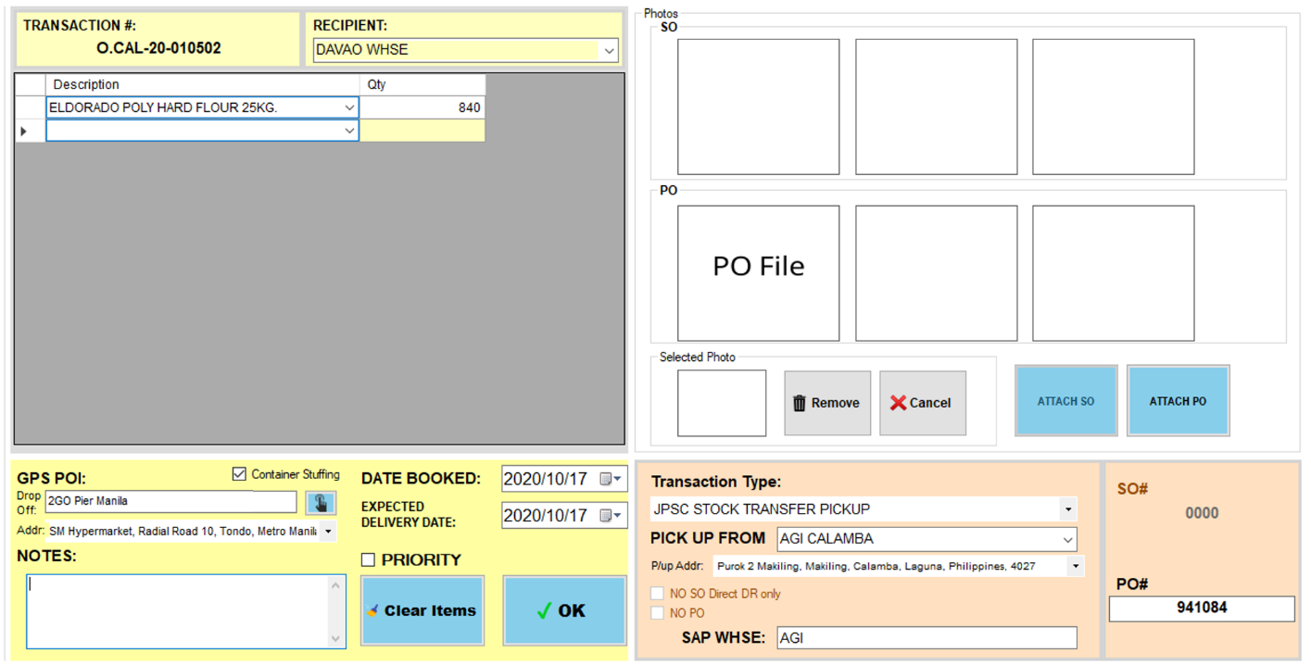

* **CREATE ORDER** – same on how to create a JPSC STOCK TRANSFER PICKUP, but the items are only for C3 warehouse, so choose c3 warehouse poi and not PIER.

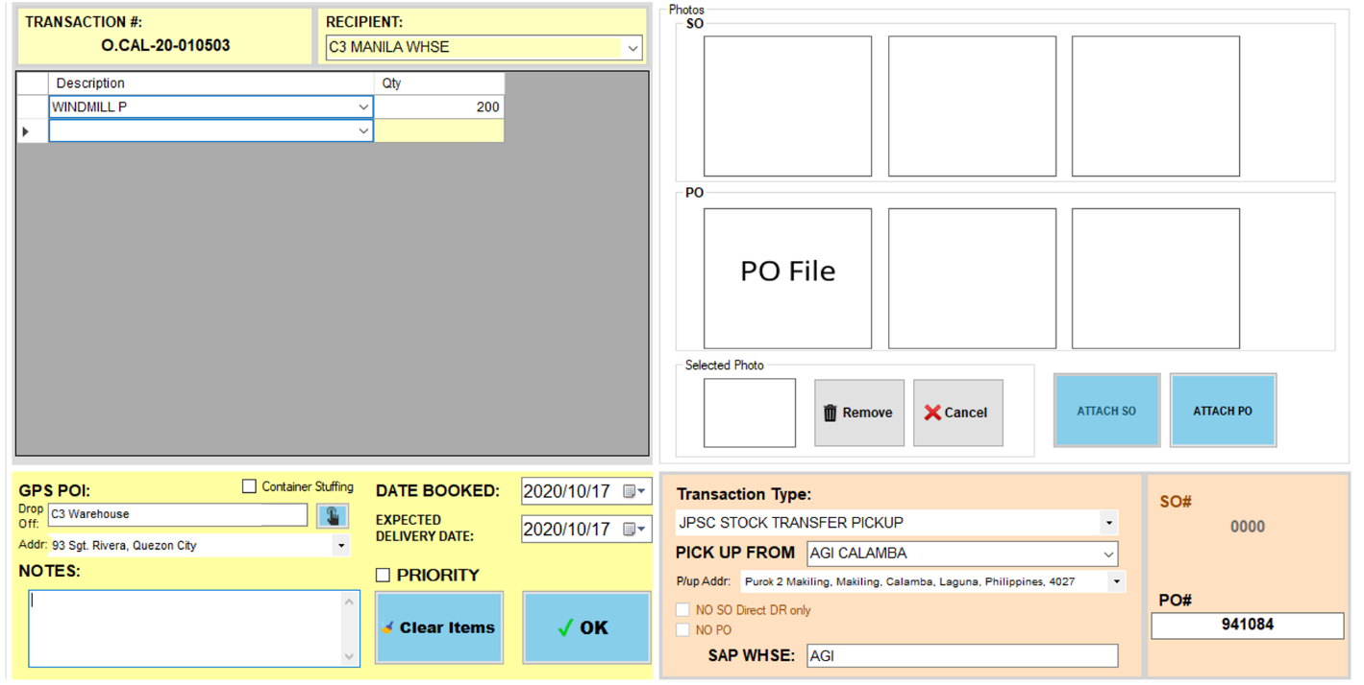

* 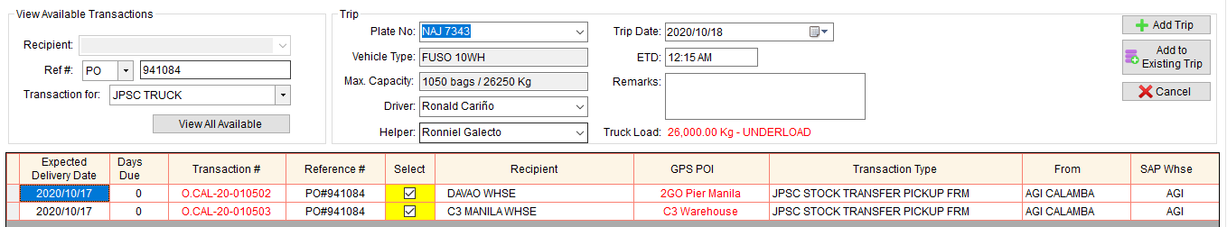**TRIP SCHEDULING** – same on how to schedule a JPSC – MULTIPLE DROP-OFF WITH PICK UP

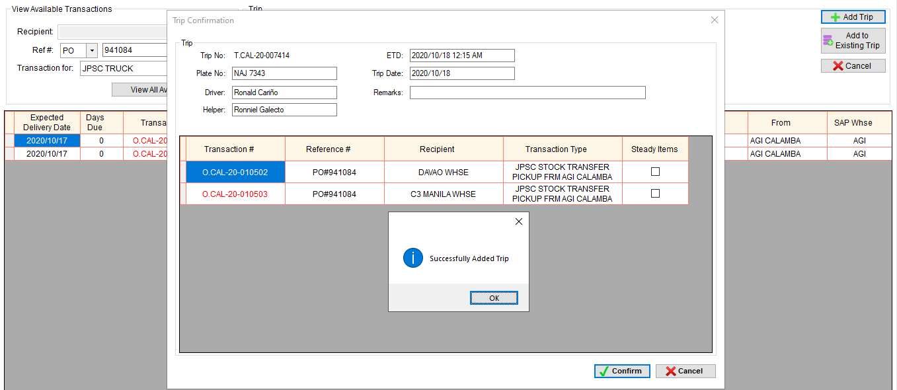

STEPS



* **TAGGING** – the administrator or supervisor accounts will tag the trip as **W/ DELIVERY VIA SHIPPING LINES.** This includes adding of Bill of Lading Document details such as BL# and Date of stuffing.

1. Once Mam Flor send the BL Document and details via viber, we will search for the trip# based on the reference#.

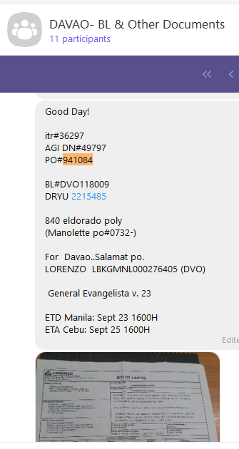

1. From this example, we can use DN#, ITR# or PO# as reference#.
2. 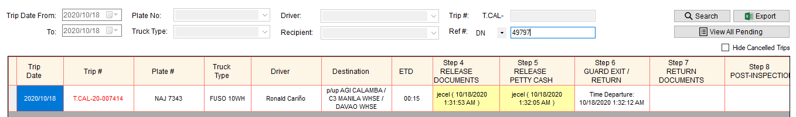In Trip Dispatch Summary, search Trip# based on DN#.
3. Right click the trip# and select **W/ Delivery via Shipping Lines.**

All the transactions that are set for container stuffing will show.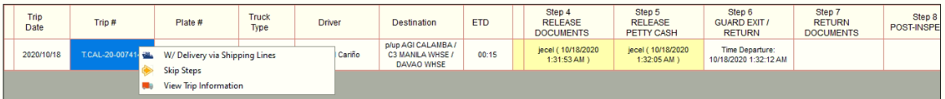 (shows Davao Whse only because C3 Manila Whse is not set for container stuffing)

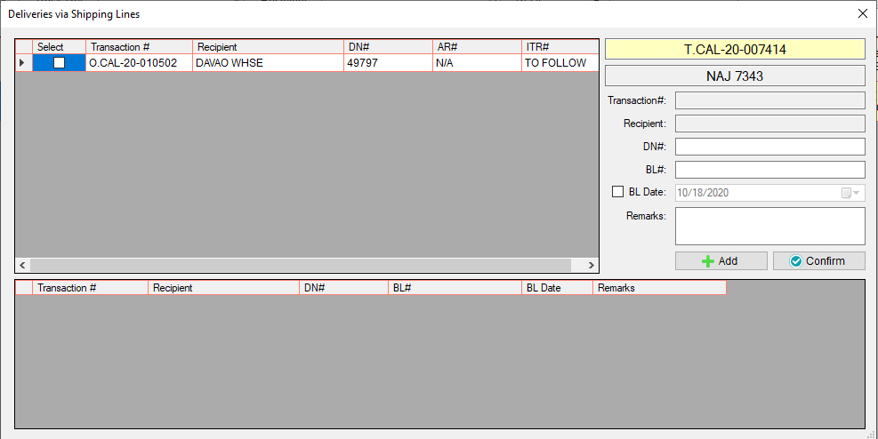

1. 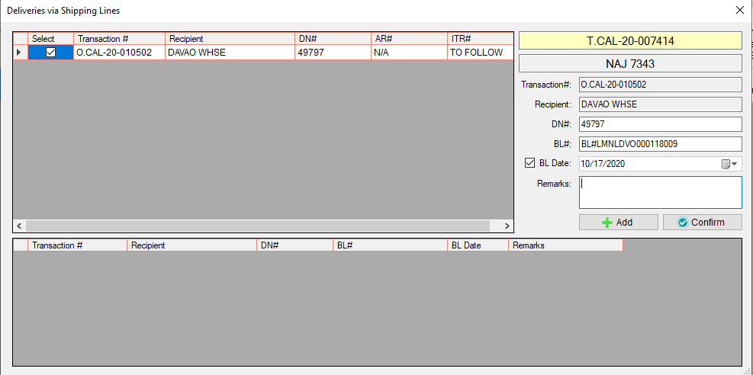Select Transaction# and input the BL# and its BL Date (Date of Stuffing).
2. 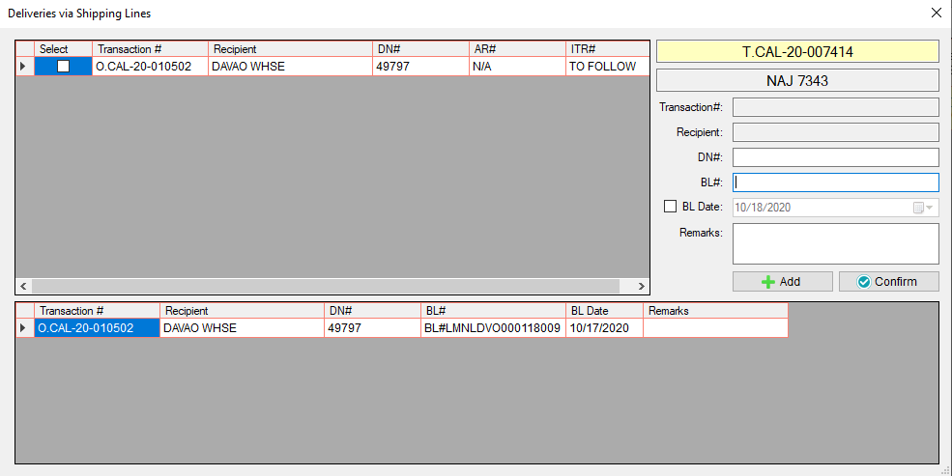Click Add button.
3. 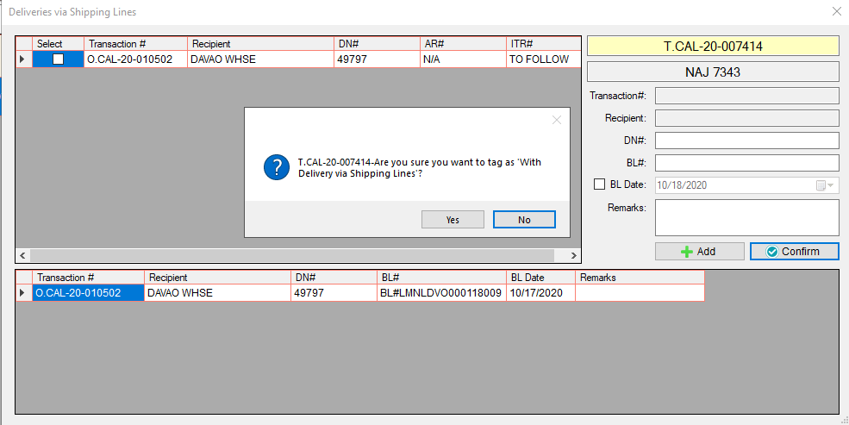Click confirm button.
4. Click Yes button.

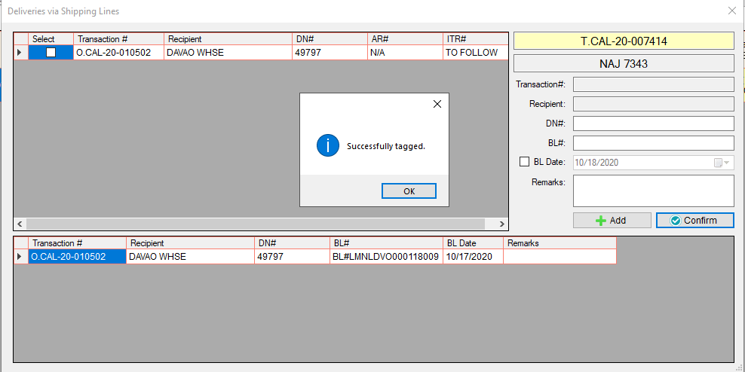

1. Click Ok button.

* In Trip Dispatch Summary, if the trip is tagged as **W/ Delivery via Shipping Lines,** an icon will appear beside the destination.



W/ Delivery via Shipping Lines

* To monitor if the items is already received by the recipient, go to **Trip via Shipping Lines (Pending)**



* This will show the list of all the BL numbers that are not yet received and all the bl numbers that are received but the step 7 is still open.

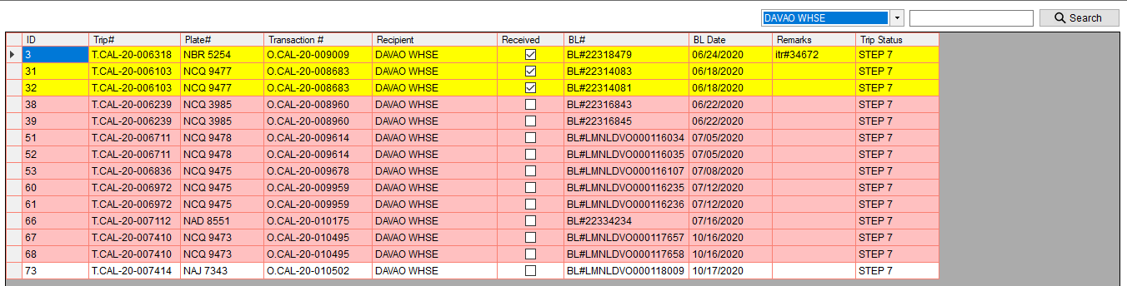

* Transactions that are highlighted in yellow – signed Document is already sent thru viber (indicates also that the items are received)
* Transactions that are highlighted in red – waiting for signed Document
* Transactions that are highlighted in white – added today

#### **CUSTOMER – PICK UP ITEMS AT WAREHOUSE**

* 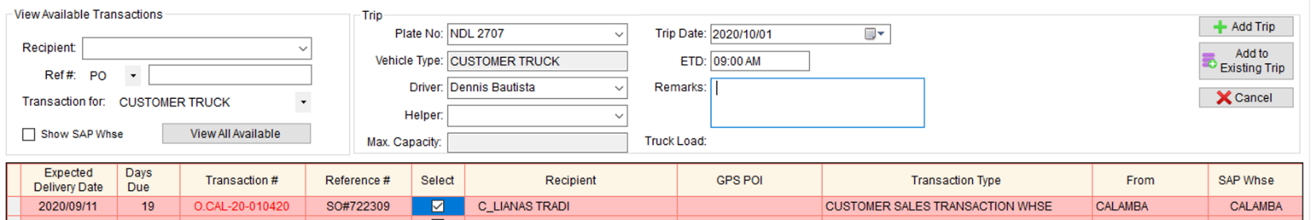No STEADY ITEMS option

1. Complete the following fields.

* Plate no.
* Trip Date
* ETD
* Driver
* Helper (Optional)
* Remarks (Optional)

1. Select order transaction(s)
2. 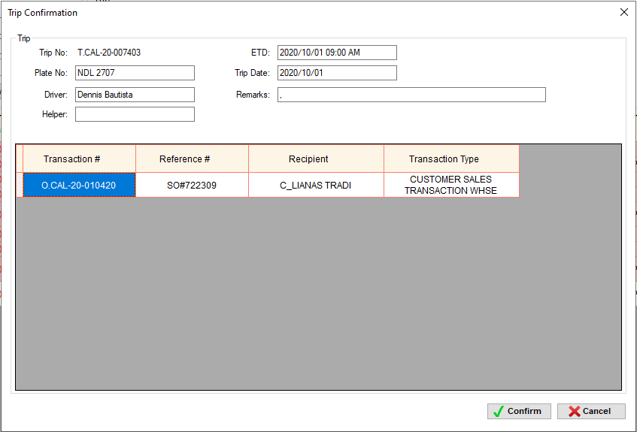Click Add Trip button
3. Trip Confirmation window will appear
4. Click Confirm button

STEPS



#### **CUSTOMER – PICK UP ITEMS AT SUPPLIER WAREHOUSE**

* 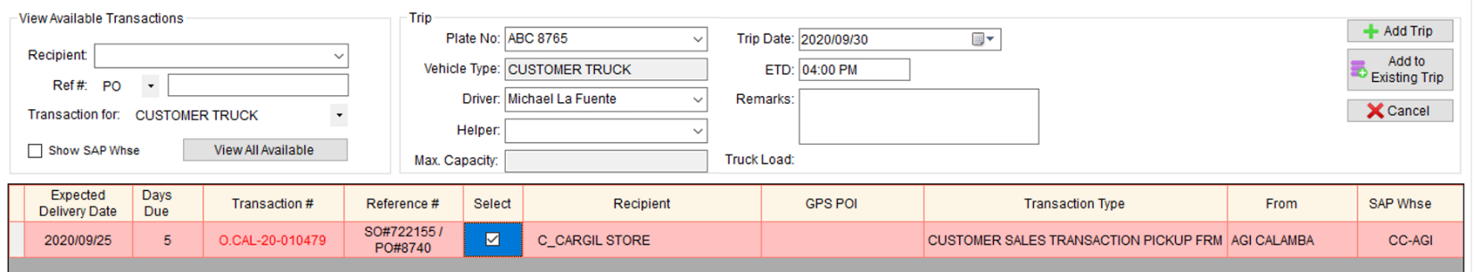No STEADY ITEMS option

1. Complete the following fields.

* Plate no.
* Trip Date
* ETD
* Driver
* Helper (Optional)
* Remarks (Optional)

1. Select order transaction(s)
2. Click Add Trip button
3. 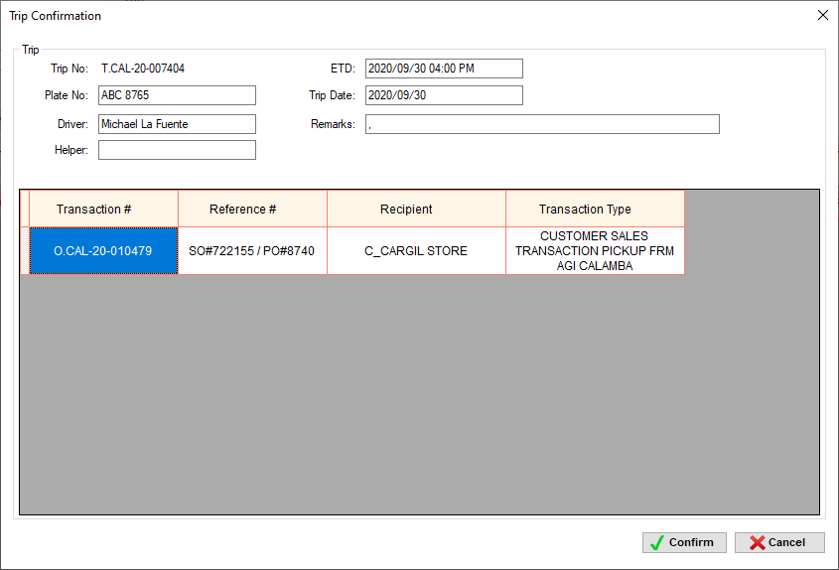Trip Confirmation window will appear
4. Click Confirm button

STEPS

#### **PPDE**

* 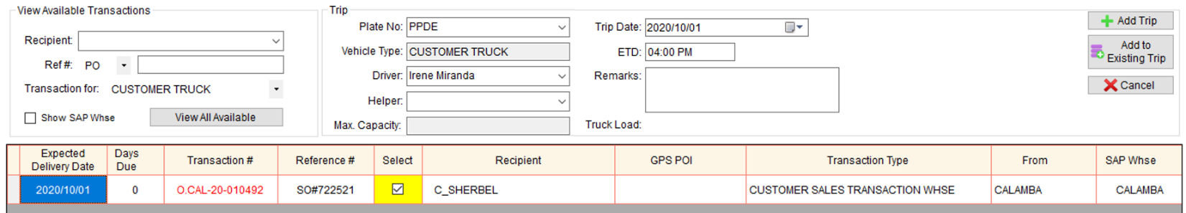No STEADY ITEMS option

1. Complete the following fields.

* Plate no. - PPDE
* Trip Date
* ETD
* Driver – SALES AGENT
* Helper (Optional)
* Remarks (Optional)

1. Select order transaction(s)
2. 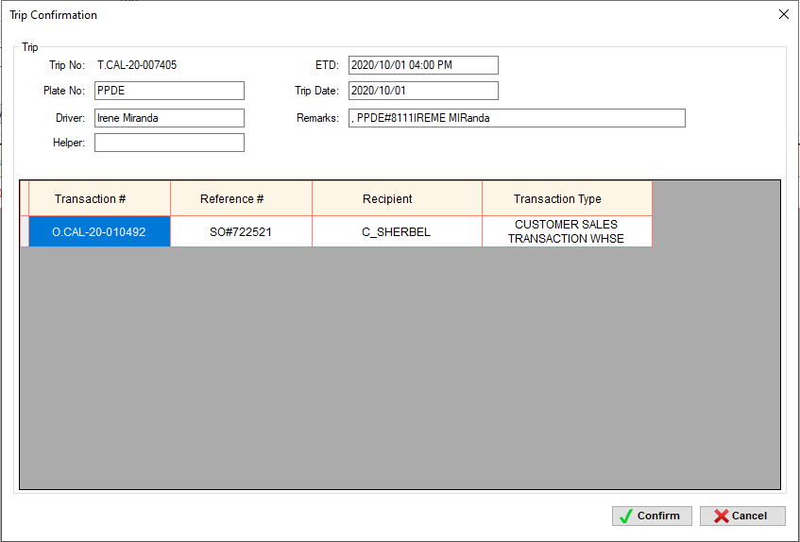Click Add Trip button
3. Trip Confirmation window will appear
4. Click Confirm button

STEPS

#### **EMPLOYEE**

* No STEADY ITEMS option
* 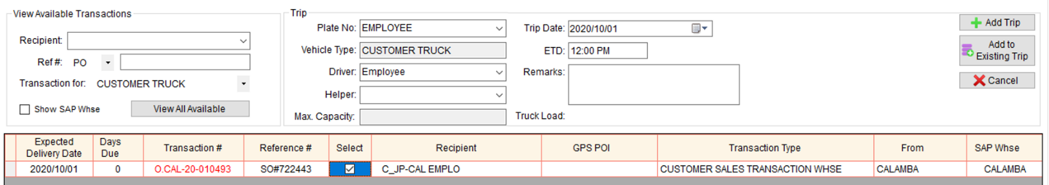Charge to Employee

1. Complete the following fields.

* Plate no. - EMPLOYEE
* Trip Date
* ETD
* Driver – EMPLOYEE
* Helper (Optional)
* Remarks (Optional)

1. Select order transaction(s)
2. 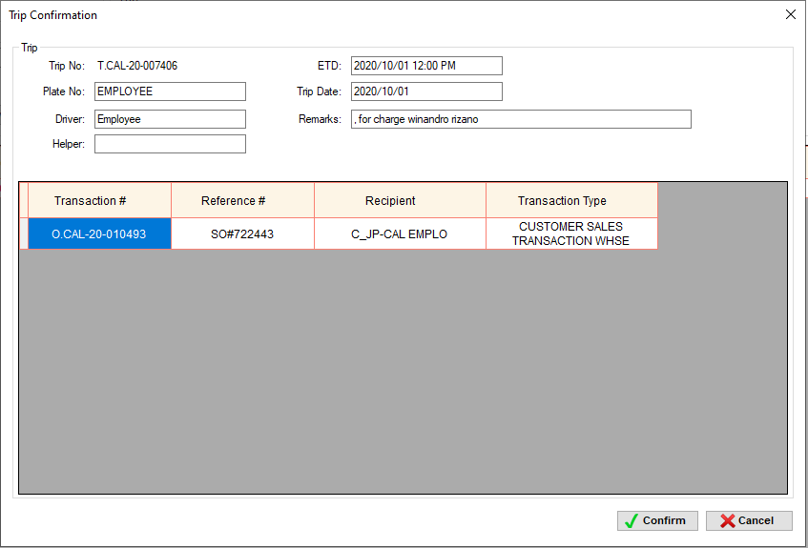Click Add Trip button
3. Trip Confirmation window will appear
4. Click Confirm button

STEPS

#### **TRUCKING TRUCK – PICKUP ITEMS AT WAREHOUSE**

* 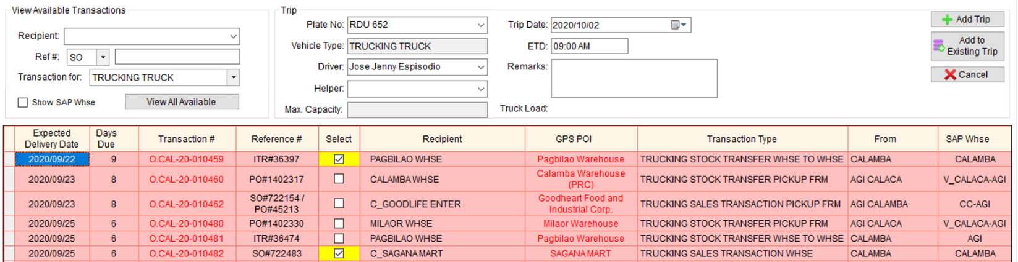No STEADY ITEMS option

1. Complete the following fields.

* Plate no.
* Trip Date
* ETD
* 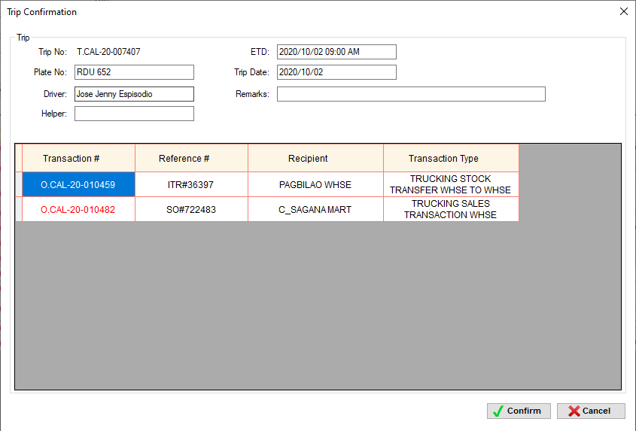Driver
* Helper (Optional)
* Remarks (Optional)

1. Select order transaction(s)
2. Click Add Trip button
3. Trip Confirmation window will appear
4. Click Confirm button

****STEPS – it depends on the transaction types. See TRANSACTION TYPE AND STEPS TABLE



#### **TRUCKING TRUCK – PICKUP ITEMS AT SUPPLIER WAREHOUSE**

* 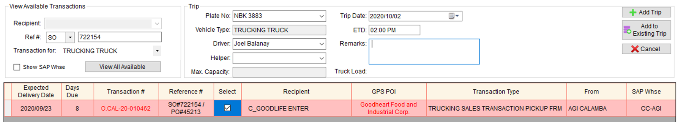No STEADY ITEMS option

1. Complete the following fields.

* Plate no.
* Trip Date
* ETD
* Driver
* Helper (Optional)
* Remarks (Optional)

1. 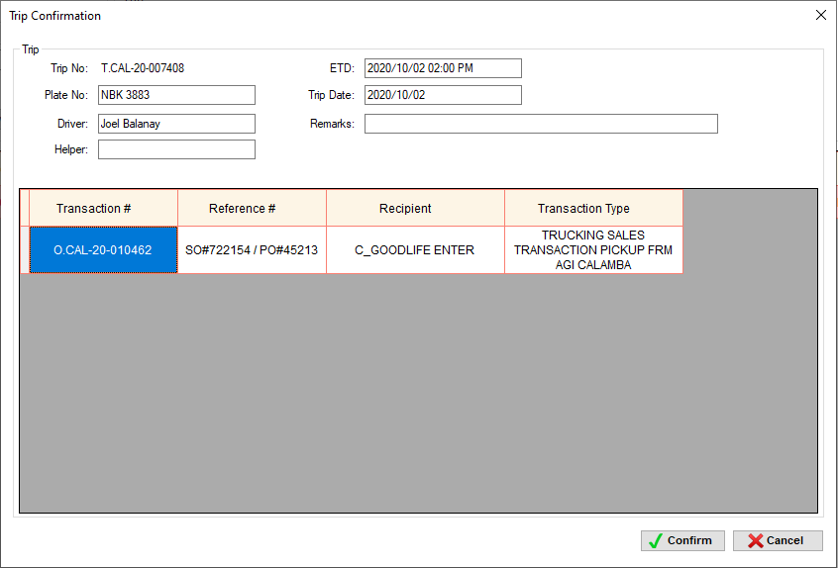Select order transaction(s)
2. Click Add Trip button
3. Trip Confirmation window will appear
4. Click Confirm button

STEPS – it depends on the transaction types. See TRANSACTION TYPE AND STEPS TABLE

### **Add to Existing Trip**

* Add another transaction to an existing tripif:

#### **VEHICLE IS STILL IN WAREHOUSE**

* Kung hindi pa naka departure ang truck sa fleet
* Panibagong Reference# sa SAP (SO#, PO#, ITR#)
* Example#1: May scheduled trip na yung truck, then since kasya pa and along the way din yung isang customer, pinasabay na rin sa truck, and dahil ibang Reference# ito, need ito i-create order at i-add sa existing trip ng truck.
* Example#2: May scheduled trip na yung truck, nagpahabol pa ng order pero same recipient ibang SO#, and dahil ibang SO# ito, need ito i-create order at i-add sa existing trip ng truck

How to add another transaction to an existing trip

1. Get the trip# where you want to add another transaction



1. 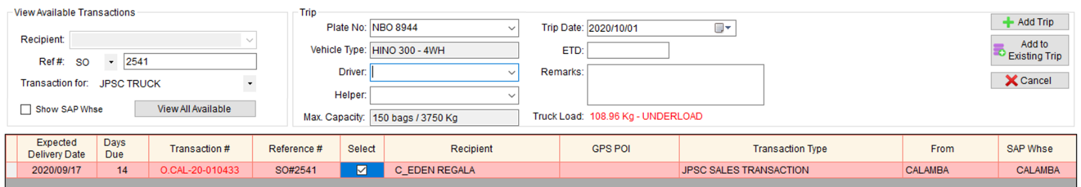In Trip Scheduling module, type the plate# and select the transaction(s). Then, click Add to Existing Trip button.
2. 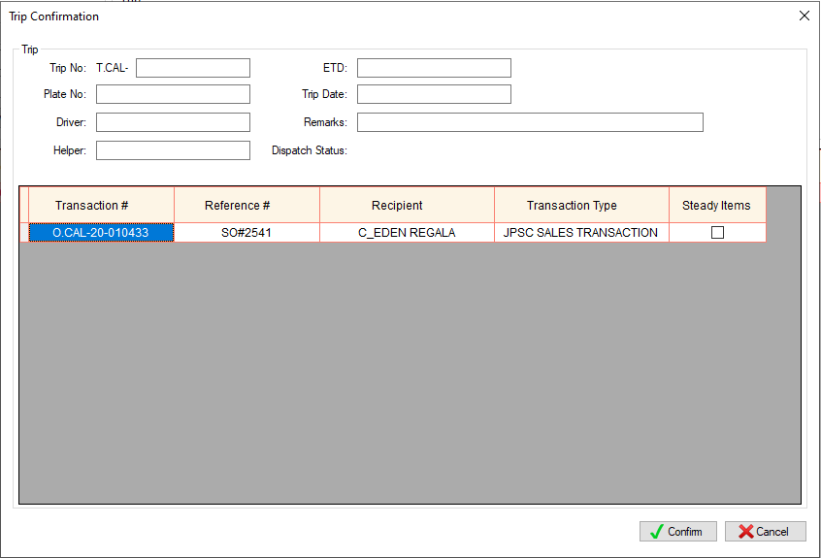Trip Confirmation window will appear.
3. 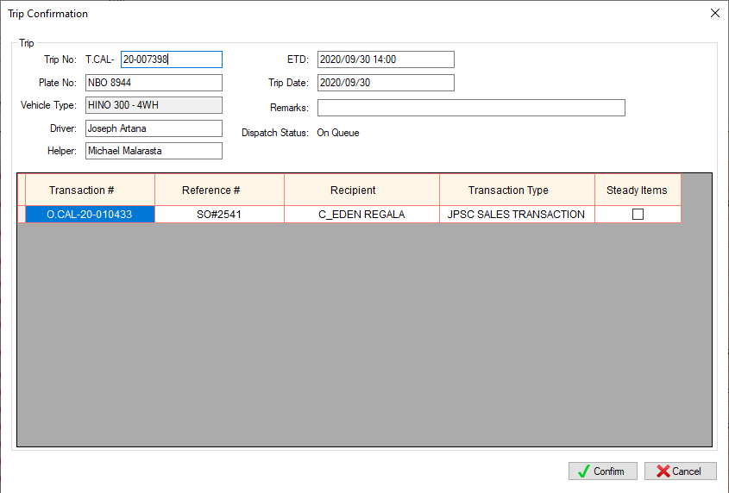Type the Trip#, then, press Enter.
4. Click Confirm button.

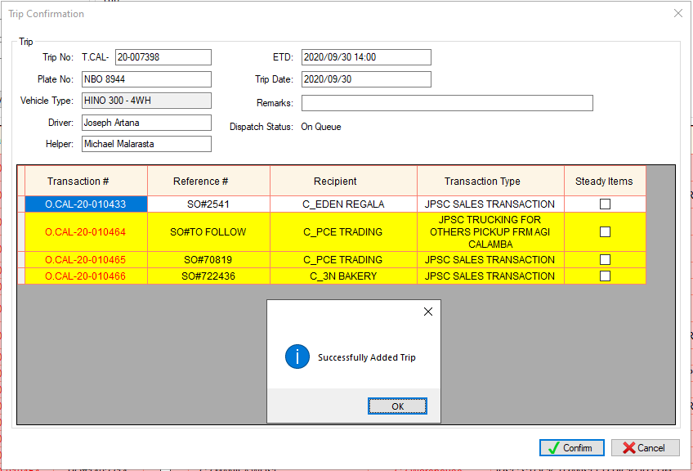

Notes:

* Transactions that are highlighted in yellow are the first transactions under that trip#.
* If you add another transaction to an existing trip before its departure, some of the steps will open again (if that step is already closed) for additional diesel, additional items to be loaded and/or additional receipt depending on the transaction type. See TRANSACTION TYPE AND STEPS TABLE

#### **VEHICLE IS IN TRANSIT**

* Kung na-dispatch na ang truck sa fleet
* Divert sa ibang recipient
* Example: Recipient 1 lang ang nasa list ng transaction and supposed to be kay Recipient 1 dapat idedeliver pero habang nasa byahe sarado na si Recipient 1. Para hindi sayang yung byahe pina divert na lang ang karga kay Recipient 2. Si Recipient 2, since wala ito sa list ng transaction, need ito i-create order at i-add sa existing trip ng truck. Ang gagawin naman sa Step 7 sa transaction ni Recipient 1 since hindi dito natuloy mag deliver is either Reschedule or For AR CM or Cancel (I-didiscuss ang process ng Reschedule or For AR CM or Cancel sa [STEP 7 (RETURN DOCUMENTS)](#_STEP_7_(RETURN)).
* Panibagong Reference# sa SAP (SO#, PO#, ITR#)
* Example#1: Additional SO – may times na sobra ng qty yung actual na naikarga ng checker and nareceive naman ito ng customer.
* Example#2: Change AR – may times na iba ang item sa actual na nareceive ni customer, sa item na nasa resibo. Para macorrect yung record sa SAP, gagawan ng credit memo yung maling item, then gagawan ng panibagong resibo yung tamang item, if iba ang SO# nito, need ito i-create order at i-add sa existing trip ng truck.
* Additional na schedule bago umuwe sa warehouse
* Example: Habang nasa byahe, pinag pick up muna sa Neco bago umuwe sa warehouse. Dahil ibang transaction ito, need ito i-create order at i-add sa existing trip ng truck.

How to add another transaction to an existing trip

1. Get the trip# where you want to add another transaction



1. 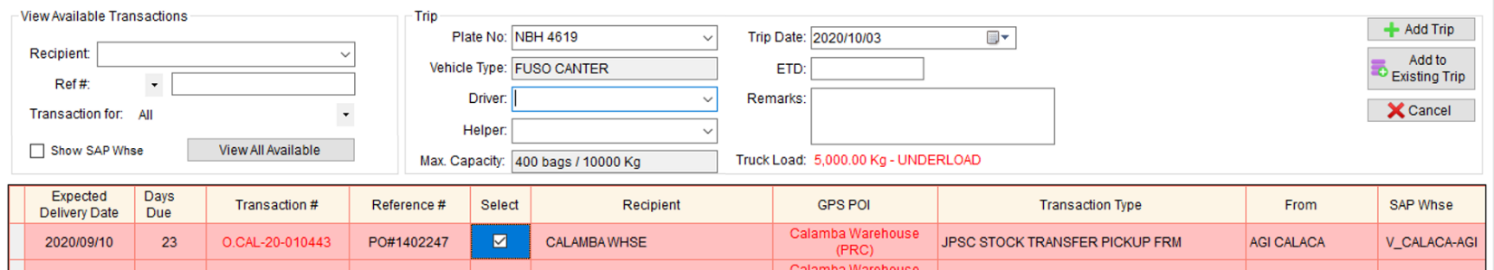In Trip Scheduling module, type the plate# and select the transaction(s). Then, click Add to Existing Trip button.
2. Trip Confirmation window will appear.

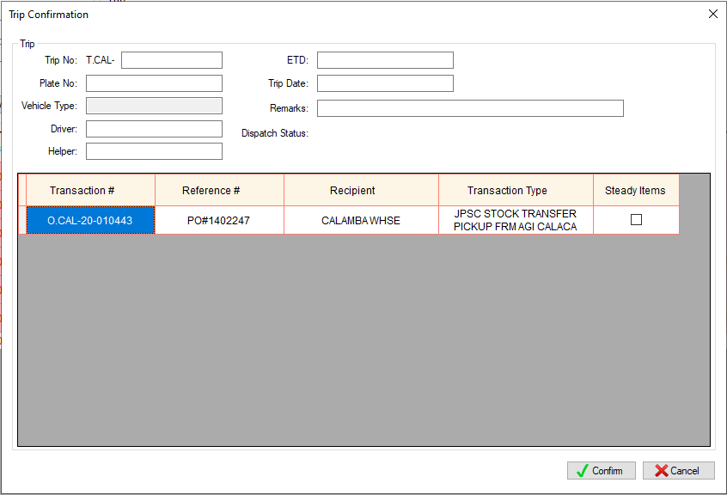

1. Type the Trip#, then, press Enter.

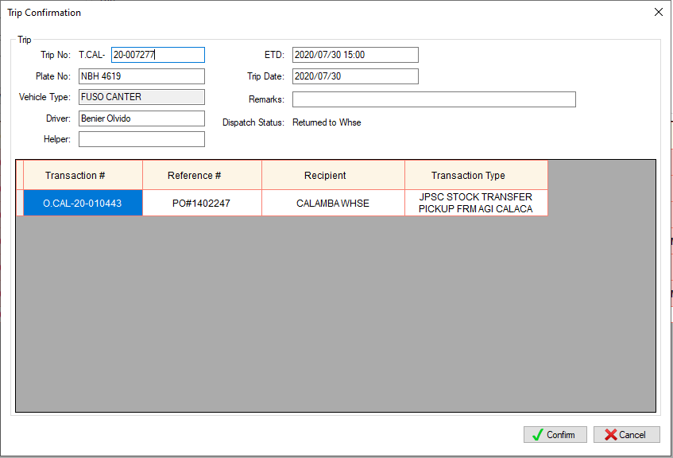

1. Click Confirm button.

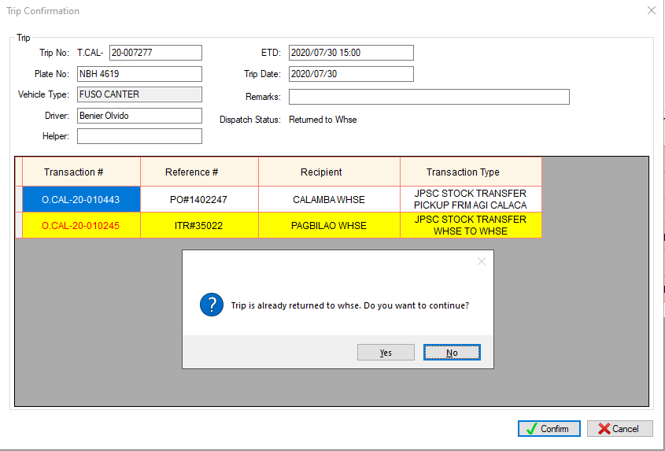

1. A confirmation dialog box will appear. Click Yes to proceed.

* Note: Transactions that are highlighted in yellow are the first transactions under that trip#.

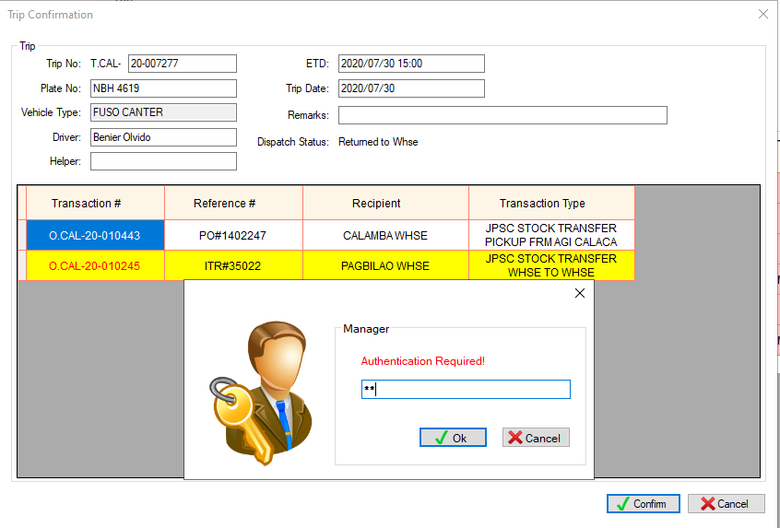

1. 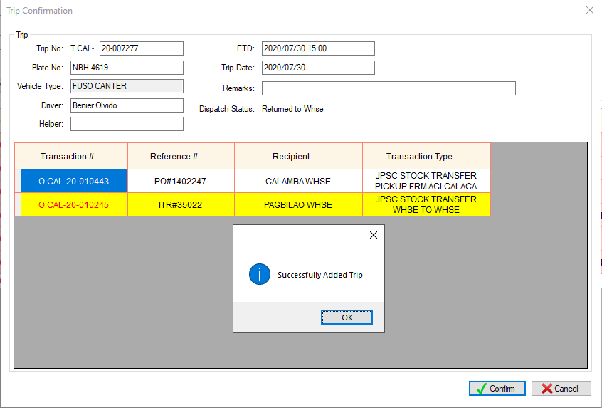Input password. Then, click Ok button.



Notes

* If you add another transaction to an existing trip after its departure, the transaction(s) will appear on the Step 7 – Return Documents if still open, if not, it will appear on the Step 9 – Recording. This will not open the previous steps like steps for diesel or release petty cash unlike in ***A. VEHICLE IS STILL IN WAREHOUSE***.
* See TRANSACTION TYPE AND STEPS TABLE

#### **COMPLETED TRIP**

* Completed na ang trip
* Panibagong Reference# sa SAP (SO#, PO#, ITR#, SWS#)
* Example#1: Late na trace tska lang nalaman na may Additional SO – may times na sobra ng qty yung actual na naikarga ng checker and nareceive naman ito ng customer.
* Example#2: Late na trace tska lang nalaman na may dapat i-Change AR – may times na iba ang item sa actual na nareceive ni customer sa item na nasa resibo. Para macorrect yung record sa SAP, gagawan ng credit memo yung maling item, then gagawan ng panibagong resibo ung tamang item, if iba ang SO# nito, need ito i-create order at i-add sa existing trip ng truck.
* Note: Warehouse ang gagawa ng create order, i-sesend sa administrator ang transaction# dahil admin lang ang authorize na mag add to existing sa completed na trip. Once na ma-add to existing na ito, mag o-open ulet ang Step 9 for recording purposes only dahil ang resibo is same lang sa resibo na nasa Step 7, ang correction is sa SAP na.

How to add another transaction to an existing trip

1. Get the trip# where you want to add another transaction



1. 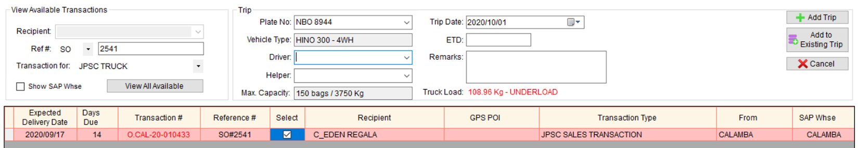In Trip Scheduling module, type the plate# and select the transaction(s). Then, click Add to Existing Trip button.
2. Trip Confirmation window will appear.



1. Type the Trip#, then, press Enter.
2. Click Confirm button.

* Trip Dispatching / View Trip Info / View Steps – mas madaling malalaman yung mga transaction na in-add to existing simula nung naka departure na ang truck based sa color coding.
* Trip Dispatching

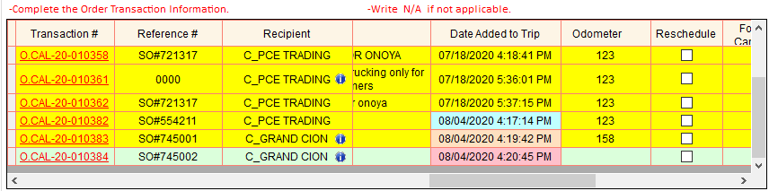

Sky Blue ang highlight kung in-add ng Naka Departure

Light Orange ang highlight kung in-add ng Naka Arrival

Pink ang highlight kung in-add ng Completed na ang trip

* View Steps

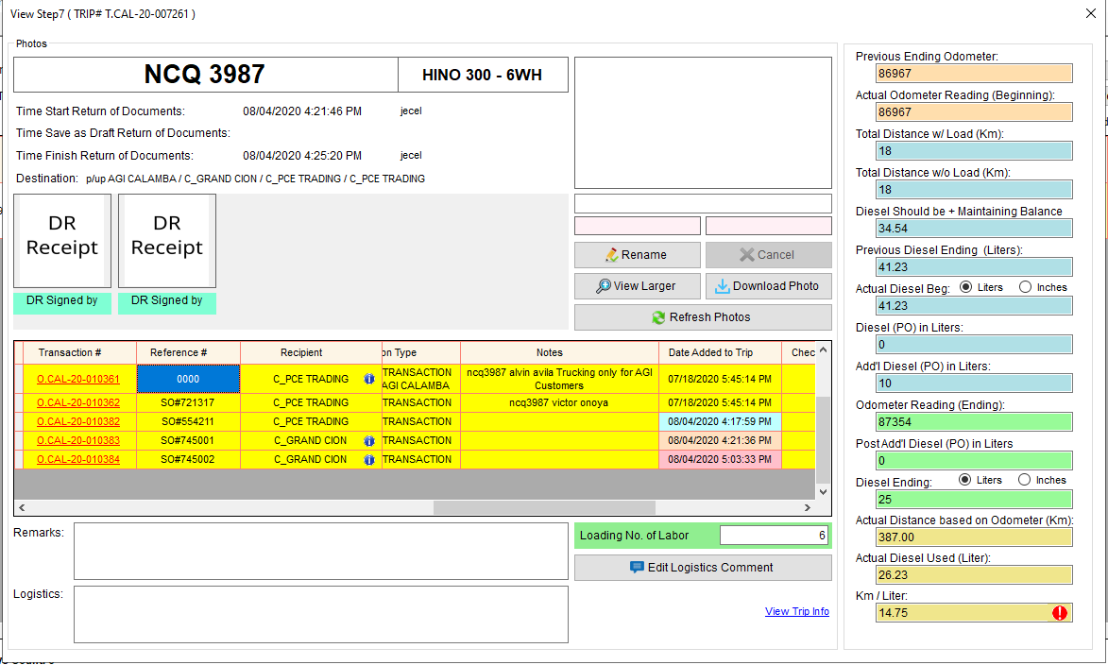

* Add to dbo.tbltripitems
* dbo.tbltripitems.tripnum – dbo.tbltripsum.tripnum
* dbo.tbltripitems.transnum – dbo.tblortrans.transnum
* dbo.tbltripitems.datecreated – GetDate()
* dbo.tbltripitems.createdby – Login Username
* dbo.tbltripitems.alreadydisp
* 0 – Added to Trip before Departure
* 1 – Added to Trip after Departure
* 2 – Added to Trip after Arrival
* dbo.tbltripitems.status – 1
* dbo.tbltripitems.cusodo
* 0 – if Vehicle Type is Customer Truck or Trucking Truck
* 0 – If Service
* Null – Default
* dbo.tbltripitems.steady
* 0 – Not Steady Items
* 1 – Steady Items
* Update status of Order transactions
* dbo.tblortrans.status – 0
* Update status of Steps
* dbo.tbldispatchsum.step
* dbo.tbldispatchsum.namestp

## **Trip Dispatching**

### **STEP 1 (PRE-INSPECTION)**

* To ensure that all the tools and all the documents (ex. OR / CR, Business Permit, Clearances, Stickers, etc.) are complete and valid.

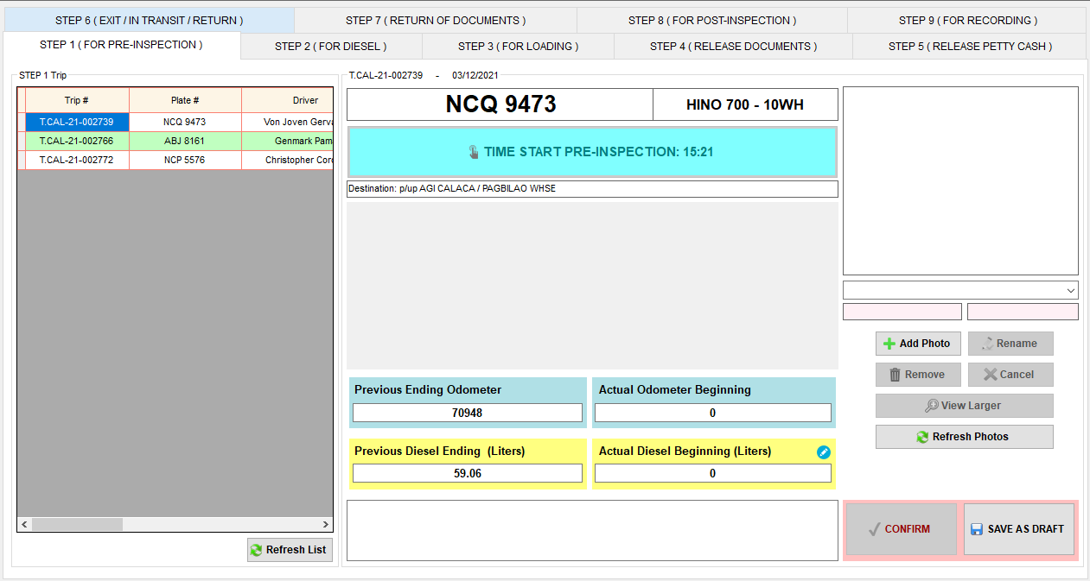

1. Select trip number or plate number.
2. Click Time Start Pre-inspection button.
3. Get the Truck Checklist Form and fill out to evaluate the truck.
4. Then, input the Actual Odometer Reading and Actual Diesel Beginning in fleet.
5. Ensure the ff:

* The form should have a signature over printed name of Driver or Helper and Inspector.
* The actual Truck Documents are complete and valid (meaning not expired).
* The tools are complete and in good condition.
* The Odometer Reading Start in the form should be the same as the Actual Odometer Reading in fleet.
* If there is a difference between Previous Ending Odometer and Actual Odometer Reading, input remarks. Valid remarks such as Truck ito ng milaor, Ending odometer ito nung huling trip sa fleet ng calamba
* If the Step 8 of the previous trip is warned by Logistics, a notification icon will appear and you need to click it to view the comment on the previous trip. It serves as a reminder to double check the actual odometer because there is something in previous step 8, such as typographical error of odometer reading.

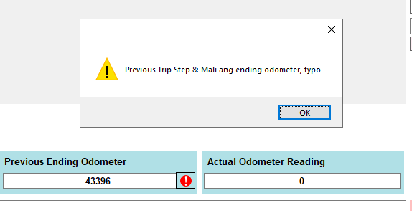

1. Then, attach the scanned copy of Truck Checklist Form.
2. Double check if all of the information is correct and complete.
3. Then, click Confirm button.
4. Then, the signature field will appear. The signatures will show that the persons involved in the pre-inspection authenticate all the information in step 1.
5. Then, the driver or helper will sign on the corresponding signature field.
6. Then, the inspector will sign also on the corresponding signature field.
7. Click Ok button to proceed to the next step.

Notes:

* Hindi makakapag Time Start sa Step 1 kung open pa ang Previous Trip Step 8.
* Pwedeng mauna maconfirm ang Step 2 kaysa sa Step 1.
* Makikita sa Step 3 ang trip kahit hindi pa nako-confirm ang Step 1, pero hindi makakapag Time Start sa Step 3 hangga’t hindi pa close ang Step 1.
* Hindi makikita sa Step 6 ang trip kung may hindi pa nako-confirm sa Step 1 to 5.

**Sample Truck Checklist Form**

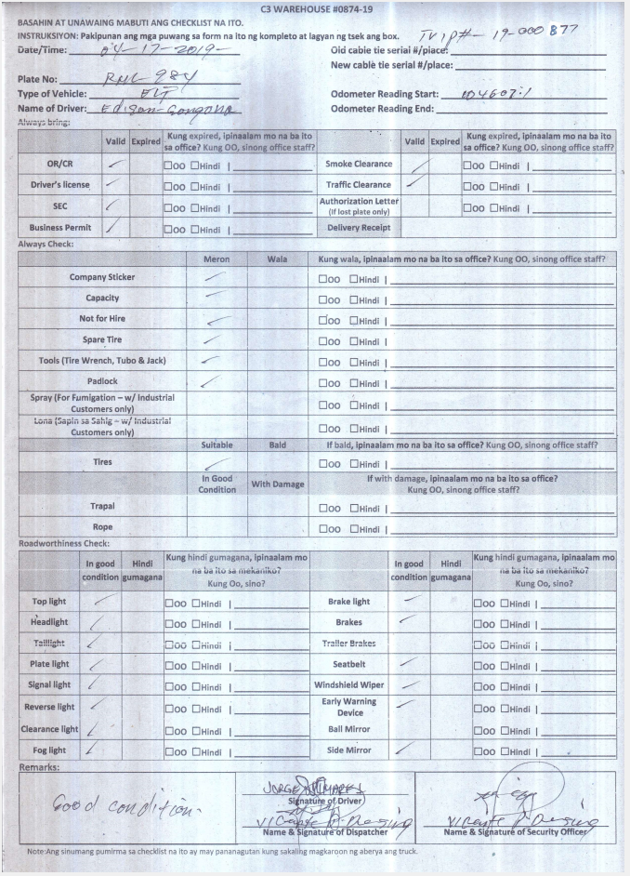

Time Start

* Update dbo.tbldispatchsum
* dbo.tbldispatchsum.startpre – GetDate()
* dbo.tbldispatchsum.startpreby – Login Username

Add Photos and Signatures

* Add Photo to dbo.tbldispatchstp1
* dbo.tbldispatchstp1.tripnum – dbo.tbltripsum.tripnum
* dbo.tbldispatchstp1.name – Photo name
* dbo.tbldispatchstp1.img – Photo
* dbo.tbldispatchstp1.status – 1
* dbo.tbldispatchstp1.datecreated – GetDate()
* dbo.tbldispatchstp1.createdby – Login Username

Save as Draft Step 1

* Update dbo.tbltripsum
* dbo.tbltripsum.odostart – Previous Ending Odometer
* dbo.tbltripsum.odoactual – Actual Odometer Reading
* dbo.tbltripsum.datemodified – GetDate()
* dbo.tbltripsum.modifiedby – Login Username
* Update dbo.tbldispatchsum
* dbo.tbldispatchsum.sneymstp1 – Login Username
* dbo.tbldispatchsum.sdeytstp1 – GetDate()
* dbo.tbldispatchsum.remstp1 – Remarks

Confirm Step 1

* Update dbo.tbltripsum
* dbo.tbltripsum.odostart – Previous Ending Odometer
* dbo.tbltripsum.odoactual – Actual Odometer Reading
* dbo.tbltripsum.datemodified – GetDate()
* dbo.tbltripsum.modifiedby – Login Username
* Update dbo.tbldispatchsum
* dbo.tbldispatchsum.step1 – 1
* dbo.tbldispatchsum.namestp1 – Login Username
* dbo.tbldispatchsum.datestp1 – GetDate()
* dbo.tbldispatchsum.remstp1 – Remarks
* dbo.tbldispatchsum.prevtrip – 0

#### **Input inches in Actual Diesel Beginning (Liters)**

Stick na ginagamit panukat ng diesel sa mga truck

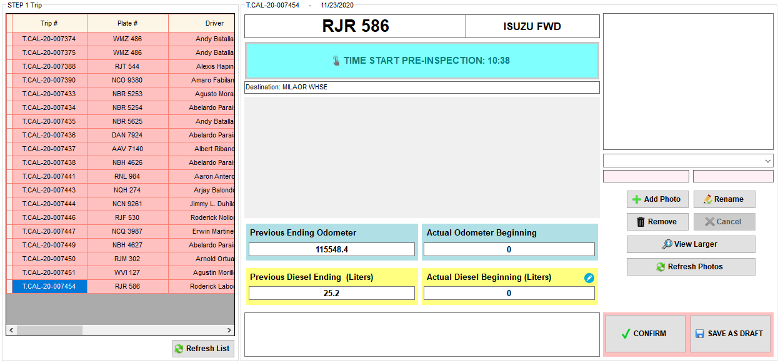

Click this icon to view the converter.

1. Click the icon beside the Actual Diesel Beginning (Liters).

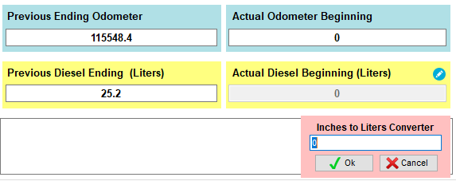

1. Input the diesel in Inches.

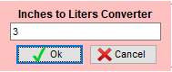

1. Click Ok button to convert.

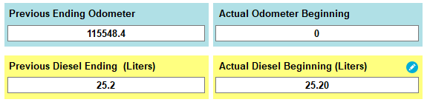

**Inches to Liters Conversion**

Plate#: **RJR 586**

Liter per Inch: **8.4**

Diesel measurement in Inches: **3.0**

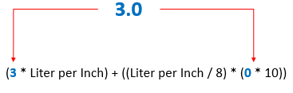

= (3 * 8.4) + ((8.4 / 8) * (0 * 10)

= (25.2) + (1.05 * 0)

= 25.2 + 0

= 25.2

Actual Diesel Beg (Liters) = **25.20 Liters**

### **STEP 2 (DIESEL)**

* 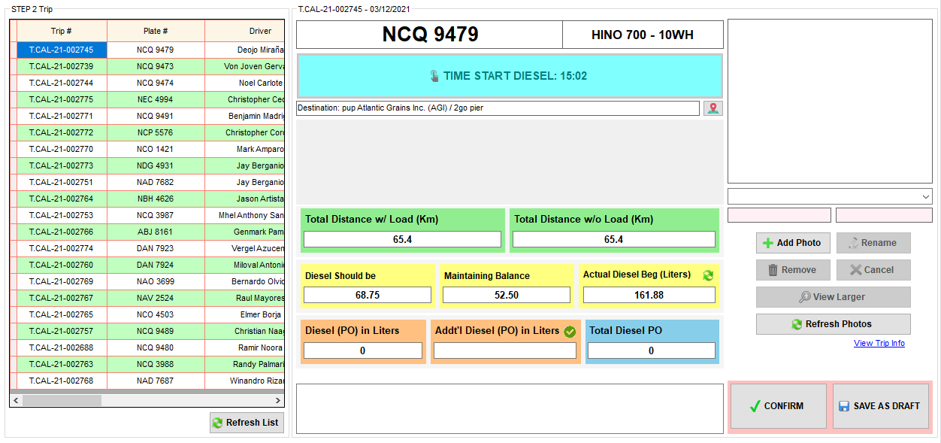Computation of Diesel

1. Select trip number or plate number.
2. Click Time Start Diesel button.
3. Get the Distance with load and without load based on the truck delivery schedule using Fasttrack and Google Maps.
4. Get the Actual Diesel Beginning of the truck and input it in fleet.
5. Diesel (PO) in Liters automatically computed.
6. Input additional Diesel PO if necessary, with remarks.
7. Fill out the Purchase Order form (if diesel outside the warehouse) or Withdrawal Slip (if in-house diesel).
8. Ensure the ff:

* The Purchase Order Form / Withdrawal Slip should have signature over printed name of Diesel Controller.
* The Plate number in the form should be the same as the Plate number in fleet.
* Diesel quantity in the P.O. form or Withdrawal Slip should be the same as the Total Diesel PO in fleet.
* If no additional diesel, Addt’l Diesel (PO) in Liters in fleet should be equal to zero.
* If No Diesel (meaning no need to purchase diesel), Total Diesel PO in fleet should be equal to zero.
* If there is a difference between Previous Diesel Ending (Liters) and Actual Diesel Beg (Liters), input remarks. Valid remarks such as Truck ito ng milaor, Diesel Ending ito nung huling trip sa fleet ng c3
* If the Step 8 of the previous trip is warned by Logistics, a notification icon will appear and you need to click it to view the comment on the previous trip. It serves as a reminder to double check the actual diesel reading because there is something in previous step 8, such as typographical error of diesel reading.

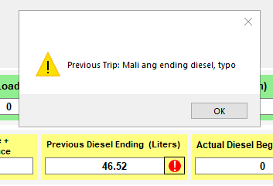

1. Then, attach the scanned copy of Purchase Order form / Withdrawal Slip.
2. Then, click Confirm button.
3. Then, the signature field will appear. The signature will show that the person involved in the computation of Diesel authenticates all the information in step 2.
4. Then, the inspector or diesel controller will sign on the corresponding signature field.
5. Click Ok button to proceed to the next step.

Notes:

* Pwedeng mauna maconfirm ang Step 2 kaysa sa Step 1.
* Hindi makikita sa Step 6 ang trip kung may hindi pa nako-confirm sa Step 1 to 5.

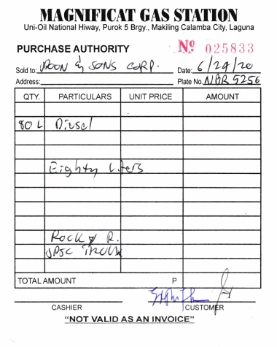**Sample Purchase Order Form Sample Withdrawal Slip**

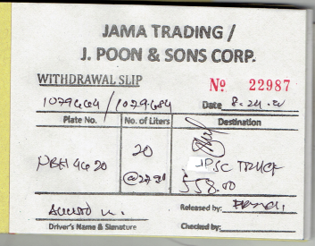

#### **Computation of Total Diesel PO**

#### **Distance Computation if One Drop off**

* Applicable only if the drop off point has a standard distance.

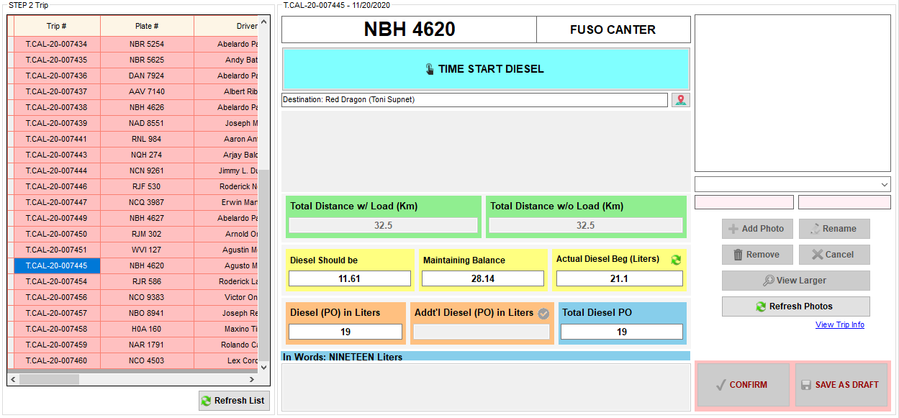

Click this button to view the standard distance

* 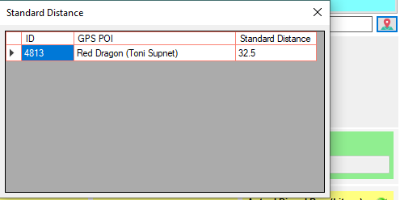To check if the standard distance is already set in the database, click the GPS POI button beside the destination label.

1. Select trip# or plate#.
2. If the trip has one drop off point only, even the step is not yet started, Total Distance w/ Load (Km) and Total Distance w/o Load (Km) are automatically computed if the standard distance is already set in the database.
3. Click TIME START DIESEL.
4. Total Distance w/ Load (Km) and Total Distance w/o Load (Km) are still editable.

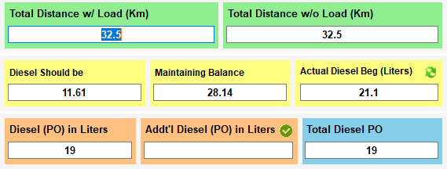

#### **Distance Computation if Multiple Drop off**

* Applicable only if all the drop off points have a standard distance.

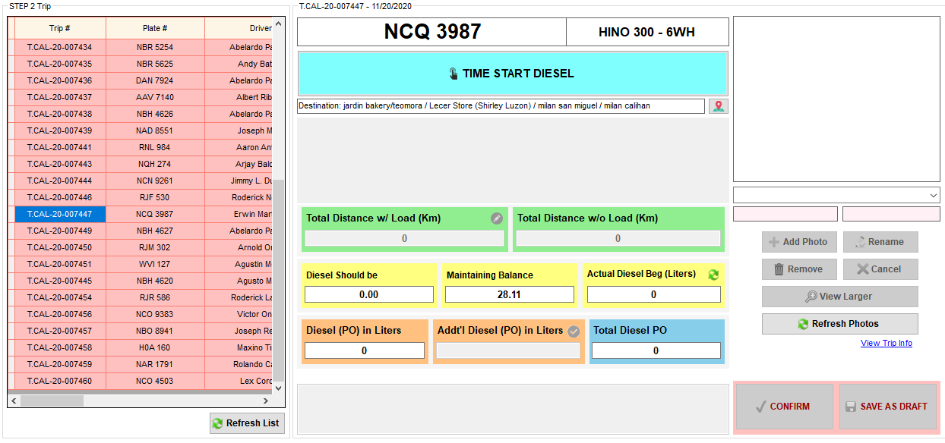

Click this button to view the standard distance

* To check if the standard distance is already set in the database, click the GPS POI button beside the destination label.

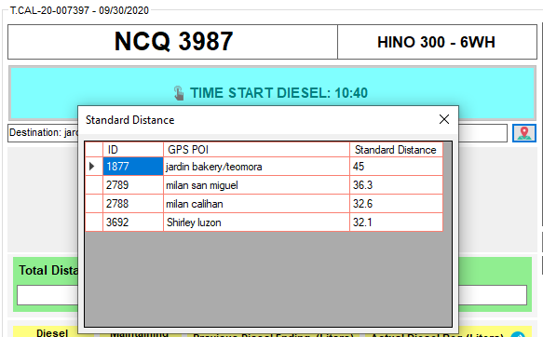

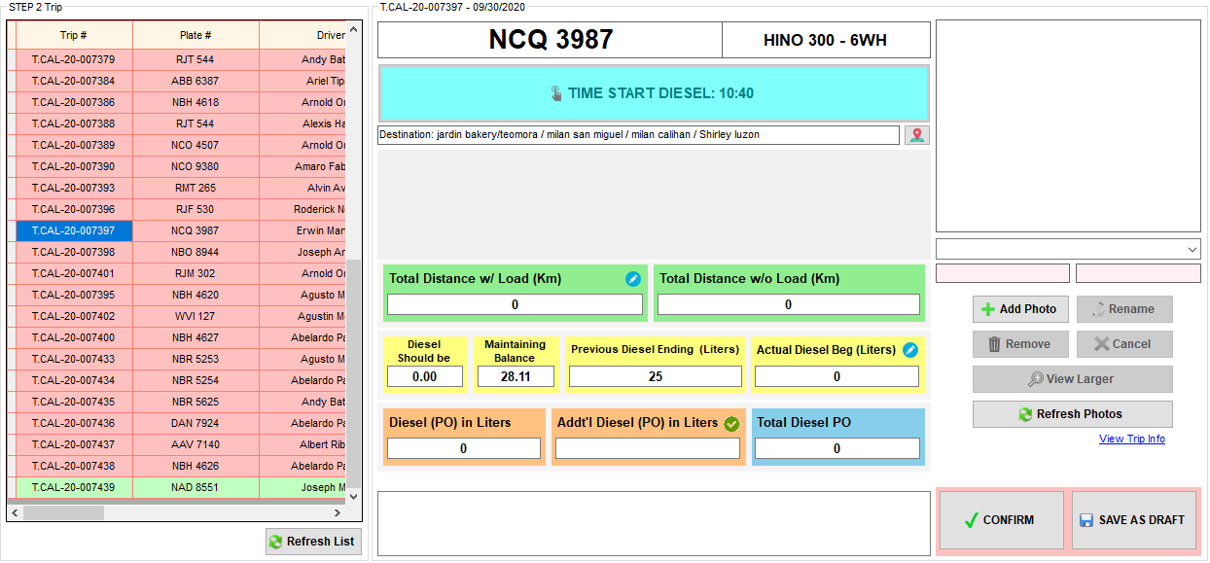

Click this icon to compute for distance

1. Click the icon beside the Total Distance w/ Load (Km)

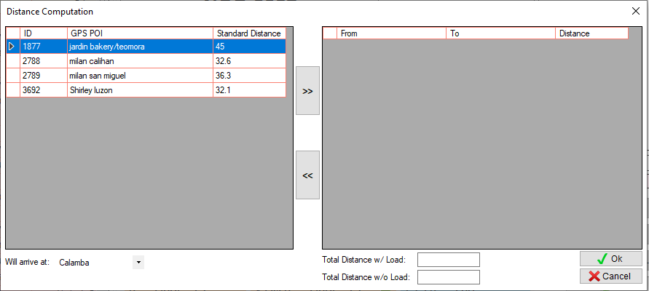

2. Select the first destination

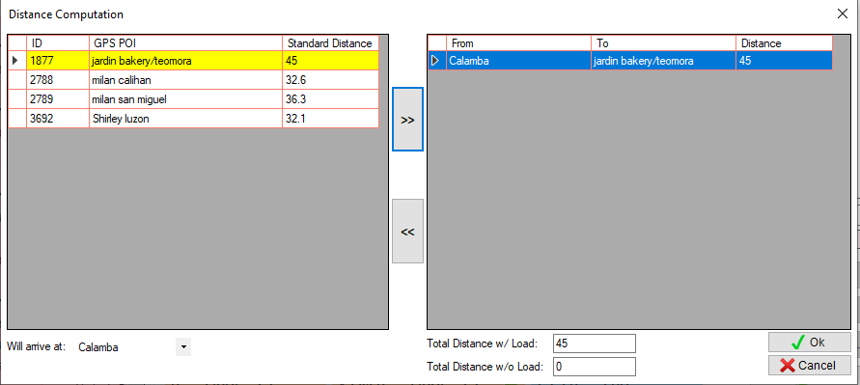

3. Click this button

4. Automatically shows the distance from warehouse to the first destination

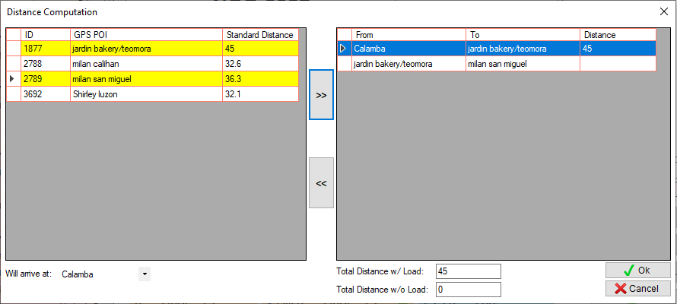

5. Select the next destination

6. Click this button

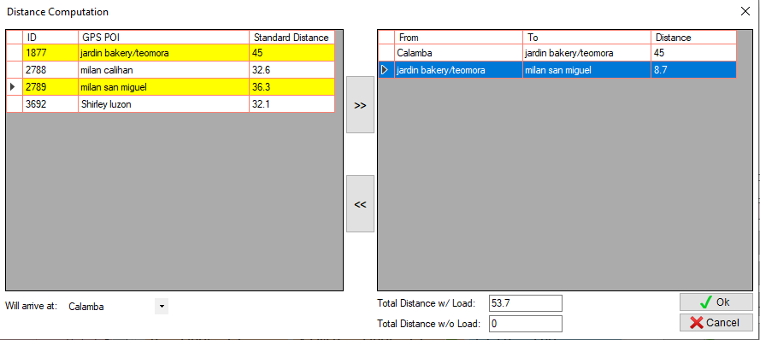

7. Input distance from jardin bakery to milan san miguel

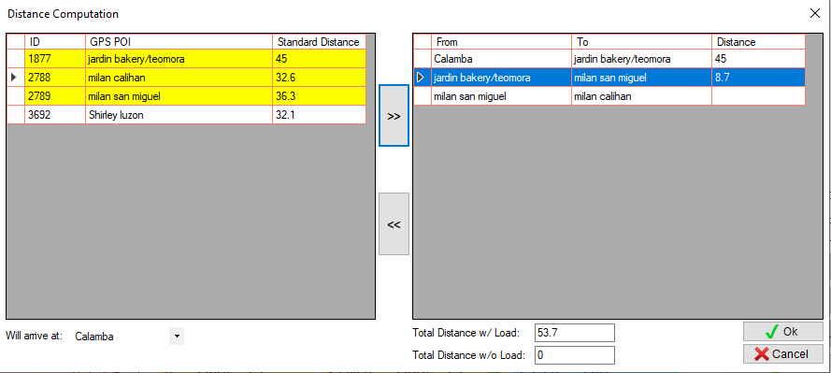

8. Select the next destination

9. Click this button

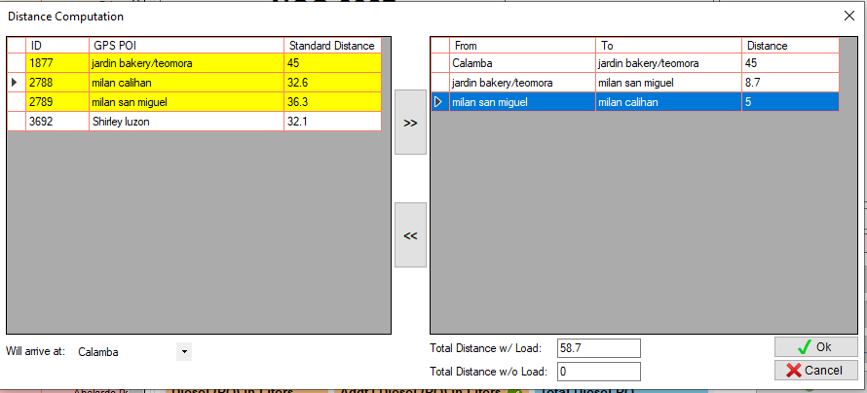

10. Input distance from milan san miguel to milan calihan

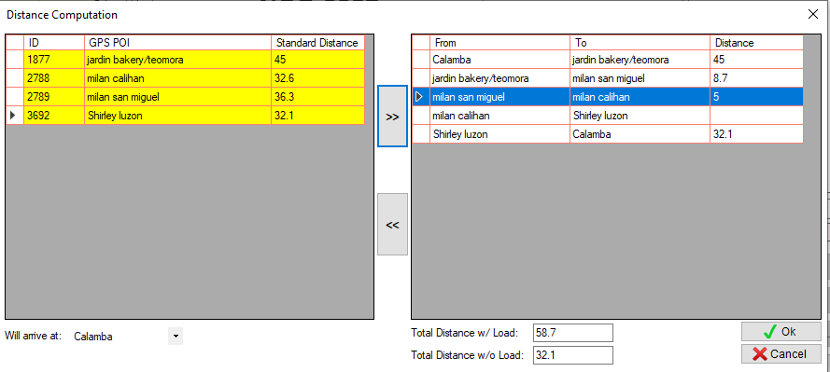

11. Select the next destination

12. Click this button

13. Last destination to warehouse will automatically added.

14. Automatically shows the distance from last destination to warehouse

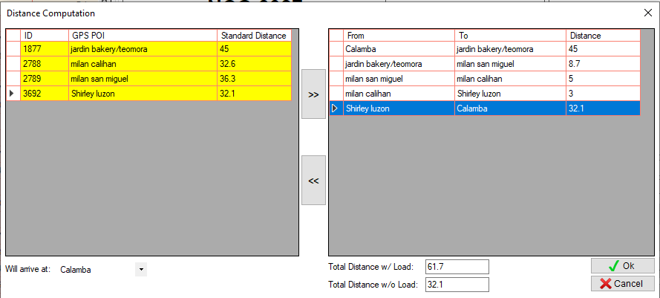

15. Input distance from milan calihan to Shirley luzon

16. Automatically computes the Total Distance w/ Load and the Total Distance w/o Load

17. Click OK button.

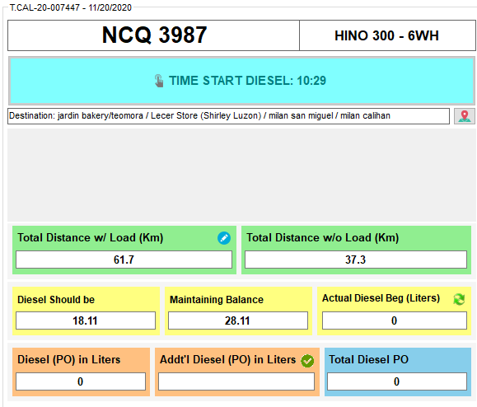

Time Start

* Update dbo.tbldispatchsum
* dbo.tbldispatchsum.startdiesel – GetDate()
* dbo.tbldispatchsum.startdieselby – Login Username

Add Photos and Signatures

* Add Photo to dbo.tbldispatchstp2
* dbo.tbldispatchstp2.tripnum – dbo.tbltripsum.tripnum
* dbo.tbldispatchstp2.name – Photo name
* dbo.tbldispatchstp2.img – Photo
* dbo.tbldispatchstp2.status – 1
* dbo.tbldispatchstp2.datecreated – GetDate()
* dbo.tbldispatchstp2.createdby – Login Username

Save as Draft Step 2

* Update dbo.tbltripsum
* dbo.tbltripsum.diswith – Total Distance with Load
* dbo.tbltripsum.diswout – Total Distance without Load
* dbo.tbltripsum.dshould – Diesel should be + Maintaining Balance
* dbo.tbltripsum.dieselbeg – Previous Ending Diesel
* dbo.tbltripsum.dieselactual – Actual Diesel Beg
* dbo.tbltripsum.podiesel – Diesel (PO) in Liters
* dbo.tbltripsum.addpo – Addt’l Diesel (PO) in Liters
* dbo.tbltripsum.pwith – dbo.tbldiesel.pwith
* dbo.tbltripsum.pwout – dbo.tbldiesel.pwout
* dbo.tbltripsum.twoinch – dbo.tbldiesel.twoinch
* dbo.tbltripsum.fulltank – dbo.tbldiesel.fulltank
* dbo.tbltripsum.datemodified – GetDate()
* dbo.tbltripsum.modifiedby – Login Username
* Update dbo.tbldispatchsum
* dbo.tbldispatchsum.sneymstp2 – Login Username
* dbo.tbldispatchsum.sdeytstp2 – GetDate()
* dbo.tbldispatchsum.remstp2 – Remarks

Confirm Step 2

* Update dbo.tbltripsum
* dbo.tbltripsum.diswith – Total Distance with Load
* dbo.tbltripsum.diswout – Total Distance without Load
* dbo.tbltripsum.dshould – Diesel should be + Maintaining Balance
* dbo.tbltripsum.dieselbeg – Previous Ending Diesel
* dbo.tbltripsum.dieselactual – Actual Diesel Beg
* dbo.tbltripsum.podiesel – Diesel (PO) in Liters
* dbo.tbltripsum.addpo – Addt’l Diesel (PO) in Liters
* dbo.tbltripsum.pwith – dbo.tbldiesel.pwith
* dbo.tbltripsum.pwout – dbo.tbldiesel.pwout
* dbo.tbltripsum.twoinch – dbo.tbldiesel.twoinch
* dbo.tbltripsum.fulltank – dbo.tbldiesel.fulltank
* dbo.tbltripsum.datemodified – GetDate()
* dbo.tbltripsum.modifiedby – Login Username
* Update dbo.tbldispatchsum
* dbo.tbldispatchsum.step2 – 1
* dbo.tbldispatchsum.namestp2 – Login Username
* dbo.tbldispatchsum.datestp2 – GetDate()
* dbo.tbldispatchsum.remstp2 – Remarks

### **STEP 3 (LOADING)**

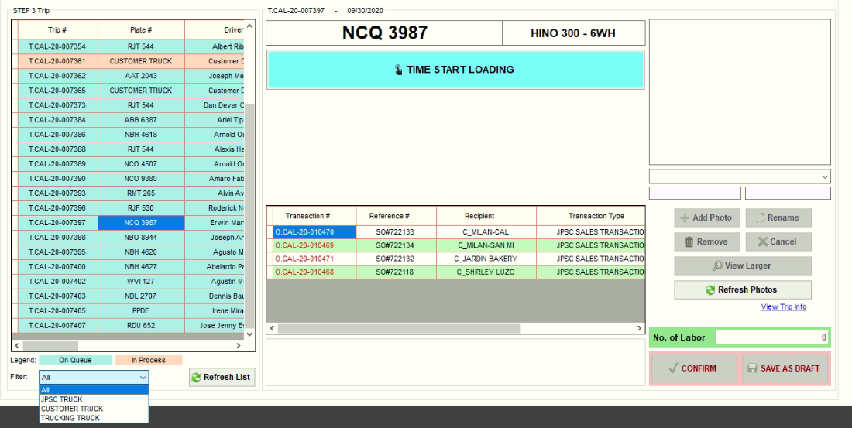

1. Get the GMP Checklist Form and Truck Cleanliness Checklist form and fill out to evaluate the truck.
2. If the truck is good for loading items, select trip number or plate number.
3. Click Time Start Loading button.
4. Then, after loading of items based on SO/ITR, sign the SO/ITR.
5. Ensure the ff:

* If the transaction type is Sales Transaction
* The Sales Order Form should have signature over printed name of Driver or helper, Checker and Senior Checker.
* The SO# in the form should be the same as the SO# in fleet.
* If the transaction type is Stock Transfer Whse to Whse
* The Stock Transfer Request Form should have signature over printed name of Driver or helper, Checker and Senior Checker.
* The ITR# in the form should be the same as the ITR# in fleet.
* No temporary Sales Order Form / Stock Transfer Request Form unless unable to connect in SAP.

1. Then, attach the scanned copy of Sales Order form / Stock Transfer Request Form.
2. Then, input no. of labor.
3. Double check if all of the information is correct and complete.
4. Then, click Confirm button.
5. Then, the signature field will appear. The signatures will show that the persons involved in loading authenticate all the information in step 3.
6. Then, the driver or helper will sign on the corresponding signature field.
7. Then, the checker and senior checker will sign also on the corresponding signature field.
8. Click Ok button to proceed to the next step.

Notes:

* Makikita sa Step 3 ang trip kahit hindi pa nako-confirm ang Step 1, pero hindi makakapag Time Start sa Step 3 hangga’t hindi pa close ang Step 1. Pinakita ito para malaman agad ng checker kung anong mga truck ang kakargahan.
* Hindi pwede maconfirm ang Step 4 at 5 kung hindi pa na confirm ang Step 3, hanggang save as draft lang muna.
* Hindi makikita sa Step 6 ang trip kung may hindi pa nako-confirm sa Step 1 to 5.

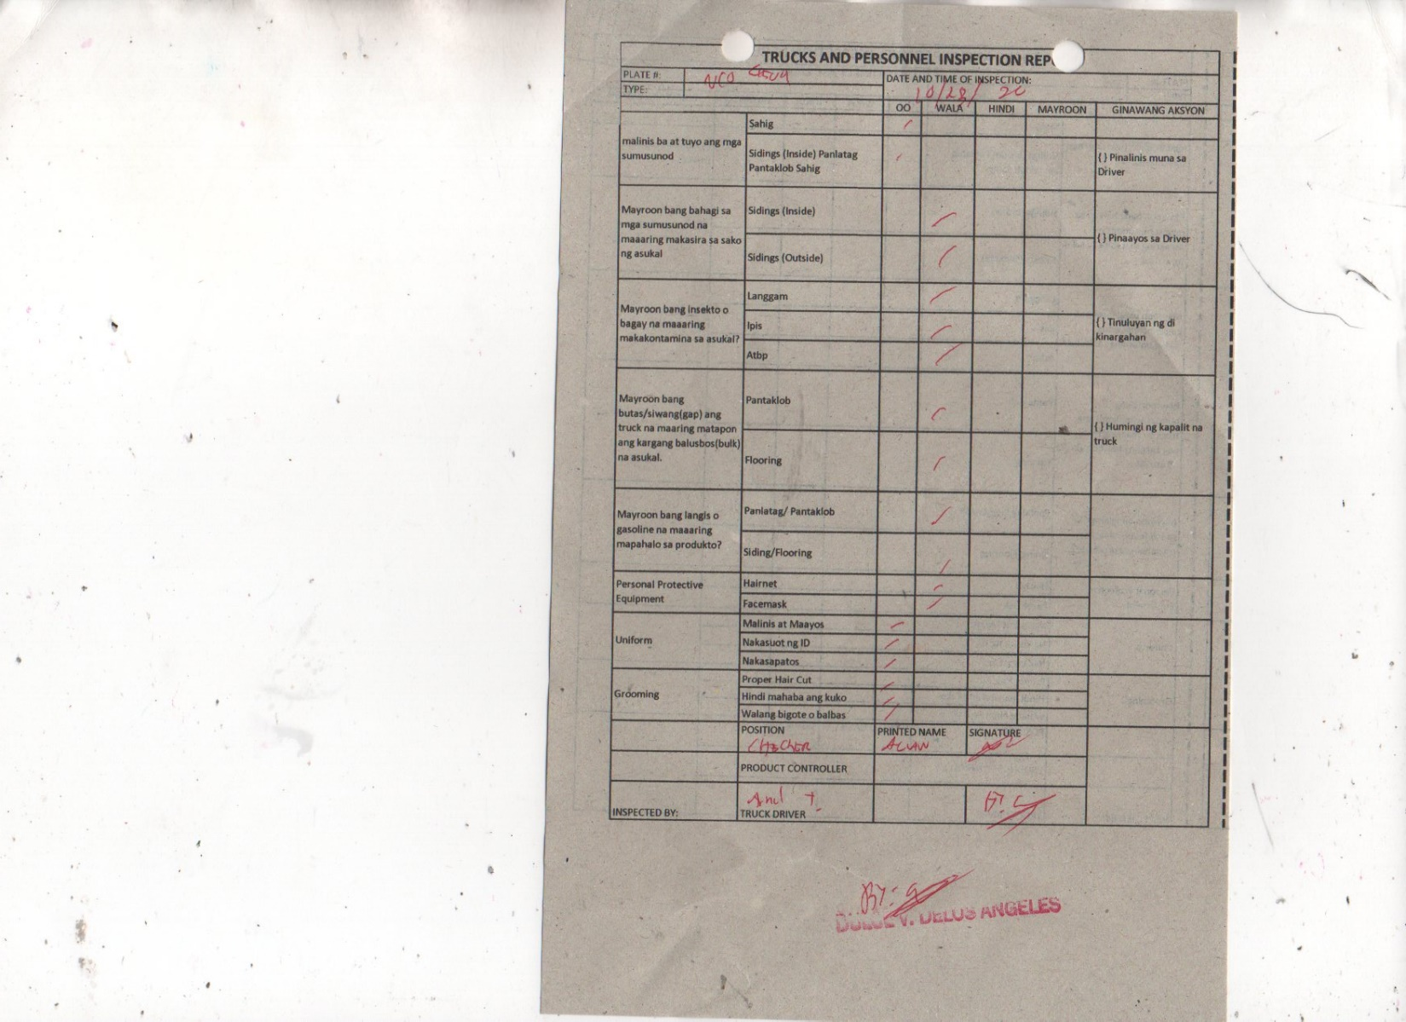**Sample Truck Cleanliness Checklist Form**

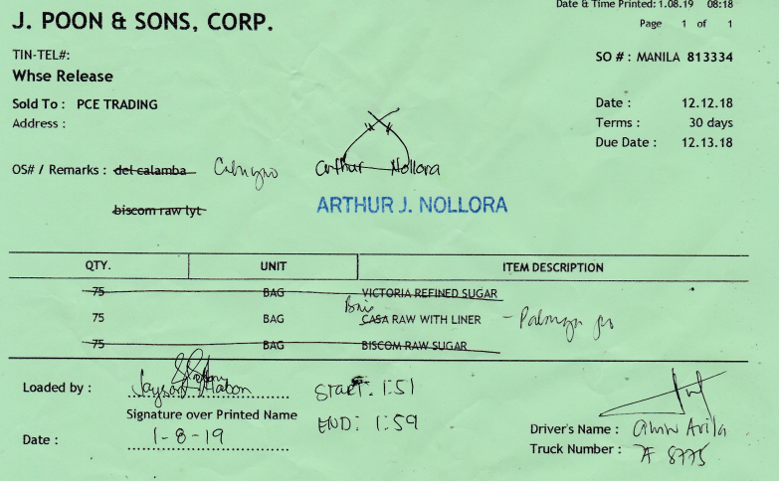**Sample Sales Order Form**

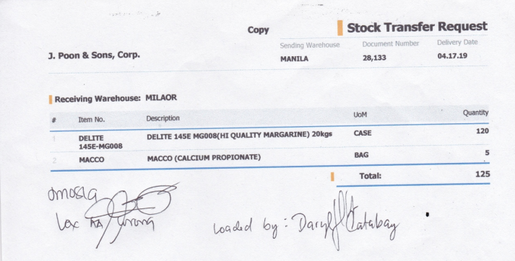**Sample Stock Transfer Request Form**

Time Start

* Update dbo.tbldispatchsum
* dbo.tbldispatchsum.startload – GetDate()
* dbo.tbldispatchsum.startloadby – Login Username

Add Photos and Signatures

* Add Photo to dbo.tbldispatchstp3
* dbo.tbldispatchstp3.tripnum – dbo.tbltripsum.tripnum
* dbo.tbldispatchstp3.name – Photo name
* dbo.tbldispatchstp3.img – Photo
* dbo.tbldispatchstp3.status – 1
* dbo.tbldispatchstp3.datecreated – GetDate()
* dbo.tbldispatchstp3.createdby – Login Username

Save as Draft Step 3

* Update dbo.tbltripsum
* dbo.tbltripsum.loadscale – No of Labors
* dbo.tbltripsum.datemodified – GetDate()
* dbo.tbltripsum.modifiedby – Login Username
* Update dbo.tbldispatchsum
* dbo.tbldispatchsum.sneymstp3 – Login Username
* dbo.tbldispatchsum.sdeytstp3 – GetDate()
* dbo.tbldispatchsum.remstp3 – Remarks

Confirm Step 3

* Update dbo.tbltripsum
* dbo.tbltripsum.loadscale – No of Labors
* dbo.tbltripsum.datemodified – GetDate()
* dbo.tbltripsum.modifiedby – Login Username
* Update dbo.tbldispatchsum
* dbo.tbldispatchsum.step3 – 1
* dbo.tbldispatchsum.namestp3 – Login Username
* dbo.tbldispatchsum.datestp3 – GetDate()
* dbo.tbldispatchsum.remstp3 – Remarks

### **STEP 4 (RELEASE DOCUMENTS)**

* 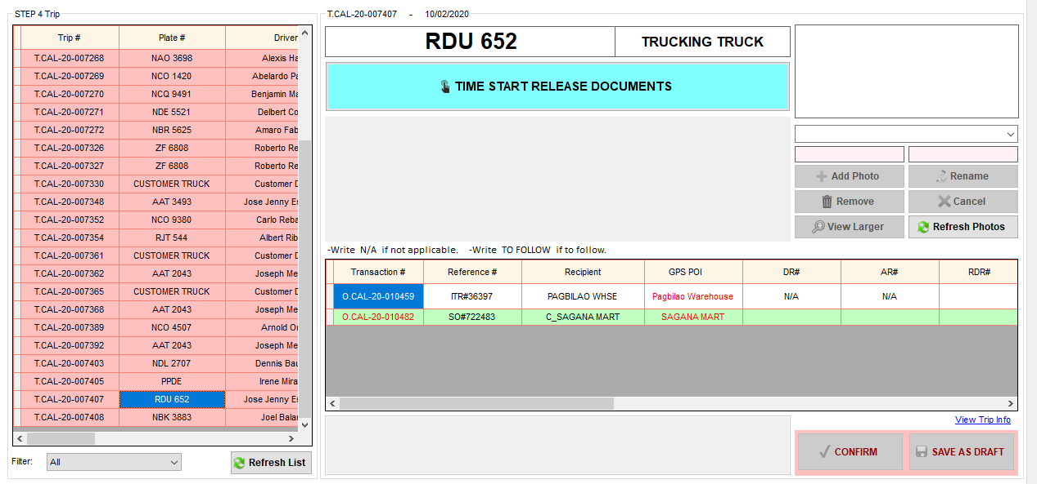Releasing of documents such as Delivery Receipt, Stock Transfer Form, Delivery Note, etc.

1. Select trip number or plate number.
2. Click Time Start Release Documents button.
3. Then, fill out the necessary information in fleet.
4. Ensure the ff:

* Temporary receipt is valid if it is for customer of customer. Usually the recipient name in temporary receipt is different from the recipient name in the fleet.
* If the recipient name in the temporary receipt is the same as the recipient name in the fleet, input valid remarks. Example: unable to connect in SAP or no internet.
* If the transaction type is Sales Transaction
* The DR (Delivery Receipt) should have signature over printed name of Driver or Helper.
* The Customer name in DR should be the same as the Recipient name in fleet.
* The DR# in Delivery Receipt should be the same as the DR# in fleet.
* If the transaction type is Stock Transfer pickup frm Agi
* The DN (Delivery Note) should have signature over printed name of Driver or Helper.
* The Customer name in DN should be the same as the Recipient name in fleet.
* The DN# in Delivery Note should be the same as the DN# in fleet.
* If the transaction type is Stock Transfer Whse to Whse
* The Stock Transfer Request Form (also ITR Form) should have signature over printed name of Driver or Helper.
* The Receiving Warehouse in ITR should be the same as the Recipient name in fleet.
* The ITR# in Stock Transfer Request Form should be the same as the ITR# in fleet.
* Edit TO FOLLOW reference numbers (SO#, PO#, ITR#).

How to edit TO FOLLOW Reference#

1. Then, attach the scanned copy of Delivery Receipt and/or Stock Withdrawal Slip and/or Stock Transfer Request form and/or Delivery Note.
2. Double check if all of the information is correct and complete.
3. Then, click Confirm button.
4. Then, the signature field will appear. The signatures will show that the persons involved in releasing documents authenticate all the information in step 4.
5. Then, the driver or helper will sign on the corresponding signature field.
6. Then, the encoder will sign also on the corresponding signature field.
7. Click Ok button to proceed to the next step.

Notes:

* Hindi pwede maconfirm ang Step 4 at 5 kung hindi pa na confirm ang Step 3, hanggang save as draft lang muna.
* Hindi makikita sa Step 6 ang trip kung may hindi pa nako-confirm sa Step 1 to 5.

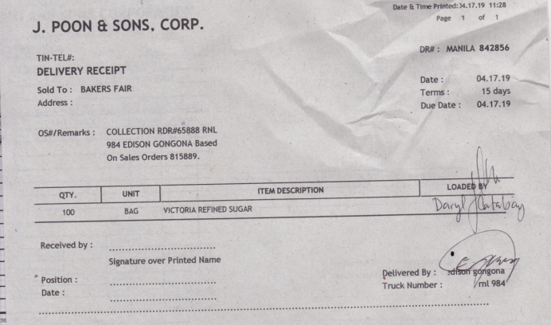**Sample Delivery Receipt**

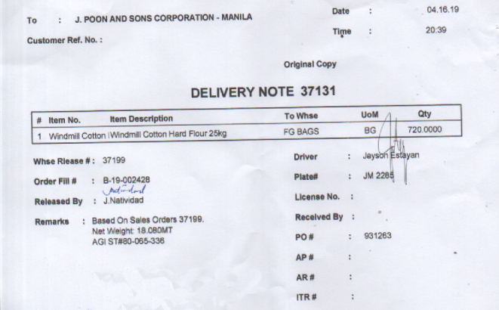**Sample Delivery Note**

**Sample Stock Transfer Request Form**



**Sample Temporary Receipt**

* YAZAKI BAKERY is a customer of ATC

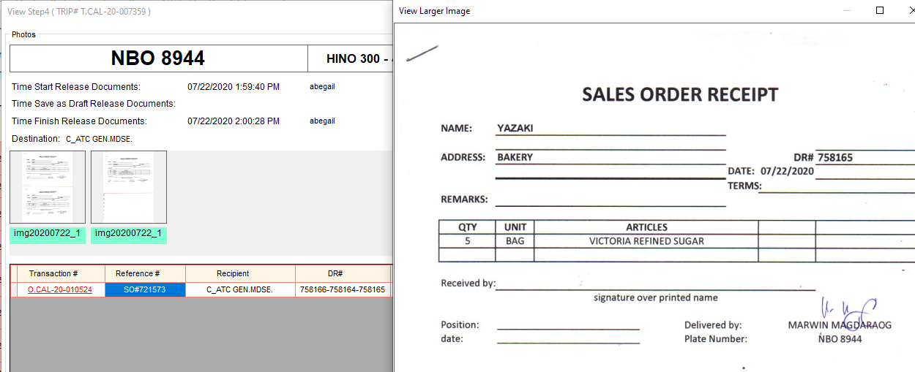

Time Start

* Update dbo.tbldispatchsum
* dbo.tbldispatchsum.startdoc – GetDate()
* dbo.tbldispatchsum.startdocby – Login Username

Add Photos and Signatures

* Add Photo to dbo.tbldispatchstp4
* dbo.tbldispatchstp4.tripnum – dbo.tbltripsum.tripnum
* dbo.tbldispatchstp4.name – Photo name
* dbo.tbldispatchstp4.img – Photo
* dbo.tbldispatchstp4.status – 1
* dbo.tbldispatchstp4.datecreated – GetDate()
* dbo.tbldispatchstp4.createdby – Login Username

Edit Reference#

* Update dbo.tblortrans
* dbo.tblortrans.refnum
* dbo.tblortrans.sonum – if SO#
* dbo.tblortrans.ponum – if PO#
* dbo.tblortrans.itrnum – if ITR#
* dbo.tblortrans.sws – if SWS#
* Add Logs to dbo.tbloredit
* dbo.tbloredit.transid – dbo.tblortrans.transid
* dbo.tbloredit.transnum – dbo.tblortrans.transnum
* dbo.tbloredit.customer – dbo.tblortrans.customer
* dbo.tbloredit.prevso – Previous SO#
* dbo.tbloredit.newso – New SO#
* dbo.tbloredit.prevpo – Previous PO#
* dbo.tbloredit.newpo – New PO#
* dbo.tbloredit.previtr – Previous ITR#
* dbo.tbloredit.newitr – New ITR#
* dbo.tbloredit.prevsws – Previous SWS#
* dbo.tbloredit.newsws – New SWS#
* dbo.tbloredit.datecreated – GetDate()
* dbo.tbloredit.createdby – Login Username
* dbo.tbloredit.status – 1

Save as Draft Step 4

* Update dbo.tblortrans
* dbo.tblortrans.arnum – AR#
* dbo.tblortrans.rdrnum – RDR#
* dbo.tblortrans.drnum – DR#
* dbo.tblortrans.dnnum – DN#
* dbo.tblortrans.itrnum – ITR#
* dbo.tblortrans.datemodified – GetDate()
* dbo.tblortrans.modifiedby – Login Username
* Update dbo.tbldispatchsum
* dbo.tbldispatchsum.sneymstp4 – Login Username
* dbo.tbldispatchsum.sdeytstp4 – GetDate()
* dbo.tbldispatchsum.remstp4 – Remarks

Confirm Step 4

* Update dbo.tblortrans
* dbo.tblortrans.arnum – AR#
* dbo.tblortrans.rdrnum – RDR#
* dbo.tblortrans.drnum – DR#
* dbo.tblortrans.dnnum – DN#
* dbo.tblortrans.itrnum – ITR#
* dbo.tblortrans.datemodified – GetDate()
* dbo.tblortrans.modifiedby – Login Username
* Update dbo.tbldispatchsum
* dbo.tbldispatchsum.step4 – 1
* dbo.tbldispatchsum.namestp4 – Login Username
* dbo.tbldispatchsum.datestp4 – GetDate()
* dbo.tbldispatchsum.remstp4 – Remarks

#### **How to Edit Items (Item name or Qty)**

### **STEP 5 (RELEASE PETTY CASH)**

* 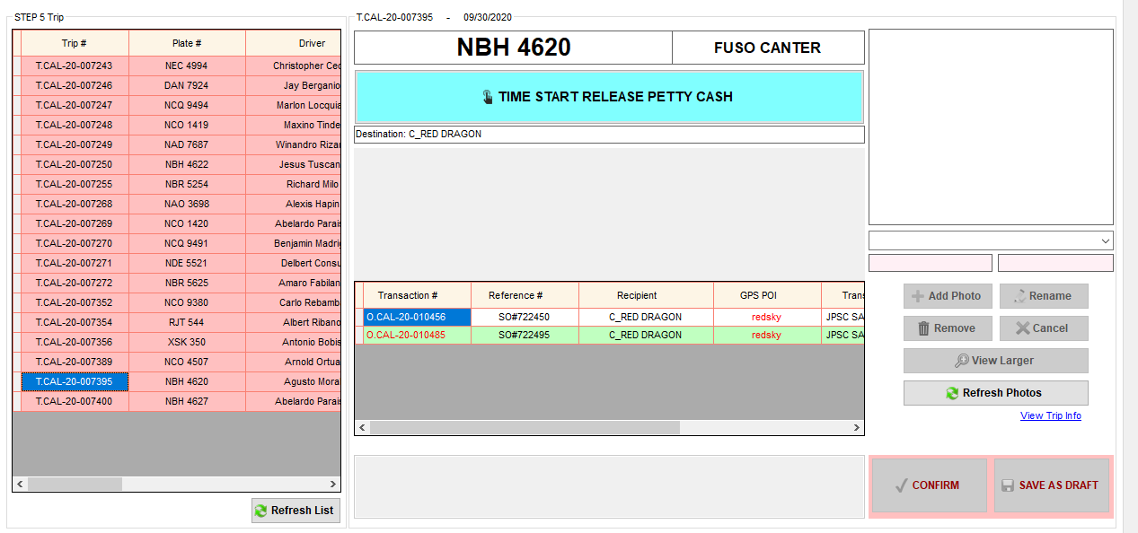Releasing of Petty Cash / Allowance / Meal Stub Form

1. Select trip number or plate number.
2. Click Time Start Release Petty Cash button.
3. Ensure the ff:

* The Petty Cash Voucher should have signature over printed name of Driver or Helper and Warehouse accounting staff.
* The Plate number in petty cash voucher should be the same as the Plate number in fleet.
* The Customer in petty cash voucher should be the same as the recipient name in fleet.

1. Then, attach the scanned copy of Petty Cash Voucher and/or Lita’s Eatery Meal Stub form.
2. Double check if all of the information is correct and complete.
3. Then, click Confirm button.
4. Then, the signature field will appear. The signatures will show that the persons involved in releasing petty cash authenticate all the information in step 5.
5. Then, the driver or helper will sign on the corresponding signature field.
6. Then, the accounting staff will sign also on the corresponding signature field.
7. Click Ok button to proceed to the next step.

Notes:

* Hindi pwede maconfirm ang Step 4 at 5 kung hindi pa na confirm ang Step 3, hanggang save as draft lang muna.
* Hindi makikita sa Step 6 ang trip kung may hindi pa nako-confirm sa Step 1 to 5.

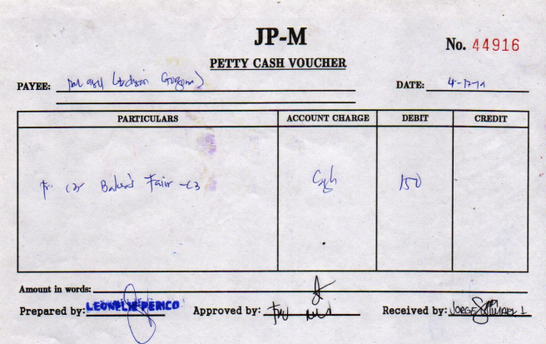**Sample Petty Cash Voucher**

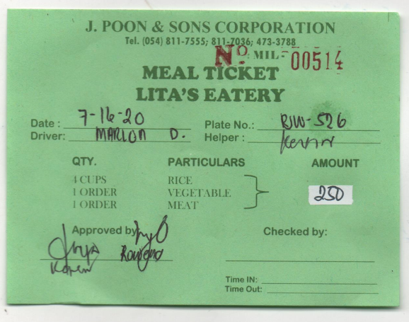**Sample Meal Stub Form**

Time Start

* Update dbo.tbldispatchsum
* dbo.tbldispatchsum.startcash – GetDate()
* dbo.tbldispatchsum.startcashby – Login Username

Add Photos and Signatures

* Add Photo to dbo.tbldispatchstp5
* dbo.tbldispatchstp5.tripnum – dbo.tbltripsum.tripnum
* dbo.tbldispatchstp5.name – Photo name
* dbo.tbldispatchstp5.img – Photo
* dbo.tbldispatchstp5.status – 1
* dbo.tbldispatchstp5.datecreated – GetDate()
* dbo.tbldispatchstp5.createdby – Login Username

Save as Draft Step 5

* Update dbo.tbldispatchsum
* dbo.tbldispatchsum.sneymstp5 – Login Username
* dbo.tbldispatchsum.sdeytstp5 – GetDate()
* dbo.tbldispatchsum.remstp5 – Remarks

Confirm Step 5

* Update dbo.tbldispatchsum
* dbo.tbldispatchsum.step5 – 1
* dbo.tbldispatchsum.namestp5 – Login Username
* dbo.tbldispatchsum.datestp5 – GetDate()
* dbo.tbldispatchsum.remstp5 – Remarks

### **STEP 6 (EXIT / IN TRANSIT / RETURN)**

* Record Time of Departure and Time of Arrival

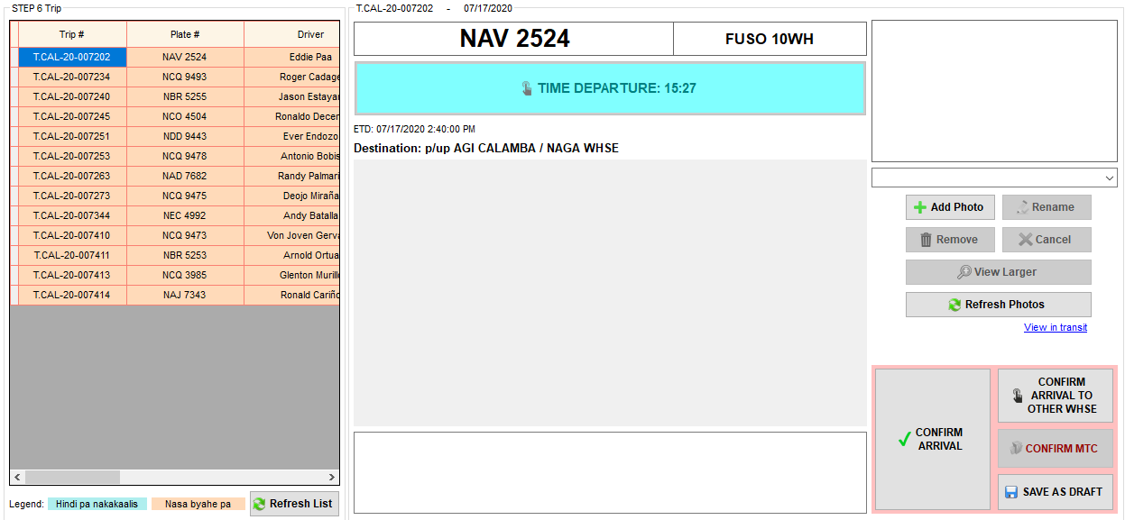

Click to view the updates or status of the transactions from the driver app. (For Manager Account only)

1. Select trip number or plate number.
2. If the truck exits the warehouse, click Time Departure button.
3. Then, input password.
4. Then, if the truck arrives at the same warehouse, click Confirm Arrival button. Otherwise, click Confirm Arrival to other warehouse button.
5. For Milaor warehouse only, if the delivery is at MTC, click the Confirm MTC button.
6. Then, input password to proceed to the next step.

Notes:

* Hindi makikita sa Step 6 ang trip kung may hindi pa nako-confirm sa Step 1 to 5.
* Pwede lang makita sa Step 7 at Step 8 ang trip once na ma-arrival na sa Step 6.

Time Start

* If Vehicle type is CUSTOMER TRUCK
* Update dbo.tbldispatchsum
* dbo.tbldispatchsum.timedep – GetDate()
* dbo.tbldispatchsum.timedepby – Login Username
* dbo.tbldispatchsum.step6 – 1
* dbo.tbldispatchsum.namestp6 – Login Username
* dbo.tbldispatchsum.datestp6 – GetDate()
* dbo.tbldispatchsum.remstp6 – Remarks
* If Vehicle type is TRUCKING TRUCK and transaction type is not Stock Transfer
* Update dbo.tbldispatchsum
* dbo.tbldispatchsum.timedep – GetDate()
* dbo.tbldispatchsum.timedepby – Login Username
* dbo.tbldispatchsum.step6 – 1
* dbo.tbldispatchsum.namestp6 – Login Username
* dbo.tbldispatchsum.datestp6 – GetDate()
* dbo.tbldispatchsum.remstp6 – ‘MTC’
* Others
* Update dbo.tbldispatchsum
* dbo.tbldispatchsum.timedep – GetDate()
* dbo.tbldispatchsum.timedepby – Login Username
* dbo.tbldispatchsum.remstp6 – Remarks

Add Photos

* Add Photo to dbo.tbldispatchstp6
* dbo.tbldispatchstp6.tripnum – dbo.tbltripsum.tripnum
* dbo.tbldispatchstp6.name – Photo name
* dbo.tbldispatchstp6.img – Photo
* dbo.tbldispatchstp6.status – 1
* dbo.tbldispatchstp6.datecreated – GetDate()
* dbo.tbldispatchstp6.createdby – Login Username

Save as Draft Step 6

* Update dbo.tbldispatchsum
* dbo.tbldispatchsum.sneymstp6 – Login Username
* dbo.tbldispatchsum.sdeytstp6 – GetDate()
* dbo.tbldispatchsum.remstp6 – Remarks

Confirm Arrival

* Update dbo.tbldispatchsum
* dbo.tbldispatchsum.step6 – 1
* dbo.tbldispatchsum.arrwhse – Login Warehouse
* dbo.tbldispatchsum.namestp6 – Login Username
* dbo.tbldispatchsum.datestp6 – GetDate()
* dbo.tbldispatchsum.remstp6 – Remarks
* Add vehicle to dbo.tblmscheckup (For Motorpool Inspection List)
* dbo.tblmscheckup.tripnum – Trip#
* dbo.tblmscheckup.platenum – Plate#
* dbo.tblmscheckup.tcondition
* 0 – For Inspection
* Insert into dbo.tbltripevent (Check GPS if there are driving behavior violations)
* dbo.tbltripevent.tripnum – Trip#
* dbo.tbltripevent.remarks – Remarks
* Insert into dbo.tbltripeventlogs (Save driving behavior violations based on Manila GPS, events like speeding and harsh_driving)
* dbo.tbltripeventlogs.id – dbo.tbltripevent.id
* dbo.tbltripeventlogs.eventid – GPS event ID
* dbo.tbltripeventlogs.eventtime – GPS Event Date and Time
* dbo.tbltripeventlogs.eventname – GPS Event Name
* dbo.tbltripeventlogs.eventaddress – GPS Event Address
* dbo.tbltripeventlogs.message – GPS Event Message

Confirm Arrival to other Whse

* Update dbo.tbldispatchsum
* dbo.tbldispatchsum.step6 – 1
* dbo.tbldispatchsum.arrwhse – Choose Warehouse where the truck arrived
* dbo.tbldispatchsum.namestp6 – Login Username
* dbo.tbldispatchsum.datestp6 – GetDate()
* dbo.tbldispatchsum.remstp6 – Remarks
* Add vehicle to dbo.tblmscheckup (For Motorpool Inspection List)
* dbo.tblmscheckup.tripnum – Trip#
* dbo.tblmscheckup.platenum – Plate#
* dbo.tblmscheckup.tcondition
* 0 – For Inspection
* Insert into dbo.tbltripevent (Check GPS if there are driving behavior violations)
* dbo.tbltripevent.tripnum – Trip#
* dbo.tbltripevent.remarks – Remarks
* Insert into dbo.tbltripeventlogs (Save driving behavior violations based on Manila GPS, events like speeding and harsh_driving)
* dbo.tbltripeventlogs.id – dbo.tbltripevent.id
* dbo.tbltripeventlogs.eventid – GPS event ID
* dbo.tbltripeventlogs.eventtime – GPS Event Date and Time
* dbo.tbltripeventlogs.eventname – GPS Event Name
* dbo.tbltripeventlogs.eventaddress – GPS Event Address
* dbo.tbltripeventlogs.message – GPS Event Message

Confirm MTC

* Update dbo.tbldispatchsum
* dbo.tbldispatchsum.timedep – GetDate()
* dbo.tbldispatchsum.timedepby – Login Username
* dbo.tbldispatchsum.step6 - 1
* dbo.tbldispatchsum.namestp6 – Login Username
* dbo.tbldispatchsum.datestp6 – GetDate()
* dbo.tbldispatchsum.remstp6 – ‘MTC’
* Add vehicle to dbo.tblmscheckup (For Motorpool Inspection List)
* dbo.tblmscheckup.tripnum – Trip#
* dbo.tblmscheckup.platenum – Plate#
* dbo.tblmscheckup.tcondition
* 0 – For Inspection
* Insert into dbo.tbltripevent (Check GPS if there are driving behavior violations)
* dbo.tbltripevent.tripnum – Trip#
* dbo.tbltripevent.remarks – Remarks
* Insert into dbo.tbltripeventlogs (Save driving behavior violations based on Manila GPS, events like speeding and harsh_driving)
* dbo.tbltripeventlogs.id – dbo.tbltripevent.id
* dbo.tbltripeventlogs.eventid – GPS event ID
* dbo.tbltripeventlogs.eventtime – GPS Event Date and Time
* dbo.tbltripeventlogs.eventname – GPS Event Name
* dbo.tbltripeventlogs.eventaddress – GPS Event Address
* dbo.tbltripeventlogs.message – GPS Event Message

### **STEP 7 (RETURN DOCUMENTS)**

* 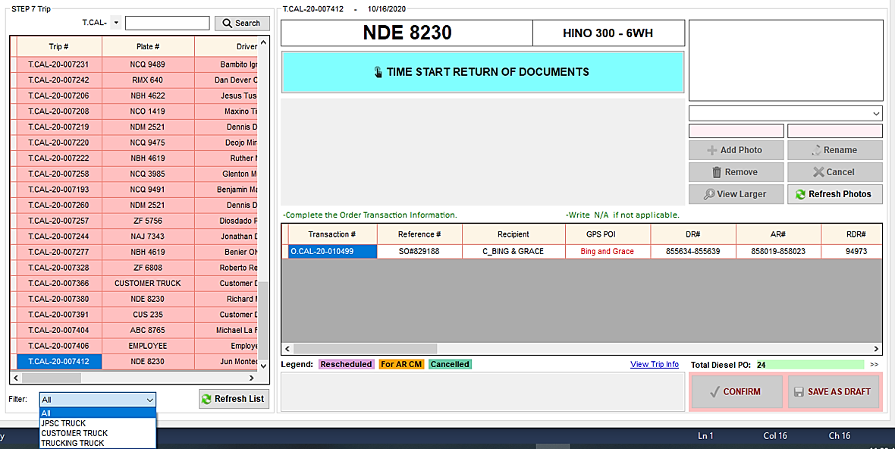To ensure that all of the items are received by the recipient and to keep all other documents such as driver's expense report and diesel receipt.

1. Select trip number or plate number.
2. Click Time Start Return Documents button.
3. Ensure the ff:

* Delivery Stamp should be filled out completely by the Driver.
* No Delivery Stamp if Customer Truck, Trucking Truck and charge to Employee.
* Kapag iisang tao lang ang mag rereceive ng maraming resibo, pwedeng isa lang dun ang may Delivery Stamp.
* Pwedeng wala ng delivery stamp if may details si driver sa app (Arrival and odometer sa customer).
* All warehouse except Calamba: Attach Diesel Receipt
* If in-house Diesel no need to attach diesel receipt
* Diesel quantity in the receipt should be the same as the Total Diesel PO.
* The Plate number in Diesel Receipt should be the same as the Plate number in fleet.
* If Diesel PO is cancelled
* If Change PO, attach the Cancelled Diesel Receipt and the Diesel Receipt of the new PO.
* If hindi na nag diesel ang truck, attach the Cancelled Diesel Receipt and input remarks na hindi na nag diesel or just simply input remarks Cancelled PO Diesel hindi na nag diesel.
* If the items are delivered via **Shipping Lines**, attach the Delivery Order document received by the consignee.

How to check if the trip has a delivery via shipping lines

* If the transaction type is **SALES TRANSACTION**
* The Receipt should have signature over printed name of Driver or Helper.
* The Receipt should have signature over printed name of customer.
* If the Receipt is signed by the owner, it’s ok If signature only or printed name only, just input remarks.
* If there is already a Check or Cash payment, it’s ok if no signature or printed name of the customer, just remarks, with Check or with Cash.
* The DR# in Delivery Receipt should be the same as the DR# in fleet.
* Attach AR receipt if the customer signed on that receipt and not on the DR.
* If charge to Employee, attach AR and remarks LBR#.
* If the transaction type is **STOCK TRANSFER PICKUP FRM PIER**
* The SWS should have signature over printed name of Driver or Helper.
* The SWS should have signature over printed name of receiving checker, start and end time of unloading, and number of labors.
* The SWS# in Stock Withdrawal Slip should be the same as the SWS# in fleet.
* If the transaction type is **STOCK TRANSFER PICKUP FRM AGI**
* The DN should have signature over printed name of Driver or Helper.
* The DN should have signature over printed name of receiving checker, start and end time of unloading, and number of labors.
* The DN# in Delivery Note should be the same as the DN# in fleet.
* If the transaction type is **STOCK TRANSFER PICKUP FRM OTHER SUPPLIER**
* The receipt should have signature over printed name of Driver or Helper.
* The receipt should have signature over printed name of receiving checker, start and end time of unloading, and number of labors.
* If the transaction type is **STOCK TRANSFER WHSE TO WHSE**
* The Stock Transfer Request Form (also ITR Form) should have signature over printed name of Driver or Helper.
* The ITR should have signature over printed name of receiving checker, start and end time of unloading, and number of labors.
* The ITR# in Stock Transfer Request Form should be the same as the ITR# in fleet.
* Driver’s Expense Report
* The Driver’s Expense Report should have signature over printed name of Driver or Helper and accounting Staff.
* The Plate number, Driver or Helper name and Customer name should be the same as the Plate number, Driver or Helper name and Recipient name in fleet.
* The breakdown should be equal to the total amount of expenses.
* If Returned cash, no need of expense report, just remarks.
* Edit TO FOLLOW reference numbers / SAP numbers.

How to edit TO FOLLOW Reference#

* Odometer Reading is required unless Rescheduled / For AR CM / Cancelled transaction.
* 0 (zero) input is not allowed
* For Plate#: CUSTOMER TRUCK, TRUCKING TRUCK, PPDE and EMPLOYEE, automatic the odometer is N/A.

1. If there is a transaction that you need to reschedule, see Reschedule a transaction.
2. If there is a transaction that is for AR credit memo, see For AR Credit Memo transaction.
3. If there is a transaction that is cancelled, see Cancel a transaction.
4. Then, fill out the necessary information in the fleet such as AR#, RDR#, DR#, DN#, ITR#, IT#, GRPO#, odometer reading.
5. Then, attach the scanned copy of Delivery Receipt with DR Stamp details and/or Stock Withdrawal Slip and/or Stock Transfer Request form and/or Delivery Note received by the recipient. Attach also the Driver’s Expense Report.
6. If there is an additional transaction for the truck while it is in-transit, that additional transaction shall be added to the existing trip.
7. Double check if all of the information is correct and complete.
8. Then, click Confirm button.
9. Then, the signature field will appear. The signatures will show that the persons involved in returning documents authenticate all the information in step 7.
10. Then, the driver or helper will sign on the corresponding signature field.
11. Then, the encoder will sign also on the corresponding signature field.
12. Click Ok button to proceed to the next step.

Notes:

* Pwede maihabol sa Step 9 kung hindi na check ang Reschedule or for AR CM / Cancelled ang transaction.
* Pwede lang makita sa Step 7 at Step 8 ang trip once na ma-arrival na sa Step 6.
* Makikita sa Step 7 ang mga in-add to existing ng naka-departure ang truck.
* For Calamba warehouse only: Hindi makikita sa Step 9 ang trip kung hindi pa nako-confirm sa Step 8.
* All warehouse except Calamba: Hindi makikita sa Step 9 ang trip kung hindi pa nako-confirm sa Step 7 and 8.

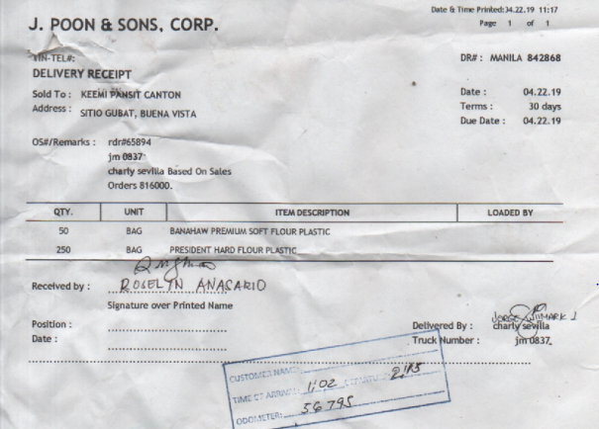**Sample Delivery Receipt**

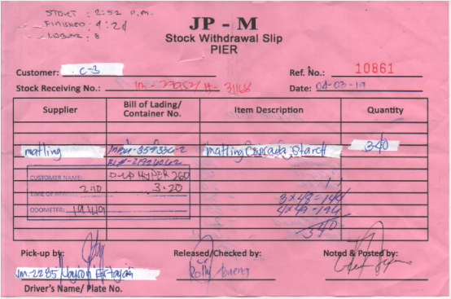**Sample Stock Withdrawal Slip**

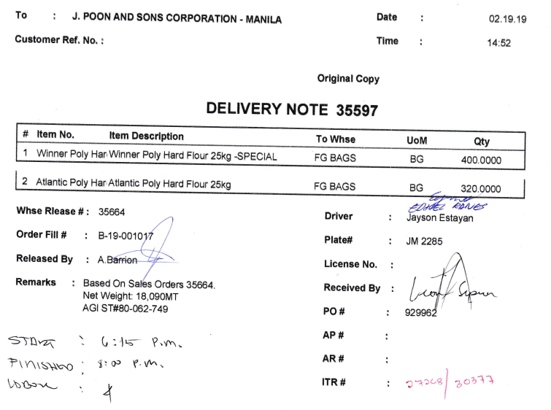**Sample Delivery Note**

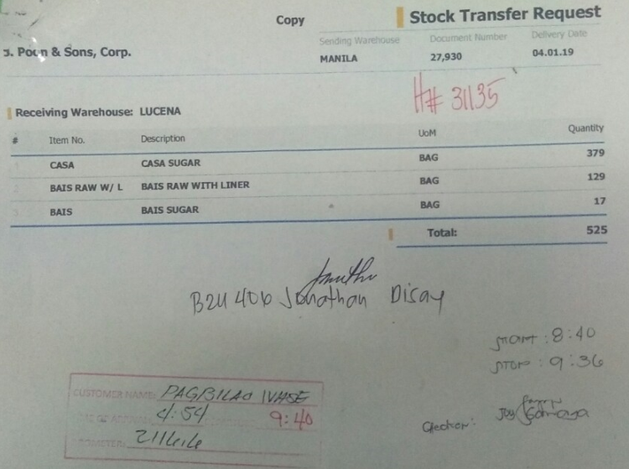**Sample Stock Transfer Request Form**

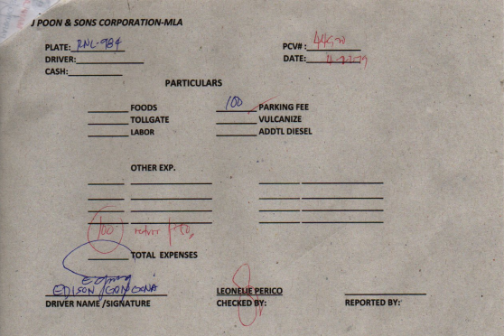**Sample Driver’s Expense Report**

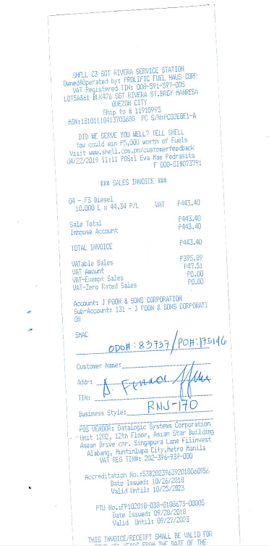**Sample Diesel Receipt**

Time Start

* Update dbo.tbldispatchsum
* dbo.tbldispatchsum.startreturn – GetDate()
* dbo.tbldispatchsum.startreturnby – Login Username

Add Photos and Signatures

* Add Photo to dbo.tbldispatchstp7
* dbo.tbldispatchstp7.tripnum – dbo.tbltripsum.tripnum
* dbo.tbldispatchstp7.name – Photo name
* dbo.tbldispatchstp7.img – Photo
* dbo.tbldispatchstp7.status – 1
* dbo.tbldispatchstp7.datecreated – GetDate()
* dbo.tbldispatchstp7.createdby – Login Username

Edit Reference#

* Update dbo.tblortrans
* dbo.tblortrans.sonum – if SO#
* dbo.tblortrans.ponum – if PO#
* dbo.tblortrans.itrnum – if ITR#
* dbo.tblortrans.sws – if SWS#
* Add Logs to dbo.tbloredit
* dbo.tbloredit.transid – dbo.tblortrans.transid
* dbo.tbloredit.transnum – dbo.tblortrans.transnum
* dbo.tbloredit.customer – dbo.tblortrans.customer
* dbo.tbloredit.prevso – Previous SO#
* dbo.tbloredit.newso – New SO#
* dbo.tbloredit.prevpo – Previous PO#
* dbo.tbloredit.newpo – New PO#
* dbo.tbloredit.previtr – Previous ITR#
* dbo.tbloredit.newitr – New ITR#
* dbo.tbloredit.prevsws – Previous SWS#
* dbo.tbloredit.newsws – New SWS#
* dbo.tbloredit.datecreated – GetDate()
* dbo.tbloredit.createdby – Login Username
* dbo.tbloredit.status – 1

Reschedule Transaction

* Checked
* Update dbo.tbltripitems
* dbo.tbltripitems.status – 4
* dbo.tbltripitems.cancelby – Login Username
* dbo.tbltripitems.canceldate – GetDate()
* Update dbo.tblortrans
* dbo.tblortrans.status – 1
* Unchecked
* Update dbo.tbltripitems
* dbo.tbltripitems.status – 1
* dbo.tbltripitems.cancelby – Login Username
* dbo.tbltripitems.canceldate – GetDate()
* Update dbo.tblortrans
* dbo.tblortrans.status – 0

For AR Credit Memo Transaction

* Checked
* Update dbo.tbltripitems
* dbo.tbltripitems.status – 5
* dbo.tbltripitems.cancelby – Login Username
* dbo.tbltripitems.canceldate – GetDate()
* Unchecked
* Update dbo.tbltripitems
* dbo.tbltripitems.status – 1
* dbo.tbltripitems.cancelby – Login Username
* dbo.tbltripitems.canceldate – GetDate()

For Cancelled Transaction

* Checked
* Update dbo.tbltripitems
* dbo.tbltripitems.status – 6
* dbo.tbltripitems.cancelby – Login Username
* dbo.tbltripitems.canceldate – GetDate()
* Unchecked
* Update dbo.tbltripitems
* dbo.tbltripitems.status – 1
* dbo.tbltripitems.cancelby – Login Username
* dbo.tbltripitems.canceldate – GetDate()

Save as Draft Step 7

* Update dbo.tblortrans
* dbo.tblortrans.arnum – AR#
* dbo.tblortrans.rdrnum – RDR#
* dbo.tblortrans.drnum – DR#
* dbo.tblortrans.dnnum – DN#
* dbo.tblortrans.itrnum – ITR#
* dbo.tblortrans.itnum – IT#
* dbo.tblortrans.grponum – GRPO#
* dbo.tblortrans.datemodified – GetDate()
* dbo.tblortrans.modifiedby – Login Username
* Update dbo.tbldispatchsum
* dbo.tbldispatchsum.sneymstp7 – Login Username
* dbo.tbldispatchsum.sdeytstp7 – GetDate()
* dbo.tbldispatchsum.remstp7 – Remarks
* Update tbltripitems
* dbo.tbltripitems.cusodo – odometer

Confirm Step 7

* Update dbo.tblortrans
* dbo.tblortrans.arnum – AR#
* dbo.tblortrans.rdrnum – RDR#
* dbo.tblortrans.drnum – DR#
* dbo.tblortrans.dnnum – DN#
* dbo.tblortrans.itrnum – ITR#
* dbo.tblortrans.itnum – IT#
* dbo.tblortrans.grponum – GRPO#
* dbo.tblortrans.datemodified – GetDate()
* dbo.tblortrans.modifiedby – Login Username
* Update dbo.tbldispatchsum
* dbo.tbldispatchsum.withpending – 0
* dbo.tbldispatchsum.step7 – 1
* dbo.tbldispatchsum.namestp7 – Login Username
* dbo.tbldispatchsum.datestp7 – GetDate()
* dbo.tbldispatchsum.remstp7 – Remarks
* Update tbltripitems
* dbo.tbltripitems.cusodo – odometer

#### **Reschedule a transaction**

Ang mga transaction na nire-reschedule ay ang mga sumusunod:

* Naibyahe na ng truck ang items pero pag dating sa destination ay nasaraduhan na or hindi na natuloy. Bumalik ng warehouse at idedeliver pa sa ibang araw ang items.
* Nasiraan ang truck at inilipat sa ibang truck para ituloy ang delivery.

How to reschedule a transaction

1. Input remarks why do you need to reschedule the transaction.
2. Tick the corresponding Reschedule checkbox of the transaction.
3. Authentication required. Input password.
4. Click Ok.
5. Transaction will be highlighted into violet.
6. The Rescheduled transaction will become available again for trip scheduling.

Notes:

* Cannot unchecked Reschedule checkbox if the transaction is already added to another trip number.
* Cannot tick Reschedule checkbox if For AR Credit Memo checkbox or Cancel checkbox is checked.
* No attachment of receipt because the items are not successfully delivered.

#### **For AR Credit Memo transaction**

Ang mga transaction na for AR credit memo ay ang mga sumusunod:

* All quantity in AR is for credit memo due to wrong price or wrong item.
* Naibyahe na ng truck ang items pero the customer refuse to receive the items dahil maaaring may bukbok, basa or hindi nagustuhan yung condition ng items and all quantity in AR is for credit memo.

How to set a For AR credit memo transaction

1. Input remarks why do you need to set the transaction for AR credit memo.
2. Tick the corresponding For AR credit memo checkbox of the transaction.
3. Authentication required. Input password.
4. Click Ok.
5. Transaction will be highlighted into orange.

Notes:

* AR# should not be empty.
* The For AR credit memo transaction will NOT become available again for trip scheduling.
* Cannot tick For AR credit memo checkbox if Reschedule checkbox or Cancel checkbox is checked.
* Cannot tick For AR credit memo checkbox if the transaction type is STOCK TRANSFER or TAXI.
* No attachment of receipt because the items are not successfully delivered.

#### **Cancel a transaction**

Ang mga transaction na ika-cancel ay ang mga sumusunod:

* Nakabyahe na ang truck at doon lang nalaman na mali ang create ng order. (Need gawan ng tamang order)
* Nakabyahe na ang truck pero hindi na natuloy ang pag pick up dahil maaring nasiraan or cancel na ang pag pick up.

How to cancel a transaction

1. Input remarks why do you need to cancel the transaction.
2. Tick the corresponding Cancel checkbox of the transaction.
3. Authentication required. Input password.
4. Click Ok.
5. Transaction will be highlighted into dark green.

Notes:

* The Cancelled transaction will NOT become available again for trip scheduling.
* Cannot tick Cancel checkbox if For AR Credit Memo checkbox or Cancel checkbox is checked.
* No attachment of receipt because the transaction is cancelled.

#### **How to check if the trip has a delivery via shipping lines**

* In Trip Dispatching – STEP 7

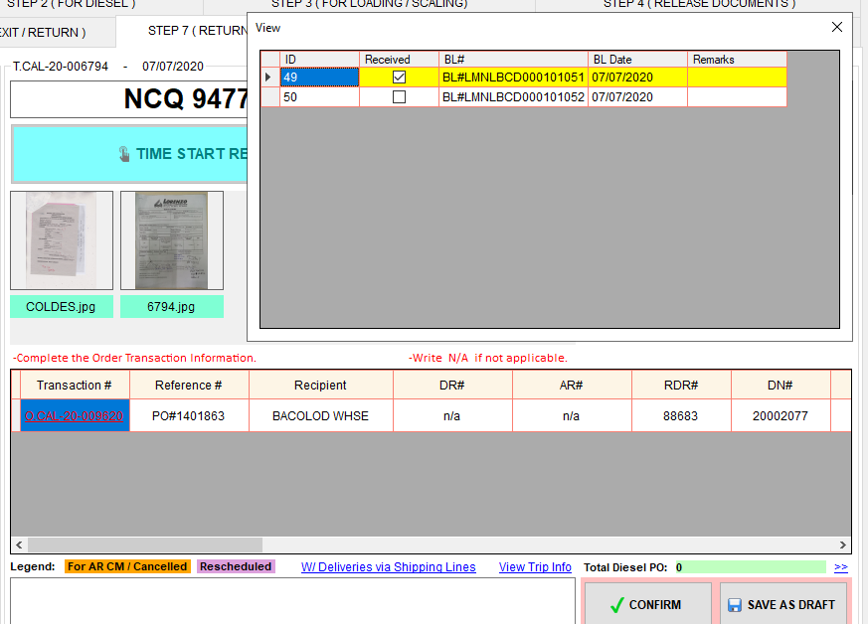

Click this link to see how many Delivery Order documents (BL# is the reference#) should be attached and if the documents are already received by the consignee.

* In Trip Dispatching Summary

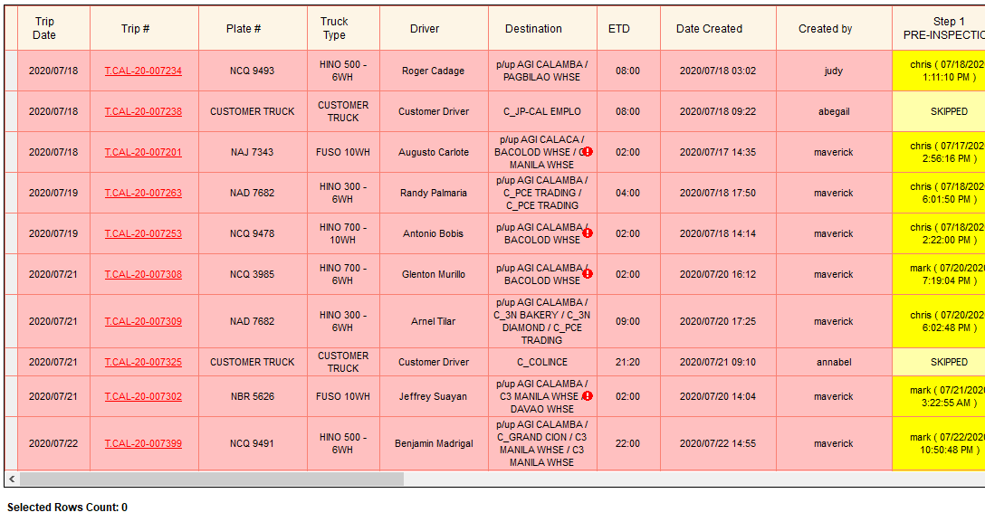

W/ Delivery via Shipping Lines

* In Trip Dispatching Summary – View Steps

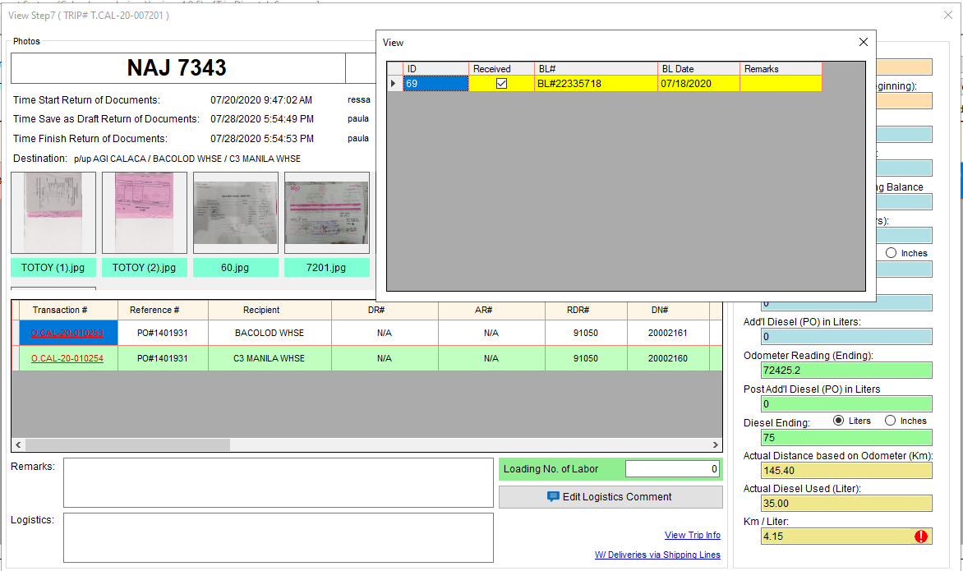

### **STEP 8 (POST-INSPECTION)**

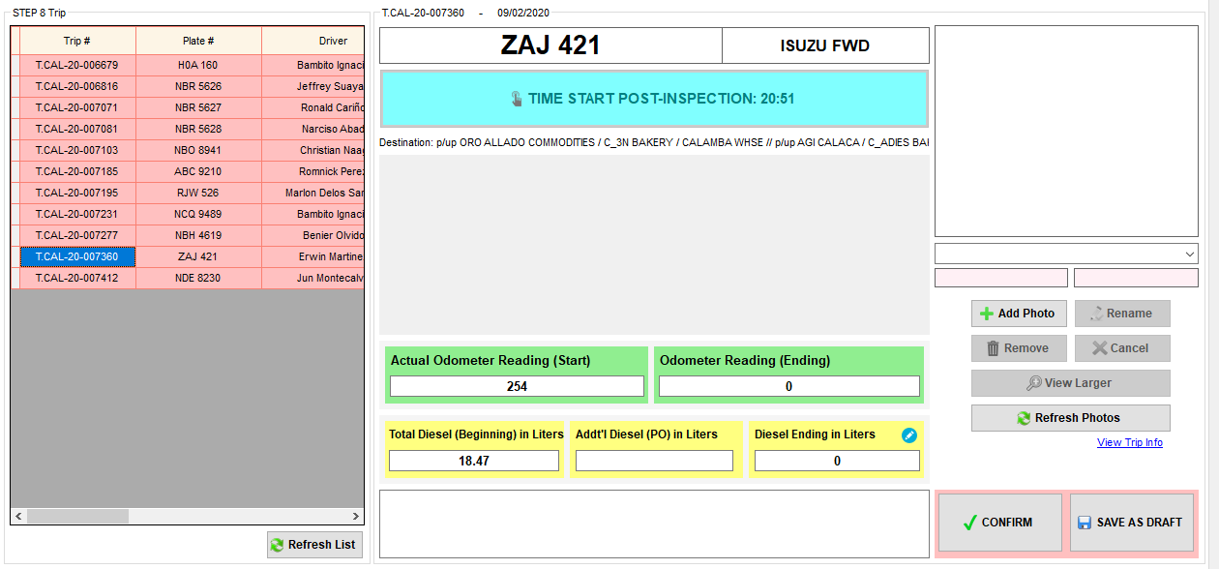

1. Select trip number or plate number.
2. Click Time Start Post-inspection button.
3. Inspect the truck and ask the driver if there is something for repair.
4. Then, input the Odometer Reading (Ending), Diesel Ending in Liters and Post-Addt’l Diesel (PO) in Liters (if there is any). Post-Additional Diesel – meaning nag pa diesel habang nasa byahe.
5. Then, attach the scanned copy of Diesel Receipt if there is a post-additional diesel.
6. Double check if all of the information is correct and complete.
7. Then, click Confirm button.
8. Then, the signature field will appear. The signatures will show that the persons involved in post-inspection authenticate all the information in step 8.
9. Then, the inspector will sign on the corresponding signature field.
10. Click Ok button to proceed to the next step.

Notes:

* Pwede i-input sa Post-Additional diesel if sobra yung nadiesel sa Step 2.
* Pwede lang makita sa Step 7 at Step 8 ang trip once na ma-arrival na sa Step 6.
* For Calamba warehouse only: Hindi makikita sa Step 9 ang trip kung hindi pa nako-confirm sa Step 8.
* All warehouse except Calamba: Hindi makikita sa Step 9 ang trip kung hindi pa nako-confirm sa Step 7 and 8.
* Kung Taxi, once na maconfirm na ang Step 8, magko-close din ang step 9 at magiging completed na ang trip.

Time Start

* Update dbo.tbldispatchsum
* dbo.tbldispatchsum.startpost – GetDate()
* dbo.tbldispatchsum.startpostby – Login Username

Add Photos and Signatures

* Add Photo to dbo.tbldispatchstp8
* dbo.tbldispatchstp8.tripnum – dbo.tbltripsum.tripnum
* dbo.tbldispatchstp8.name – Photo name
* dbo.tbldispatchstp8.img – Photo
* dbo.tbldispatchstp8.status – 1
* dbo.tbldispatchstp8.datecreated – GetDate()
* dbo.tbldispatchstp8.createdby – Login Username

Save as Draft Step 8

* Update dbo.tbltripsum
* dbo.tbltripsum.odoend – Odometer Ending
* dbo.tbltripsum.dieselend – Diesel Ending
* dbo.tbltripsum.postaddpo – Addt’l Diesel PO
* dbo.tbltripsum.datemodified – GetDate()
* dbo.tbltripsum.modifiedby – Login Username
* Update dbo.tbldispatchsum
* dbo.tbldispatchsum.sneymstp8 – Login Username
* dbo.tbldispatchsum.sdeytstp8 – GetDate()
* dbo.tbldispatchsum.remstp8 – Remarks

Confirm Step 8

* If not Taxi
* Update dbo.tbltripsum
* dbo.tbltripsum.odostart – Previous Ending Odometer
* dbo.tbltripsum.odoactual – Actual Odometer Reading
* dbo.tbltripsum.datemodified – GetDate()
* dbo.tbltripsum.modifiedby – Login Username
* Update dbo.tbldispatchsum
* dbo.tbldispatchsum.step8 – 1
* dbo.tbldispatchsum.namestp8 – Login Username
* dbo.tbldispatchsum.datestp8 – GetDate()
* dbo.tbldispatchsum.remstp8 – Remarks
* If Taxi
* Update dbo.tbltripsum
* dbo.tbltripsum.odostart – Previous Ending Odometer
* dbo.tbltripsum.odoactual – Actual Odometer Reading
* dbo.tbltripsum.datemodified – GetDate()
* dbo.tbltripsum.modifiedby – Login Username
* dbo.tbltripsum.status – 2
* Update dbo.tbldispatchsum
* dbo.tbldispatchsum.step8 – 1
* dbo.tbldispatchsum.namestp8 – Login Username
* dbo.tbldispatchsum.datestp8 – GetDate()
* dbo.tbldispatchsum.remstp8 – Remarks
* dbo.tbldispatchsum.step9 – 1
* dbo.tbldispatchsum.complete – 1

#### **Input inches in Diesel Ending in Liters**



Stick na ginagamit panukat ng diesel sa mga truck

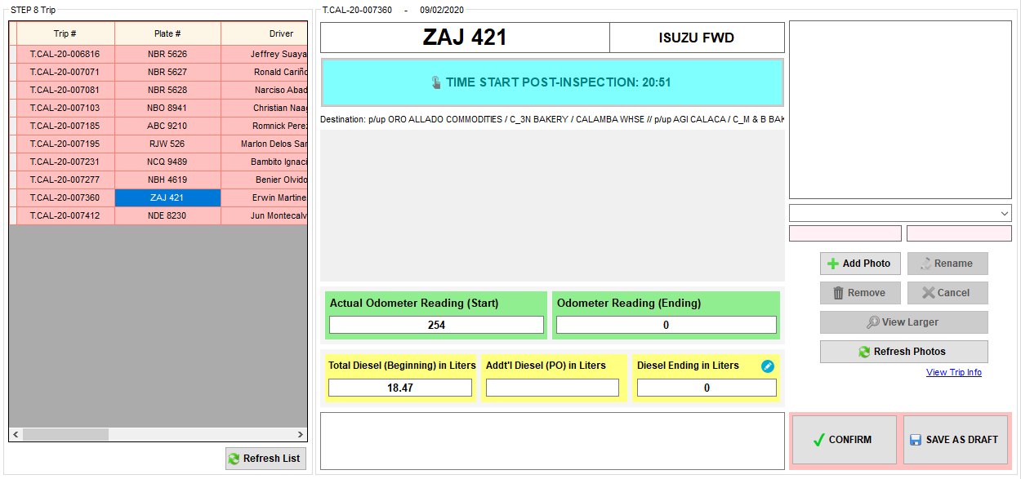

Click this icon to view the converter.

1. Click the icon beside the Actual Diesel Beg (Liters).

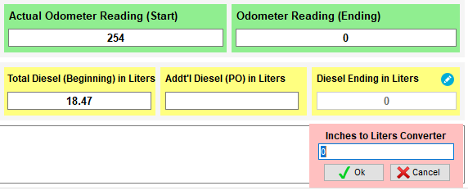

1. Input the diesel in Inches.

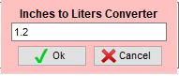

1. Click Ok button to convert.

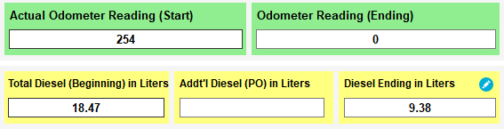

**Inches to Liters Conversion**

Plate#: **ZAJ 421**

Liter per Inch: **7.5** (dbo.tbldiesel.liter)

Diesel measurement in Inches: **1.2**

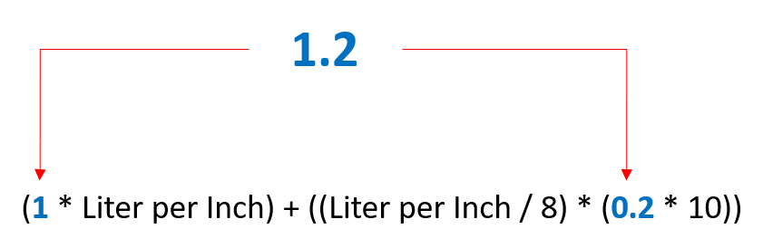

= (1 * 7.5) + ((7.5 / 8) * (0.2 * 10)

= (7.5) + (0.9375 * 2)

= 7.5 + 1.875

= 9.375

Actual Diesel Beg (Liters) = **9.38 Liters**

### **STEP 9 (RECORDING)**

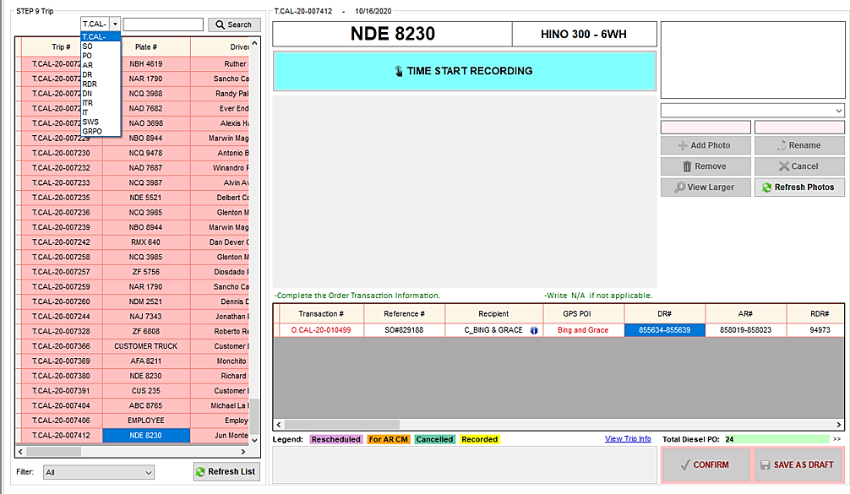

Transactions with this icon are transactions to be recorded by LC Accounting Staff or AGI Accounting Staff or another warehouse. Just move the mouse pointer on the icon to see whose account is this.

1. Select trip number or plate number.
2. Click Time Start Recording button.
3. Ensure the ff:

* Cannot confirm if there is a TO FOLLOW reference number unless Rescheduled transaction or For AR CM / Cancelled Transaction. Input the final reference numbers.

How to edit TO FOLLOW Reference#

* Odometer Reading is required unless Reschedule / For AR CM / Cancelled transaction.
* 0 (zero) input is not allowed
* For Plate#: CUSTOMER TRUCK, TRUCKING TRUCK, PPDE and EMPLOYEE, automatic the odometer is N/A.
* For Calamba warehouse only: Attach Diesel Receipt
* Diesel quantity in the receipt should be the same as the Total Diesel PO.
* The Plate number in Diesel Receipt should be the same as the Plate number in fleet.
* If Diesel PO is cancelled
* If Change PO, attach the Cancelled Diesel Receipt and the Diesel Receipt of the new PO.
* If hindi na nag diesel ang truck, attach the Cancelled Diesel Receipt and input remarks na hindi na nag diesel.
* If the transaction type is **JPSC STOCK TRANSFER PICK UP**
* Warehouse staff will record this transaction.
* If pick up from AGI – there should be PO#, RDR#, DN#, ITR#, IT#. The rest is N/A.
* If pick up from PIER – there should be SWS#, ITR#, IT#. The rest is N/A.
* If pick up from LUDO/NECO – there should be RDR#, GRPO#. The rest is N/A.
* If pick up from Other Supplier – there should be RDR#, ITR#, IT#. The rest is N/A.
* If the transaction type is **JPSC STOCK TRANSFER WHSE TO WHSE**
* Warehouse staff will record this transaction.
* There should be ITR#, IT#. The rest is N/A.
* If the transaction type is **JPSC SALES TRANSACTION**
* If *No SO Direct DR only*, there should be DR# and AR#. The rest is N/A.
* If regular transaction only, there should be SO#, DR#, AR#, RDR#. The rest is N/A.
* If the transaction type is **JPSC SALES TRANSACTION PICK UP**
* If pick up from AGI only – there should be SO#, PO#, DR#, AR#, RDR#, DN#. The rest is N/A.
* If pick up from AGI and *No SO Direct DR only* – there should be PO#, DR#, AR#, RDR#, DN#. The rest is N/A.
* If pick up from PIER only – there should be SWS#, SO#, DR#, AR#, RDR#. The rest is N/A.
* If pick up from PIER and *No SO Direct DR only* – there should be SWS#, DR#, AR#, RDR#. The rest is N/A.
* If pick up from Other Supplier – there should be SO#, DR#, AR#, RDR#. The rest is N/A.
* If the transaction type is **JPSC TRUCKING FOR OTHERS PICK UP**
* There should be SO#, DR#, AR#. The rest is N/A.
* If the transaction type is **JPSC TAXI**
* The rest is N/A.
* If the transaction type is **CUSTOMER SALES TRANSACTION WHSE**
* If *No SO Direct DR only*, there should be DR# and AR#. The rest is N/A.
* If regular transaction only, there should be SO#, DR#, AR#, RDR#. The rest is N/A.
* If the transaction type is **CUSTOMER SALES TRANSACTION PICK UP FRM**
* If pick up from AGI only – there should be SO#, PO#, DR#, AR#, RDR#, DN#. The rest is N/A.
* If pick up from AGI and *No SO Direct DR only* – there should be PO#, DR#, AR#, RDR#, DN#. The rest is N/A.
* If pick up from PIER only – there should be SWS#, SO#, DR#, AR#, RDR#. The rest is N/A.
* If pick up from PIER and *No SO Direct DR only* – there should be SWS#, DR#, AR#, RDR#. The rest is N/A.
* If pick up from Other Supplier – there should be SO#, DR#, AR#, RDR#. The rest is N/A.
* If transaction type is **TRUCKING STOCK TRANSFER PICK UP FRM**
* Warehouse staff will record this transaction.
* If pick up from AGI – there should be PO#, RDR#, DN#, ITR#, IT#. The rest is N/A.
* If pick up from PIER – there should be SWS#, ITR#, IT#. The rest is N/A.
* If pick up from LUDO/NECO – there should be RDR#, GRPO#. The rest is N/A.
* If pick up from Other Supplier – there should be RDR#, ITR#, IT#. The rest is N/A.
* If the transaction type is **TRUCKING STOCK TRANSFER WHSE TO WHSE**
* Warehouse staff will record this transaction.
* There should be ITR#, IT#. The rest is N/A.
* If transaction type is **TRUCKING SALES TRANSACTION WHSE**
* If *No SO Direct DR only*, there should be DR# and AR#. The rest is N/A.
* If regular transaction only, there should be SO#, DR#, AR#, RDR#. The rest is N/A.
* If the transaction type is **TRUCKING SALES TRANSACTION PICK UP**
* If pick up from AGI only – there should be SO#, PO#, DR#, AR#, RDR#, DN#. The rest is N/A.
* If pick up from AGI and *No SO Direct DR only* – there should be PO#, DR#, AR#, RDR#, DN#. The rest is N/A.
* If pick up from PIER only – there should be SWS#, SO#, DR#, AR#, RDR#. The rest is N/A.
* If pick up from PIER and *No SO Direct DR only* – there should be SWS#, DR#, AR#, RDR#. The rest is N/A.
* If pick up from Other Supplier – there should be SO#, DR#, AR#, RDR#. The rest is N/A.
* If the transaction is **account of Pagbilao or Milaor warehouse**, since they don’t have access in calamba fleet, just attach the transmittal of the receipts signed by the consignee. This will serve as a proof that they already recorded those receipts.
* If the transaction is **account of Manila warehouse**, attach the transmittal of the receipts before you send it to them. LC Accounting Staff will access to Step 9 to record it.
* If the transaction is **account of AGI**, attach the transmittal of the receipts before you send it to them. AGI Accounting Staff will access to Step 9 to record it.
* If the transaction is **PPDE**, since the receipts will be given to the sales admin, just attach the transmittal of the receipts signed by the consignee. This will serve as a proof that they already recorded those receipts.

1. If there is a transaction that you need to reschedule, see Reschedule a transaction.
2. If there is a transaction that is for AR credit memo, see For AR Credit Memo transaction.
3. If there is a transaction that is cancelled, see Cancel a transaction.
4. If you want to record a single transaction, just tick the corresponding Recorded checkbox,

* Make sure to double check the numbers in the fleet to the numbers in the SAP before checking the Recorded checkbox.
* Once na nacheck na ito, hindi na pwede i-edit ang mga numbers sa transaction, unless i-uncheck ng nagrecorded.

1. Double check if all of the information is correct and complete.
2. Check if you received the original copy of the Receipt.
3. Put the receipts to the corresponding accounts envelope.
4. Then, click Confirm button.
5. Then, input password to complete the trip transaction.

Notes:

* Pwede maihabol sa Step 9 kung hindi na check ang Reschedule or for AR CM / Cancelled ang transaction.
* For Calamba warehouse only: Hindi makikita sa Step 9 ang trip kung hindi pa nako-confirm sa Step 8.
* All warehouse except Calamba: Hindi makikita sa Step 9 ang trip kung hindi pa nako-confirm sa Step 7 and 8.
* Search by Trip# or SAP#
* Filter by Warehouse or Accounting Staff

If LC Accounting Staff / AGI Accounting Staff ang mag ko close ng Step 9

1. Step 9 lang ang kayang ma access.
2. Sa Step 9, ang pwede lang ma access ay Recorded checkbox, Remarks field, Save as Draft button at Confirm button, maliban dun ay Access Denied na.

Time Start

* Update dbo.tbldispatchsum
* dbo.tbldispatchsum.startrecord – GetDate()
* dbo.tbldispatchsum.startrecordby – Login Username

Add Photos and Signatures

* Add Photo to dbo.tbldispatchstp9
* dbo.tbldispatchstp9.tripnum – dbo.tbltripsum.tripnum
* dbo.tbldispatchstp9.name – Photo name
* dbo.tbldispatchstp9.img – Photo
* dbo.tbldispatchstp9.status – 1
* dbo.tbldispatchstp9.datecreated – GetDate()
* dbo.tbldispatchstp9.createdby – Login Username

Edit Reference#

* Update dbo.tblortrans
* dbo.tblortrans.sonum – if SO#
* dbo.tblortrans.ponum – if PO#
* dbo.tblortrans.itrnum – if ITR#
* dbo.tblortrans.sws – if SWS#
* Add Logs to dbo.tbloredit
* dbo.tbloredit.transid – dbo.tblortrans.transid
* dbo.tbloredit.transnum – dbo.tblortrans.transnum
* dbo.tbloredit.customer – dbo.tblortrans.customer
* dbo.tbloredit.prevso – Previous SO#
* dbo.tbloredit.newso – New SO#
* dbo.tbloredit.prevpo – Previous PO#
* dbo.tbloredit.newpo – New PO#
* dbo.tbloredit.previtr – Previous ITR#
* dbo.tbloredit.newitr – New ITR#
* dbo.tbloredit.prevsws – Previous SWS#
* dbo.tbloredit.newsws – New SWS#
* dbo.tbloredit.datecreated – GetDate()
* dbo.tbloredit.createdby – Login Username
* dbo.tbloredit.status – 1

Reschedule Transaction

* Checked
* Update dbo.tbltripitems
* dbo.tbltripitems.status – 4
* dbo.tbltripitems.cancelby – Login Username
* dbo.tbltripitems.canceldate – GetDate()
* Update dbo.tblortrans
* dbo.tblortrans.status – 1
* Unchecked
* Update dbo.tbltripitems
* dbo.tbltripitems.status – 1
* dbo.tbltripitems.cancelby – Login Username
* dbo.tbltripitems.canceldate – GetDate()
* Update dbo.tblortrans
* dbo.tblortrans.status – 0

For AR CM Transaction

* Checked
* Update dbo.tbltripitems
* dbo.tbltripitems.status – 5
* dbo.tbltripitems.cancelby – Login Username
* dbo.tbltripitems.canceldate – GetDate()
* Unchecked
* Update dbo.tbltripitems
* dbo.tbltripitems.status – 1
* dbo.tbltripitems.cancelby – Login Username
* dbo.tbltripitems.canceldate – GetDate()

Cancelled Transaction

* Checked
* Update dbo.tbltripitems
* dbo.tbltripitems.status – 6
* dbo.tbltripitems.cancelby – Login Username
* dbo.tbltripitems.canceldate – GetDate()
* Unchecked
* Update dbo.tbltripitems
* dbo.tbltripitems.status – 1
* dbo.tbltripitems.cancelby – Login Username
* dbo.tbltripitems.canceldate – GetDate()

Record specific transaction only

* Checked
* Update dbo.tbltripitems
* dbo.tbltripitems.status – 2
* dbo.tbltripitems.cancelby – Login Username
* dbo.tbltripitems.canceldate – GetDate()
* Update dbo.tblortrans
* dbo.tblortrans.status – 2
* Unchecked
* Update dbo.tbltripitems
* dbo.tbltripitems.status – 1
* dbo.tbltripitems.cancelby – Login Username
* dbo.tbltripitems.canceldate – GetDate()
* Update dbo.tblortrans
* dbo.tblortrans.status – 0

Save as Draft Step 9

* Update dbo.tblortrans
* dbo.tblortrans.arnum – AR#
* dbo.tblortrans.rdrnum – RDR#
* dbo.tblortrans.drnum – DR#
* dbo.tblortrans.dnnum – DN#
* dbo.tblortrans.itrnum – ITR#
* dbo.tblortrans.itnum – IT#
* dbo.tblortrans.grponum – GRPO#
* dbo.tblortrans.datemodified – GetDate()
* dbo.tblortrans.modifiedby – Login Username
* Update dbo.tbldispatchsum
* dbo.tbldispatchsum.sneymstp9 – Login Username
* dbo.tbldispatchsum.sdeytstp9 – GetDate()
* dbo.tbldispatchsum.remstp9 – Remarks
* Update tbltripitems
* dbo.tbltripitems.cusodo – odometer
* Insert tblsdraftstp9

Confirm Step 9

* Update dbo.tblortrans
* dbo.tblortrans.arnum – AR#
* dbo.tblortrans.rdrnum – RDR#
* dbo.tblortrans.drnum – DR#
* dbo.tblortrans.dnnum – DN#
* dbo.tblortrans.itrnum – ITR#
* dbo.tblortrans.itnum – IT#
* dbo.tblortrans.grponum – GRPO#
* dbo.tblortrans.datemodified – GetDate()
* dbo.tblortrans.modifiedby – Login Username
* dbo.tblortrans.status – 2 (applicable only if the transaction is not yet recorded)
* Update dbo.tbldispatchsum
* dbo.tbldispatchsum.complete – 1
* dbo.tbldispatchsum.step9 – 1
* dbo.tbldispatchsum.namestp9 – Login Username
* dbo.tbldispatchsum.datestp9 – GetDate()
* dbo.tbldispatchsum.remstp9 – Remarks
* Update dbo.tbltripitems
* dbo.tbltripitems.cusodo – odometer
* dbo.tbltripitems.status – 2 (applicable only if dbo.tbltripitems.status is 1)
* dbo.tbltripitems.datemodified – GetDate()
* dbo.tbltripitems.modifiedby – Login Username
* Update dbo.tbltripsum
* dbo.tbltripsum.status – 2
* dbo.tbltripsum.datemodified – GetDate()
* dbo.tbltripsum.modifiedby – Login Username

#### **How to know who will confirm the Step 9 if the transactions are from different accounts.**

* Example: If in one trip there is a transaction for AGI Accounting Staff and another transaction for LC Accounting Staff.

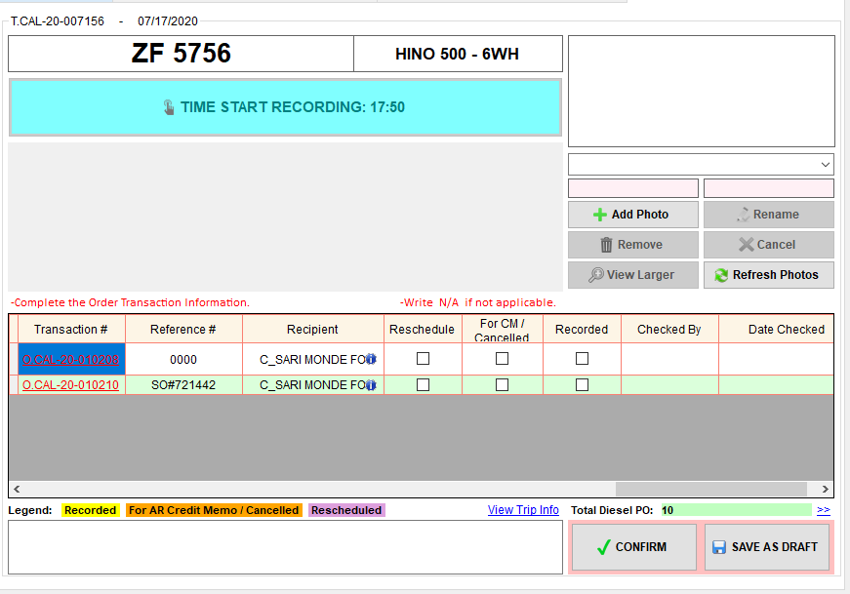

AGI Accounting Staff

LC Accounting Staff

1. Click the Time Start button.
2. Kung sino ang maunang magrerecord sa LC Accounting Staff at AGI Accounting Staff, ang gagawin lang is tick the Recorded checkbox of the corresponding transaction. Once na macheck ito, the transaction will be highlighted in yellow.
3. If Total Diesel PO is not equal to zero, warehouse diesel controller should attach diesel receipt.
4. Among the transactions, kung kaninong account yung pinakamatitira na hindi pa narerecord,

* If need ng diesel receipt pero wala pang naka attach, just tick the Recorded checkbox of the corresponding transaction. Once na macheck ito, the transaction will be highlighted in yellow.
* If meron ng diesel receipt or Total Diesel PO is equal to zero, no need to tick the checkbox, just click the Confirm button. It will record that transaction, and at the same time it will close the Step 9. The transaction will be highlighted in yellow.

#### **How to edit TO FOLLOW Reference#**

1. Make sure to Time Start first. Editing Reference# is allowed in Step 4, 7 and 9.
2. 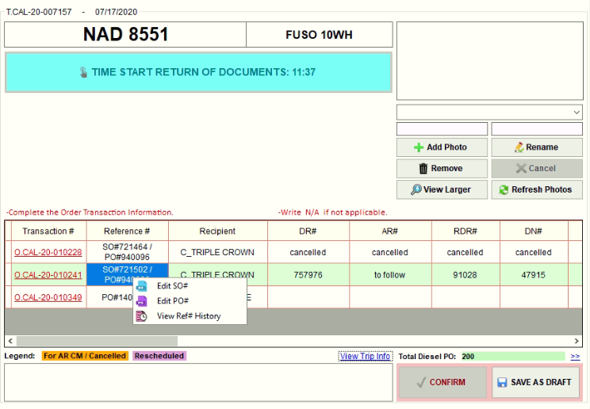In the Reference# column, right click the reference# you want to edit. Then select from the list of reference. If you want to edit SO#, then select SO#.
3. Then, input the correct SO#. Then, click OK button.

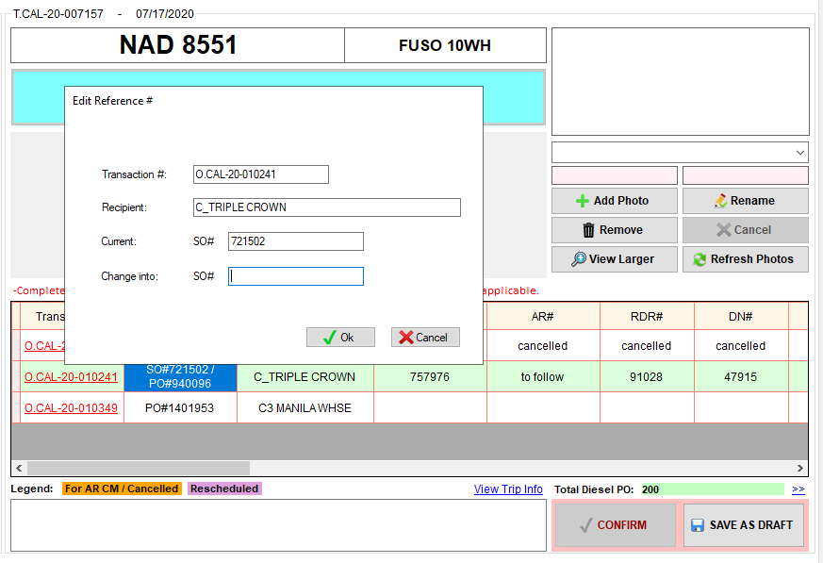

1. 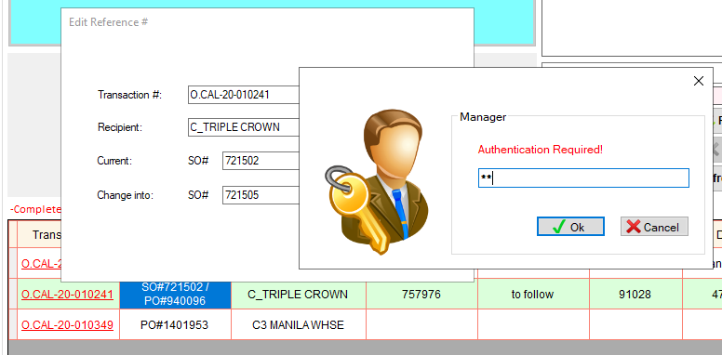Authentication is required. Input password. Then, click OK button.
2. A message will pop up if successfully saved. Then, click OK button to close the message.

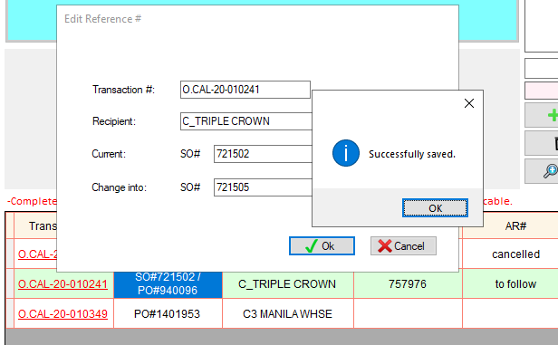

1. Edited SO#

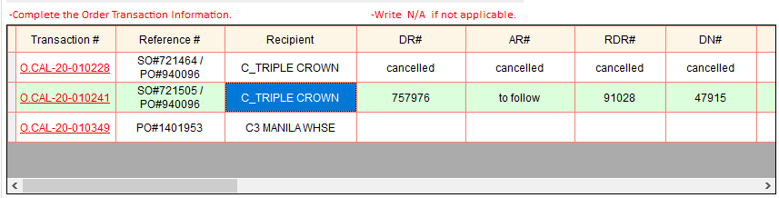

1. You can also view the reference history. Right click the reference#, then, select View Ref# History.

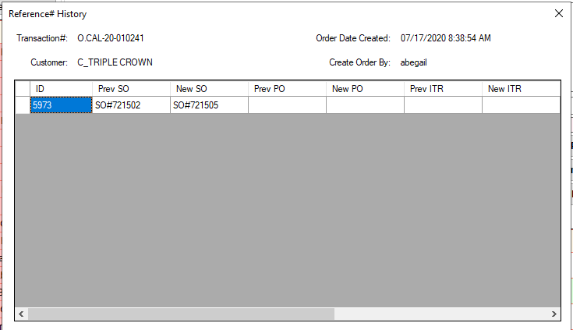

1. Scroll to see who modified and when did the reference# modified.

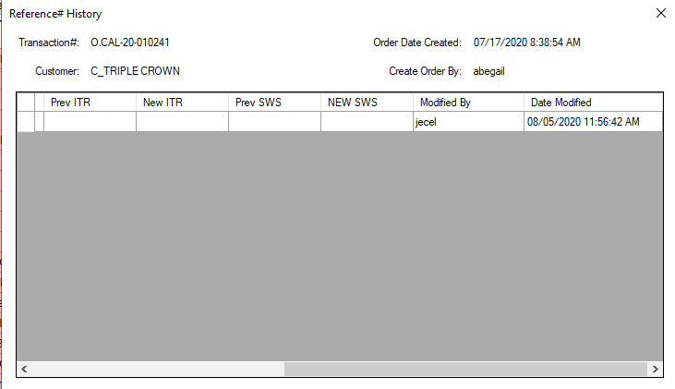

Scroll

## **Trip Dispatching Summary**

Note:

* Red Highlight – Pending trips of Previous dates and Pending trips of Today as of 5:00PM cut off
* Blue Highlight – Cancelled trip
* Light Yellow Highlight – Steps that are not yet checked by the logistics
* Bright Yellow Highlight – Steps checked by the logistics
* Others – Alternate row colors only
* Double click the cell to view the details of every step.

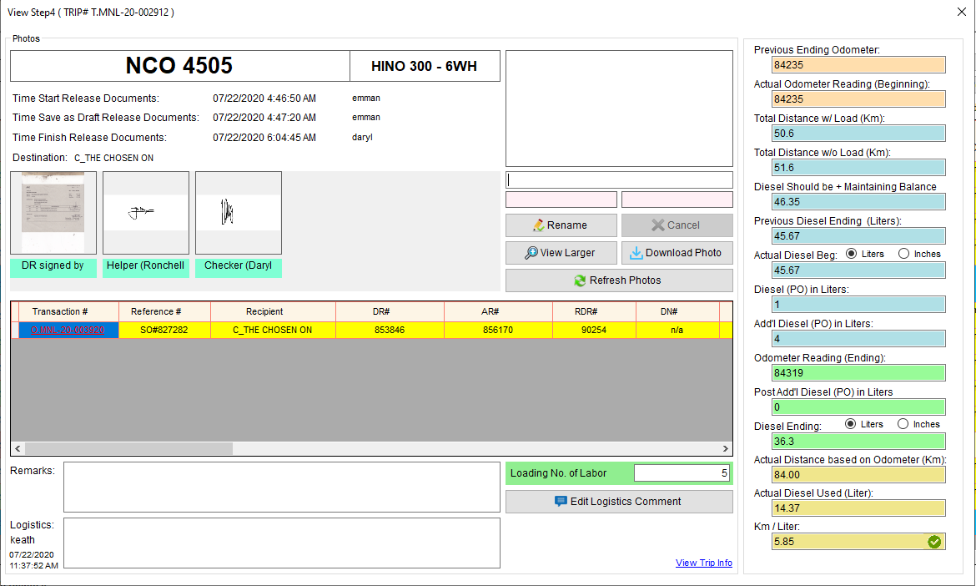

Selected photo file name

Selected photo date added

Selected photo added by

Selected photo

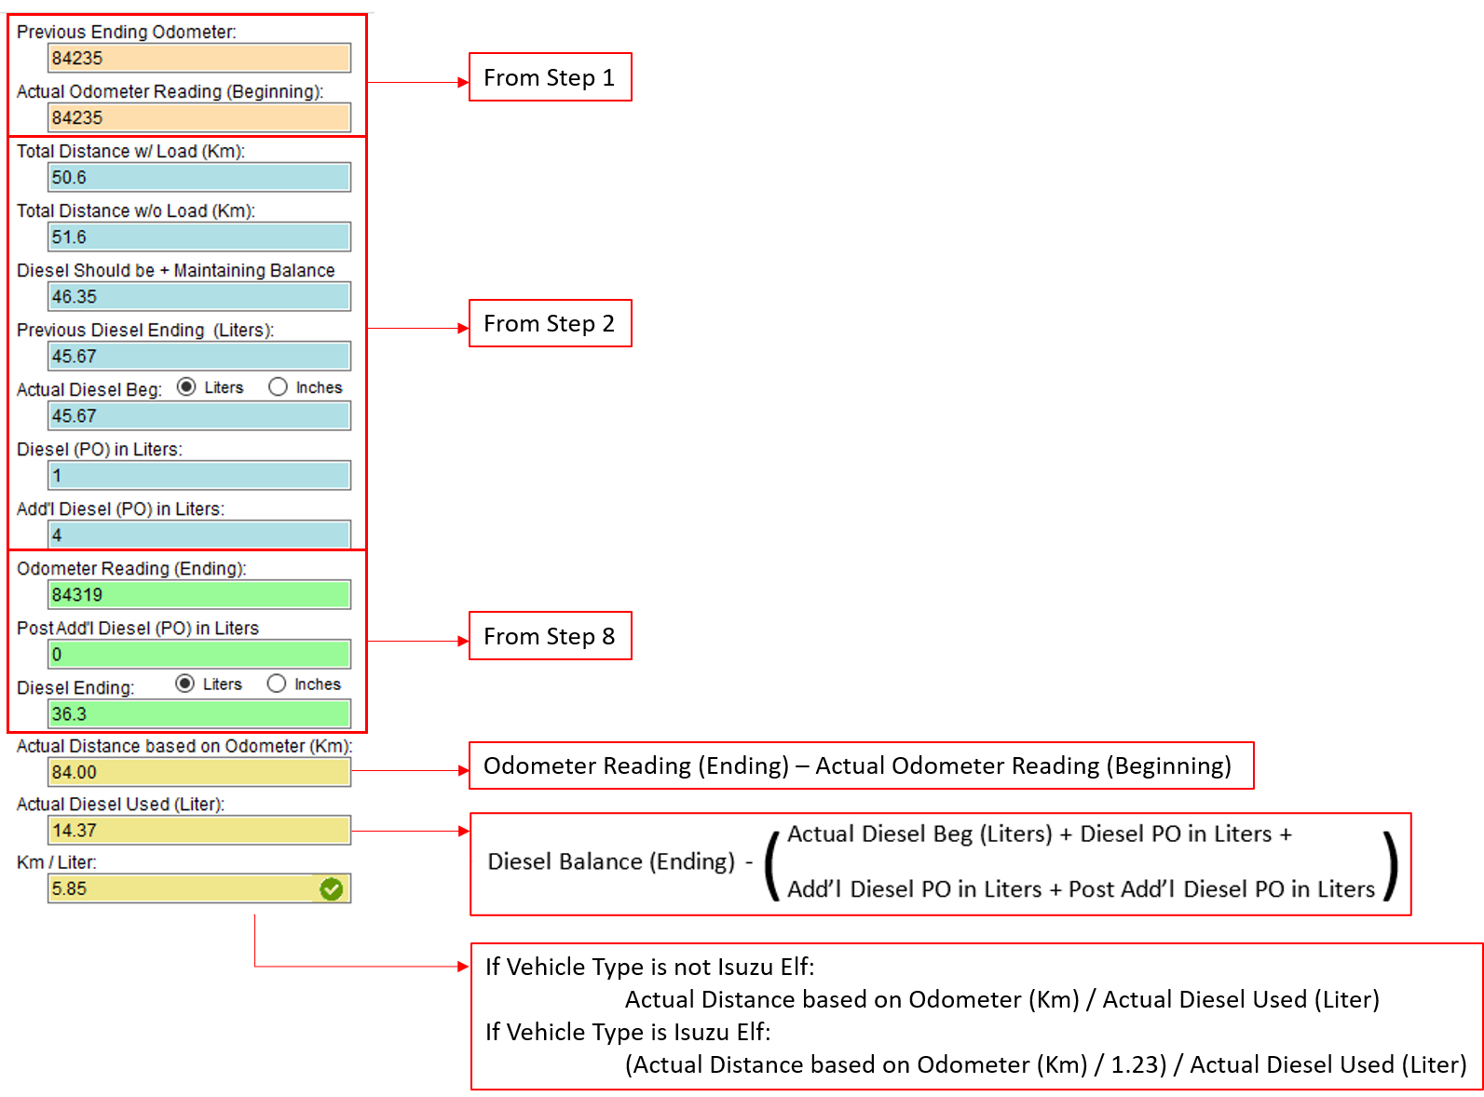

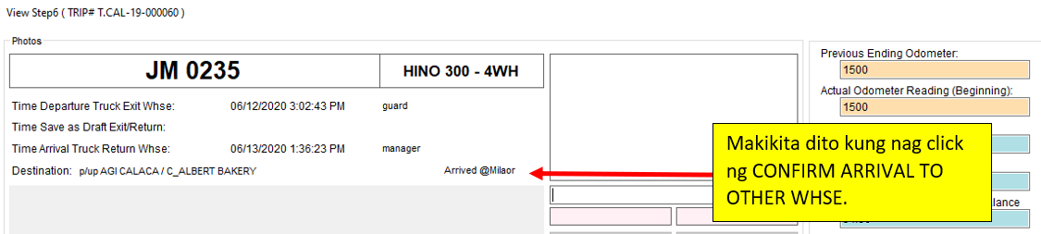

* View Steps – View Larger button – Nag iiba iba ng location ang photo depende sa Steps para mas madali mai-compare ang attachments sa fleet.
* STEP 1

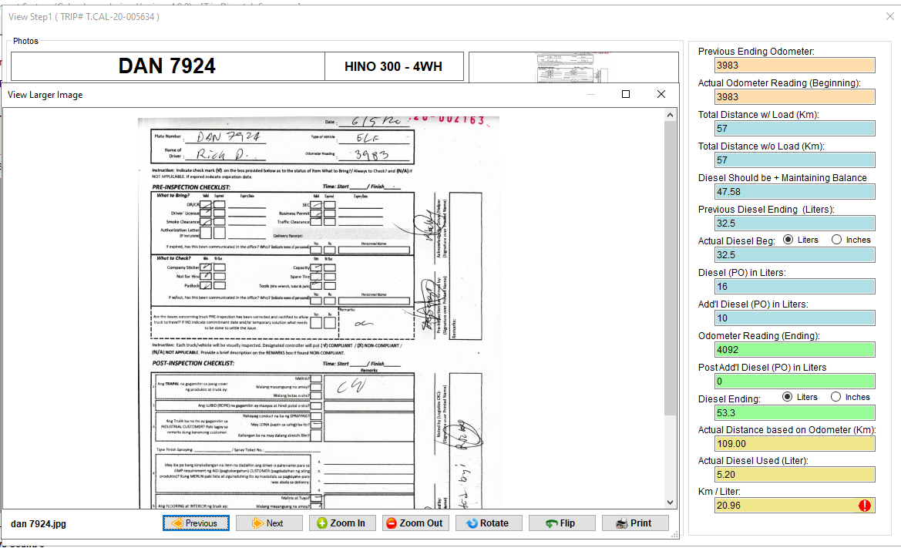

* STEP 2

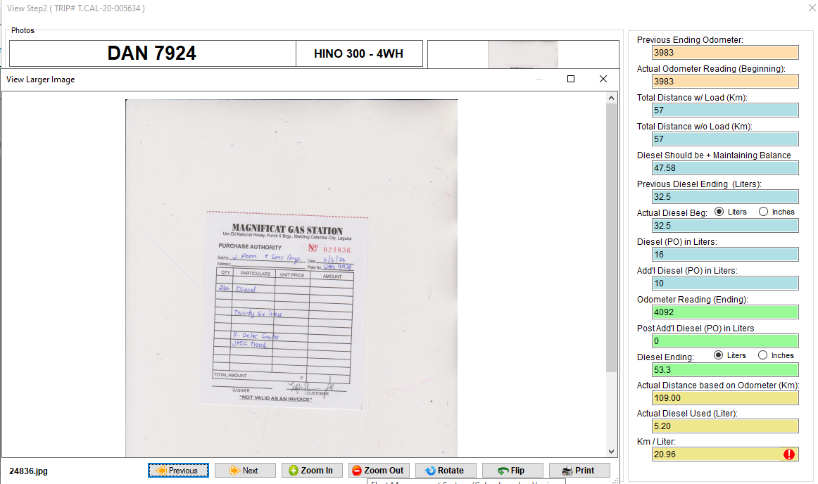

* STEP 3

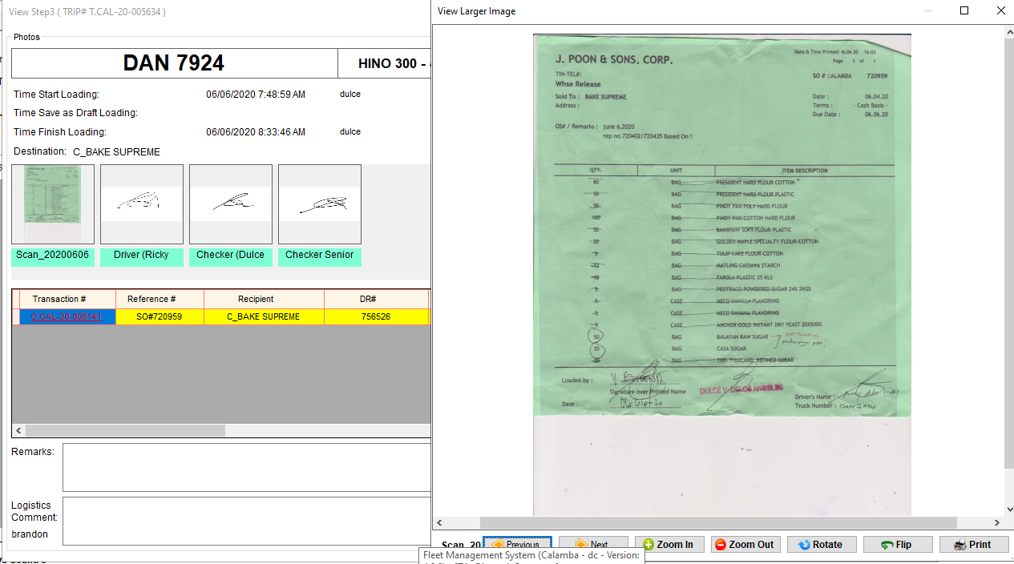

* STEP 4 and 7

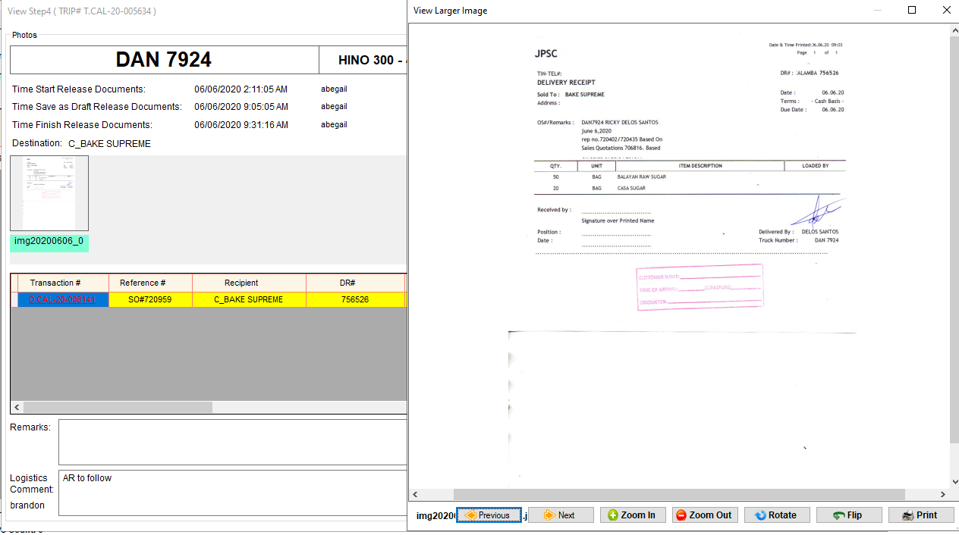

* STEP 5

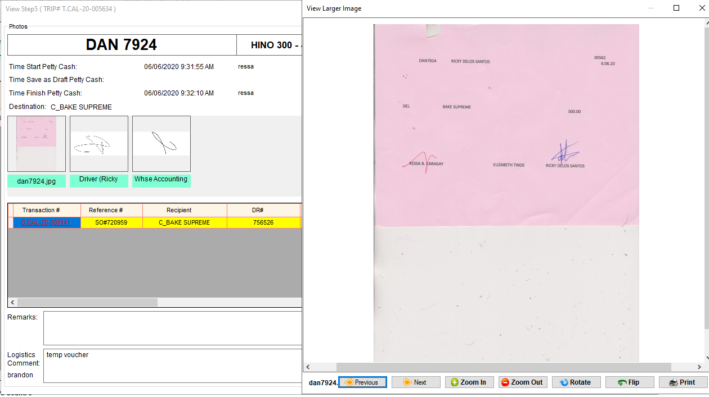

## **Trip Summary**

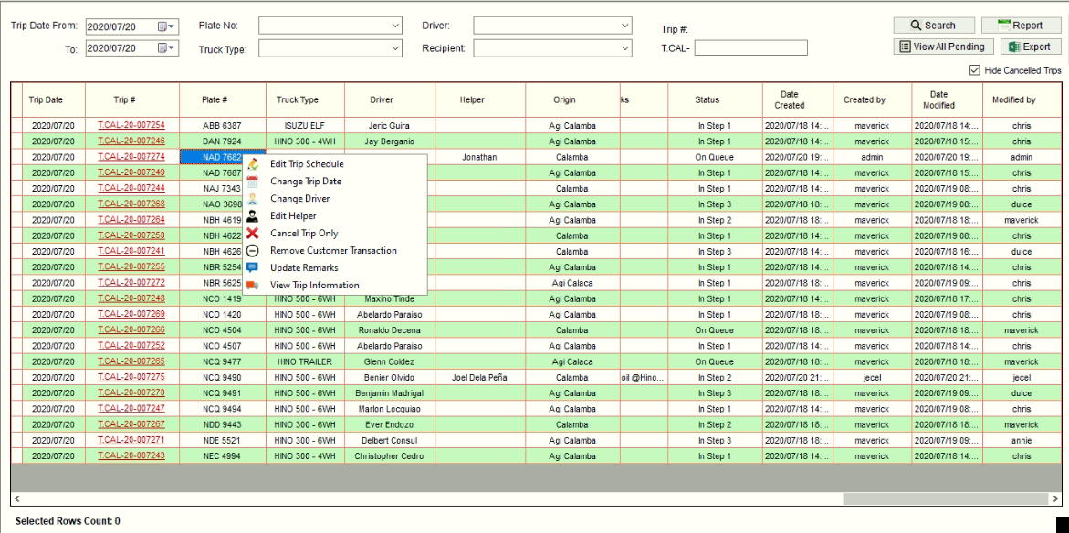Right click Trip# to

* Edit Trip Schedule – Edit Trip General Information. Cannot edit Plate# if any of the step is already started.

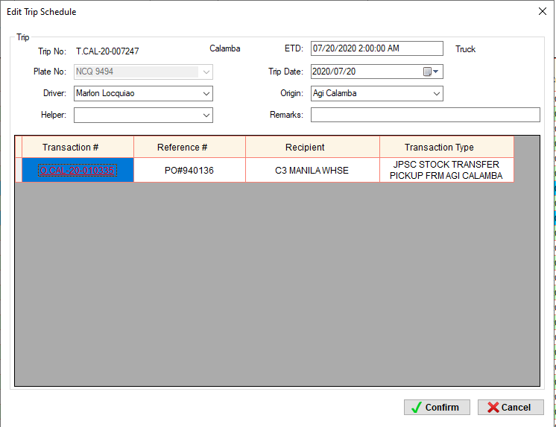

* Update dbo.tbltripsum
* dbo.tbltripsum.platenum – Plate#
* dbo.tbltripsum.driver – Driver
* dbo.tbltripsum.helper – Helper
* dbo.tbltripsum.datepick – Trip Date
* dbo.tbltripsum.etd – Estimated Time of Departure
* dbo.tbltripsum.remarks – Remarks
* dbo.tbltripsum.assigned – tblgeneral.whsename
* dbo.tbltripsum.datemodified – GetDate()
* dbo.tbltripsum.modifiedby – Login Username
* If na edit yung Plate#
* Update dbo.tbldispatchsum
* dbo.tbldispatchsum.step8
* 0 – If Truck yung bagong plate#
* 1 – If Service vehicle yung bagong plate#
* Change Trip Date – Edit Trip Date only. Cannot Edit Trip Date if naka Departure na.

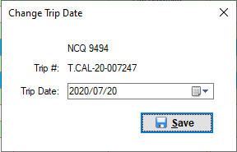

* Update dbo.tbltripsum
* dbo.tbltripsum.datepick – Trip Date
* 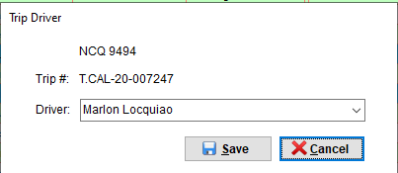Change Driver – Edit Driver only
* Update dbo.tbltripsum
* dbo.tbltripsum.driver – Driver
* Edit Helper – Edit Helper only

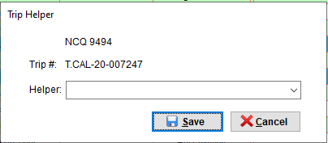

* Update dbo.tbltripsum
* dbo.tbltripsum.helper – Helper
* Cancel Trip Only – meaning cancel the trip but all the order transactions under the trip will become available for scheduling, except for those order transactions that is removed. Cannot Cancel Trip if naka Departure na.

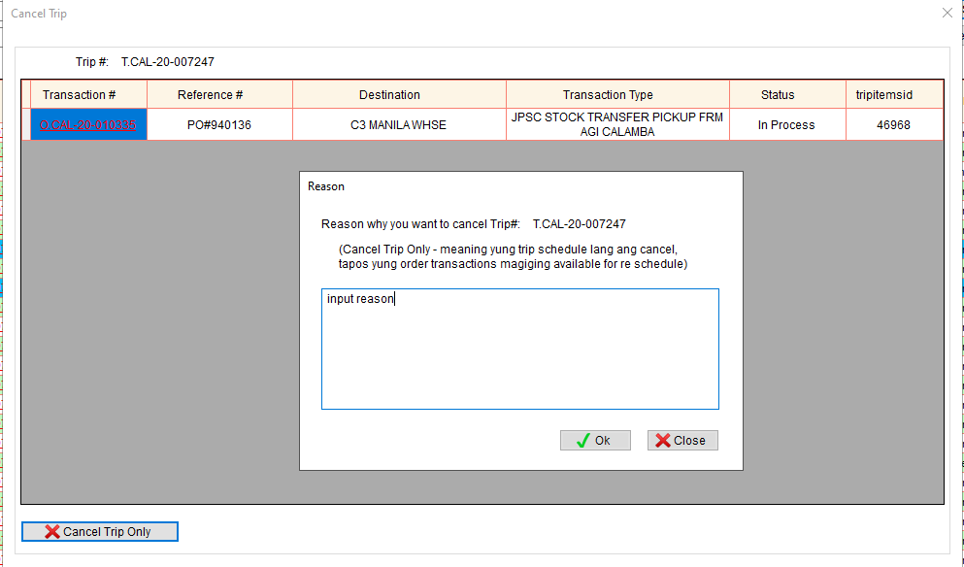

* Update dbo.tbltripsum
* dbo.tbltripsum.status – 3
* dbo.tbltripsum.creason – Reason why you need to cancel the trip
* dbo.tbltripsum.datecancelled – GetDate()
* dbo.tbltripsum.cancelledby – Login Username
* Update dbo.tblortrans
* dbo.tblortrans.status – 1
* Update dbo.tbltripitems
* dbo.tbltripitems.status – 0
* dbo.tbltripitems.cancelby – Login Username
* dbo.tbltripitems.canceldate – GetDate()
* Remove Customer Transaction – remove one or more order transactions under the trip. All the removed transactions will become available for trip scheduling. Cannot Remove Customer Transaction if naka Departure na.

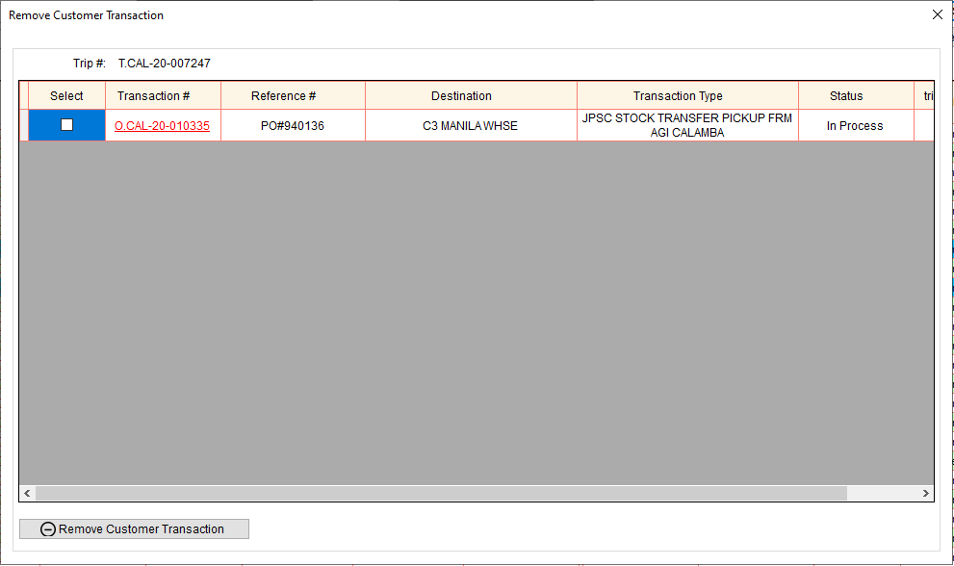

Check the transactions you want to remove.

* Update dbo.tblortrans
* dbo.tblortrans.status – 1
* Update dbo.tbltripitems
* dbo.tbltripitems.status – 3
* dbo.tbltripitems.cancelby – Login Username
* dbo.tbltripitems.canceldate – GetDate()
* Update Remarks

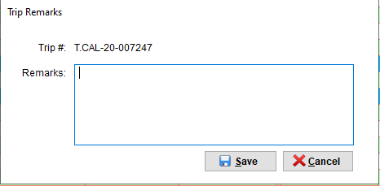

* Update dbo.tbltripsum
* dbo.tbltripsum.remarks – Remarks
* View Trip Information

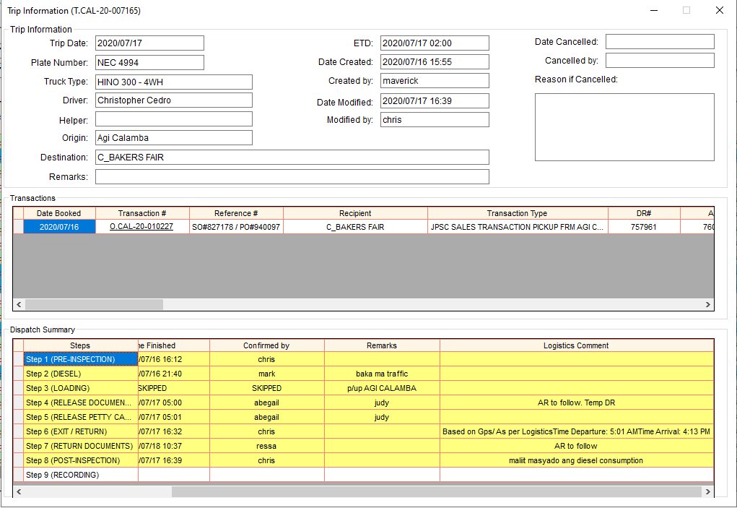

Note: View Trip info window also appears automatically when confirming Step 7, 8 and 9 for you to read those remarks and Logistics’ comments as a reminder before closing the steps. There is also a View Trip Info link in every step in Trip Dispatching

**Vehicle Trip Access**

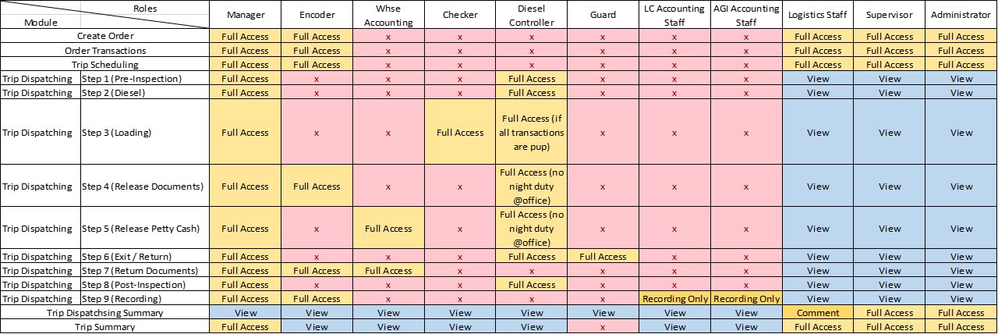

# REPORTS

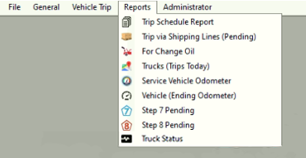

## Trip Schedule Report

* 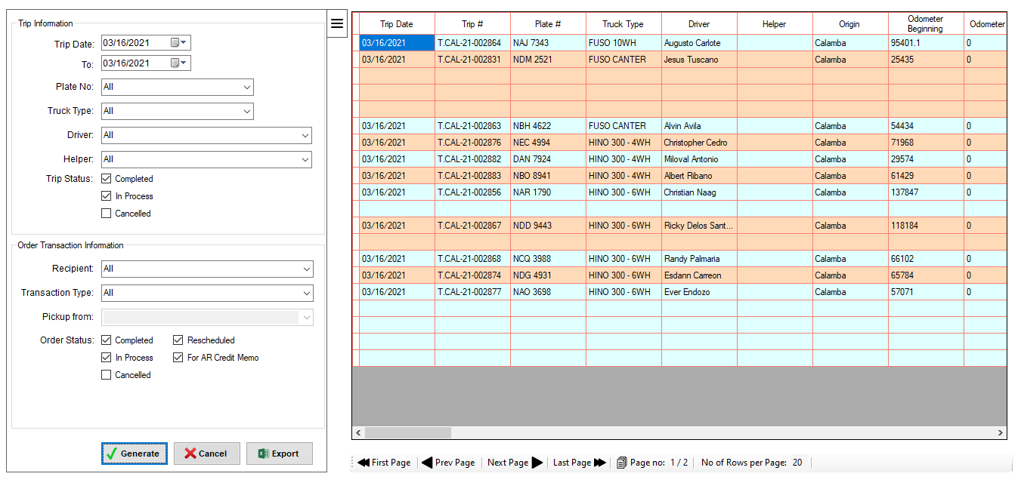Search trip report, then click Generate button.

## Trip via Shipping Lines

## For Change Oil

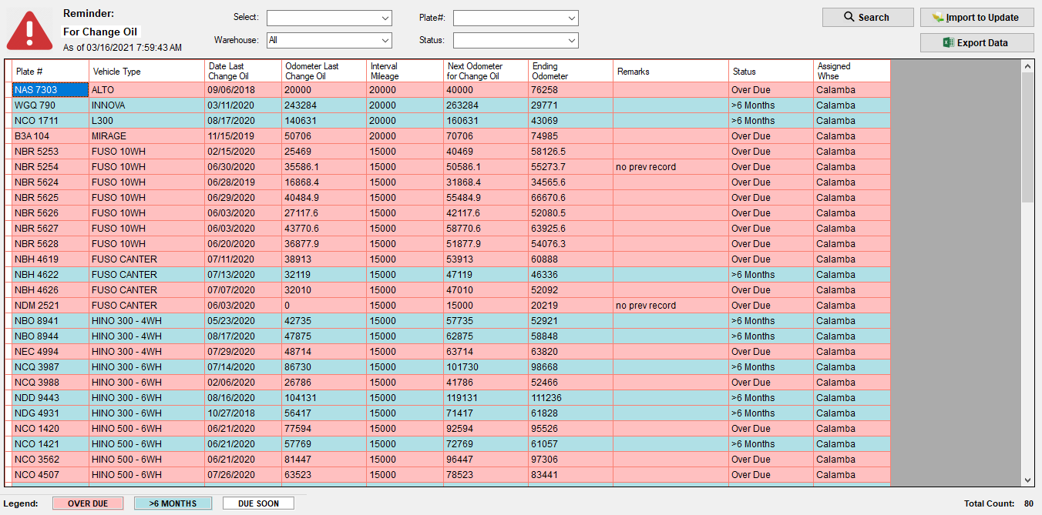

## Pending Trip Status per Date

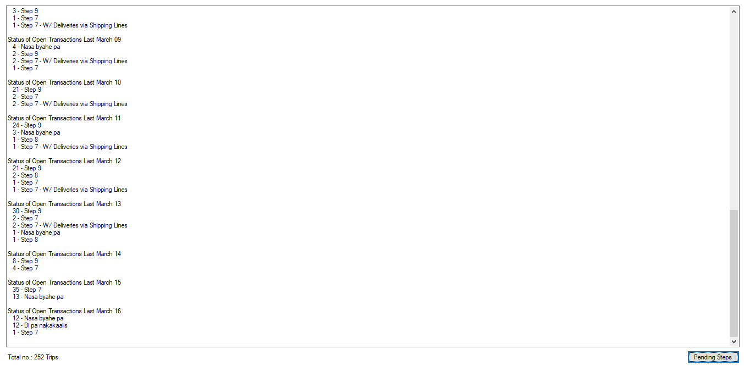

## Service Vehicle Odometer

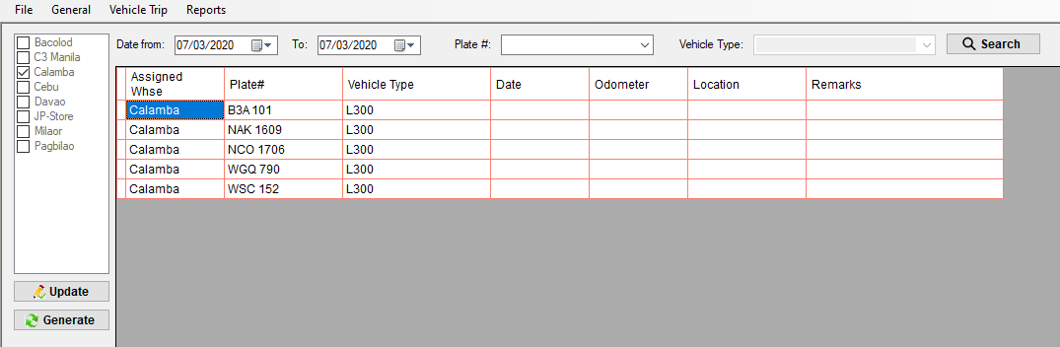



* Click Update button to enable editing.

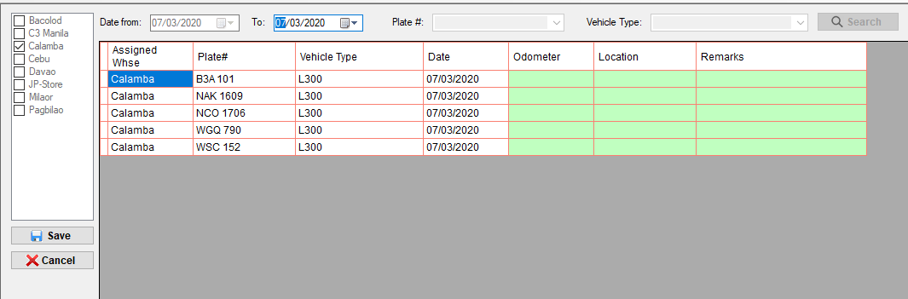

* Lahat lang ng naka highlight ng green ang mga field na pwede i-edit.

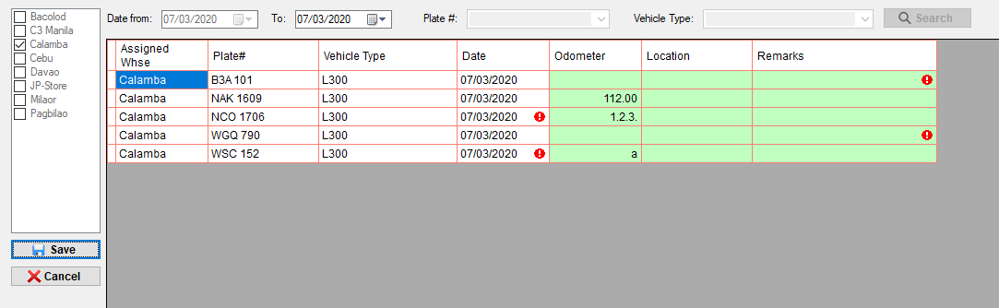

Invalid odometer.

No odometer. Input remarks.

* Hindi mag se-save kung may ***Invalid odometer*** at ***No odometer. Input remarks.*** error.
* Pwedeng hindi agad malagyan yung odometer provided na may remarks dahil pwede pa ulet yan i-update basta within the day.
* Hindi mag se-save kung ang mga plate# na wala pang odometer na naka input ay wala ring remarks.

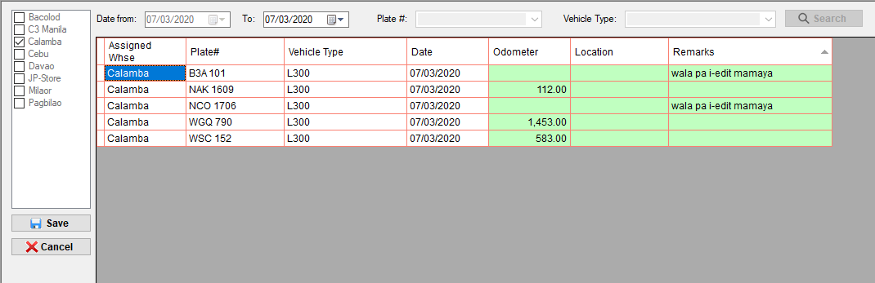

* After maayos ang mga error, click Save button.

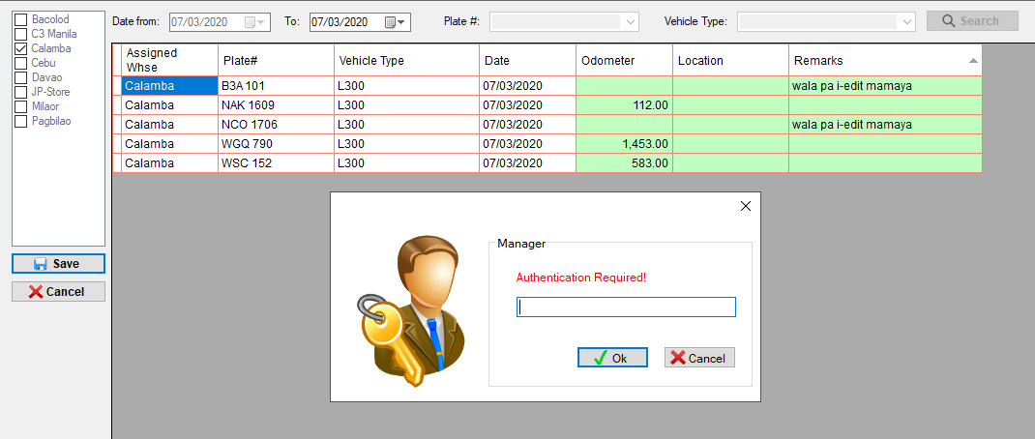

* Authentication required. Input password.
* Then, click Ok button.

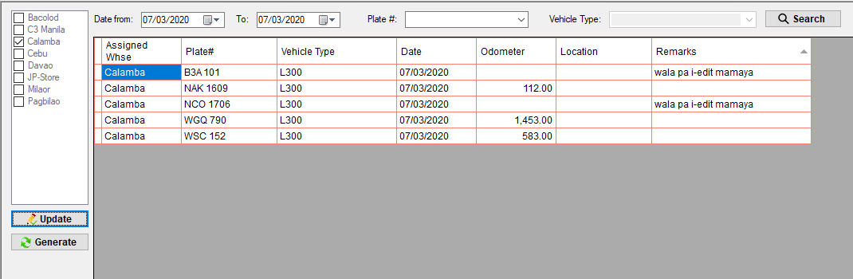

* Successfully saved.

## Vehicle Ending Odometer

* Show the last ending odometer

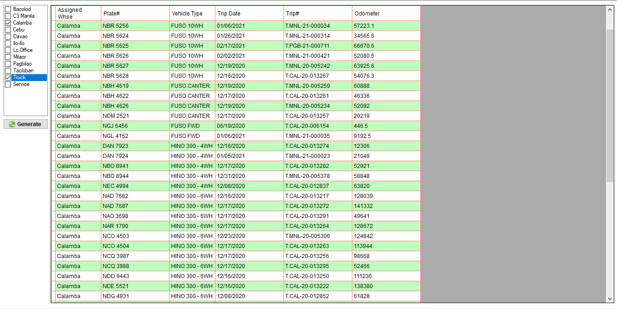

## Vehicular Accident / LTO Apprehension Report

* (not yet done)

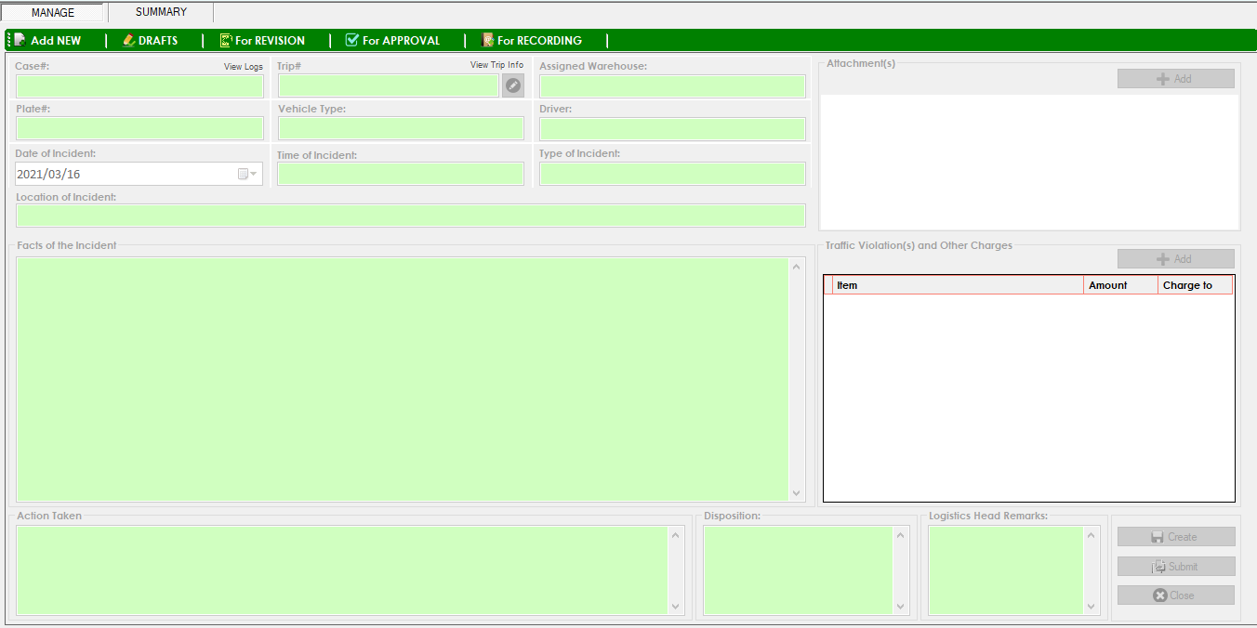

## Truck Status

**How to set reason if the truck has no trip.**

* Dito mag create ng truck status ang warehouse.
* One truck status per day only.

1. Click NEW.

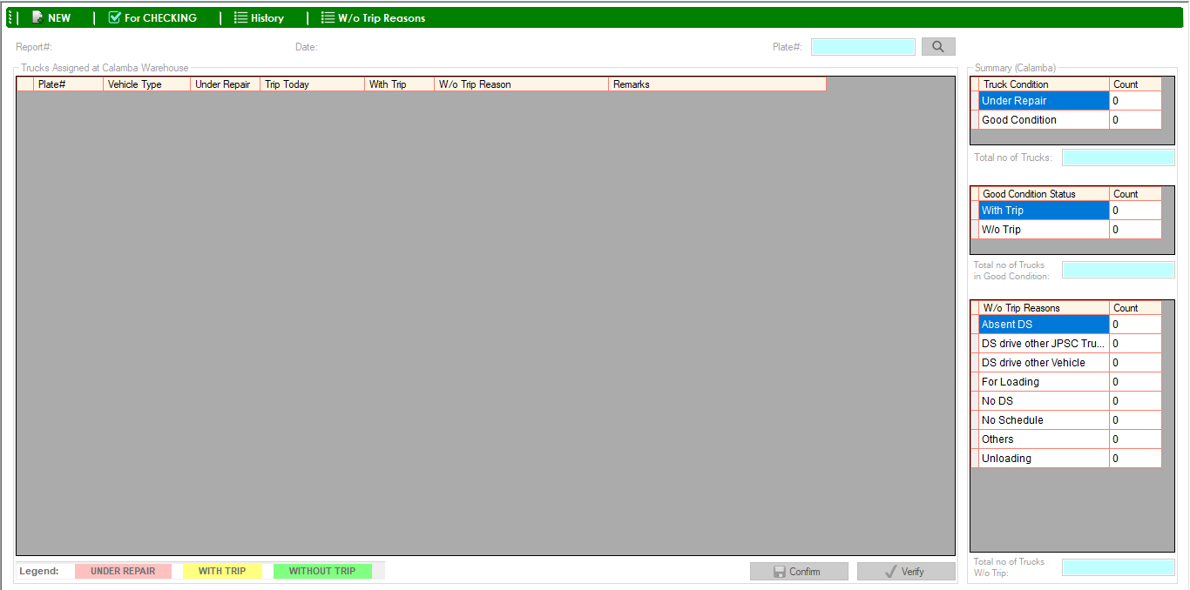

1. Mag show lahat ng plate# na naka assigned sa warehouse kung saan nag login. Kung may trip today ang truck, automatic naka check ang **With Trip** na column. Kung may connection ang fleet sa ibang warehouse, mache-check din doon kung may trip ang truck. Kung with trip, mag sho-show din ang trip# nito. Kung connected sa Motorpool, at ang condition ng truck ay under repair, automatic naka check ang **Under Repair** na column.

example: Nag login ako sa Calamba fleet kaya lahat ng plate# na makikita dito ay naka assigned sa Calamba Warehouse.

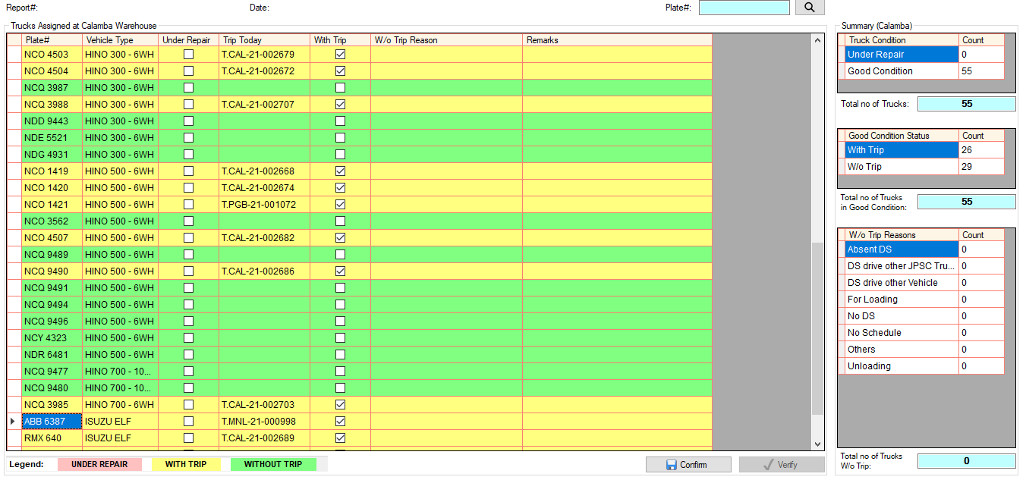

May trip today sa Calamba Fleet

May trip today sa Pagbilao Fleet

May trip today sa C3 Manila Fleet

Summary

1. 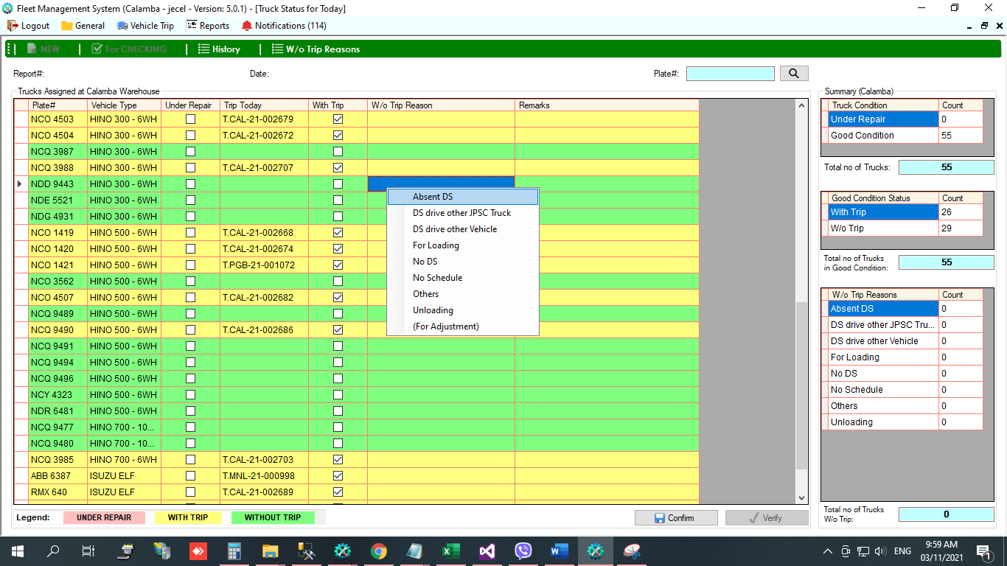Lahat ng mga plate# na naka highlight ng green ay without trip, meaning walang nakitang trip for today. Lahat ng without trip na truck kailangan lagyan ng reason kung bakit walang trip. Right click the plate#, then select reason.
2. Kada set ng reason, automatic ding nagbabago ang summary.

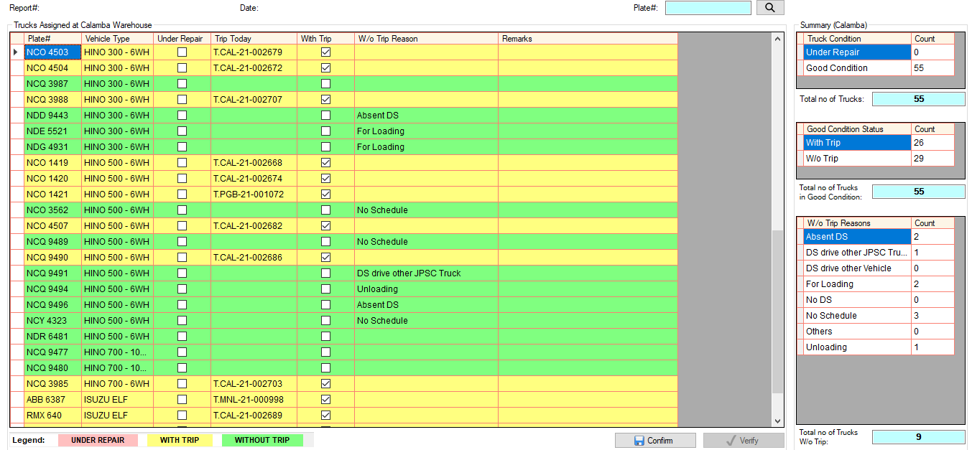

1. 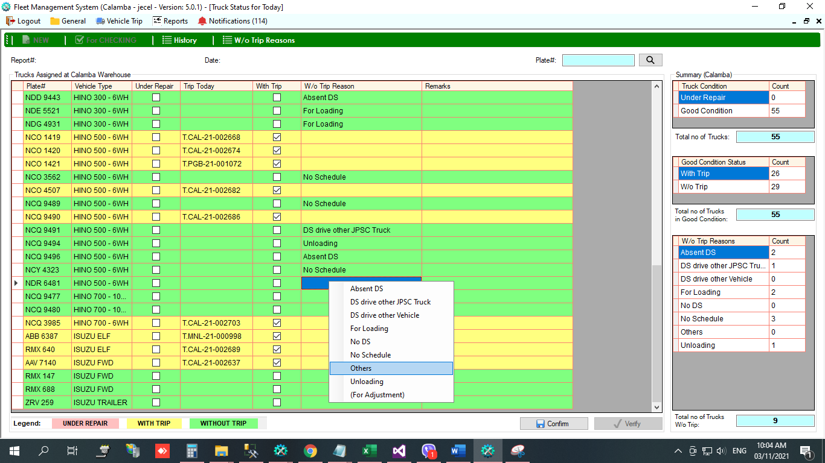Kung wala sa list ang reason, select **Others,** required na mag input ng remarks.

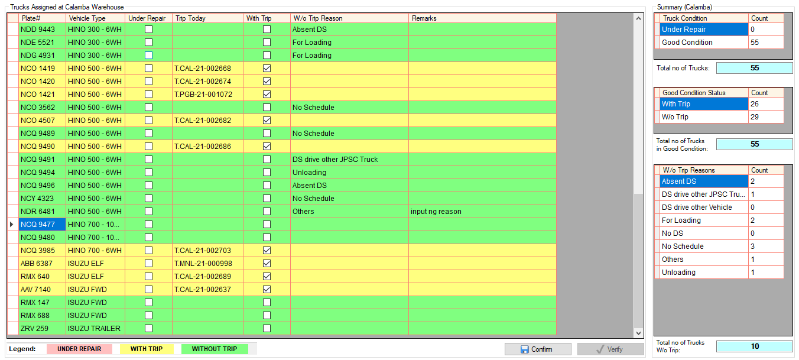

1. 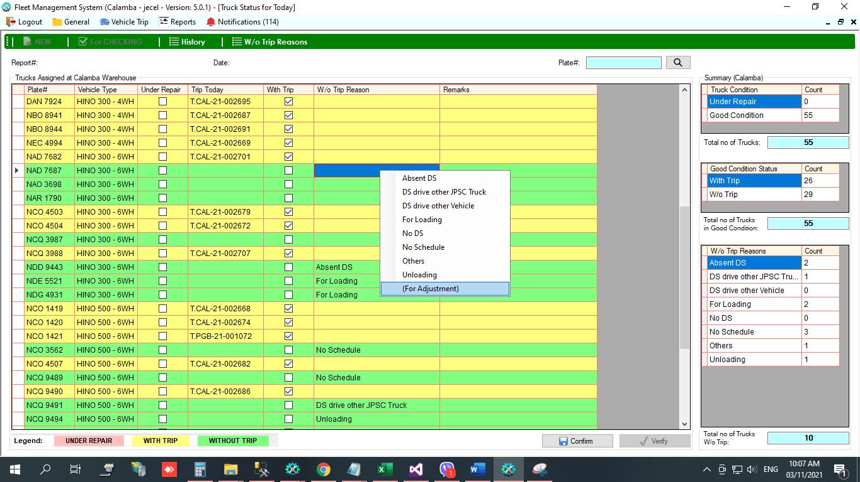Kung hindi nag automatic **With Trip** ang truck dahil hindi connected ang fleet sa ibang warehouse kung saan nandoon ginamit ang truck. Right click the plate#, then select **(For Adjustment)**, required ang remarks. Kapag for adjustment, logistics staff ang authorize na mag check ng **With Trip** na column, provided na nacheck talaga na may trip ang truck sa ibang warehouse. (same kapag hindi automatic Under Repair dahil hindi connected sa Motorpool)

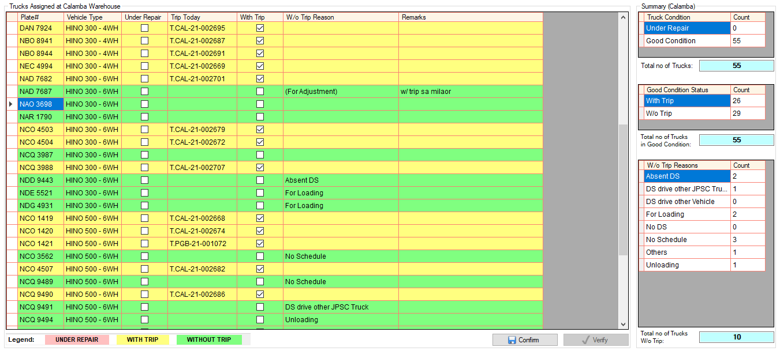

1. 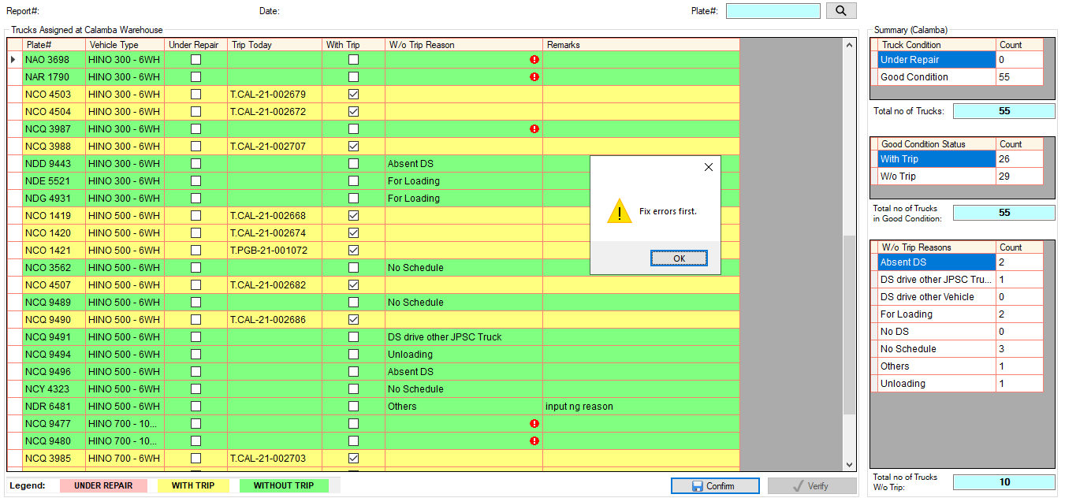Cannot confirm if may plate# na walang reason.
2. Kung complete na, click Confirm button. Then input password, then click OK button.

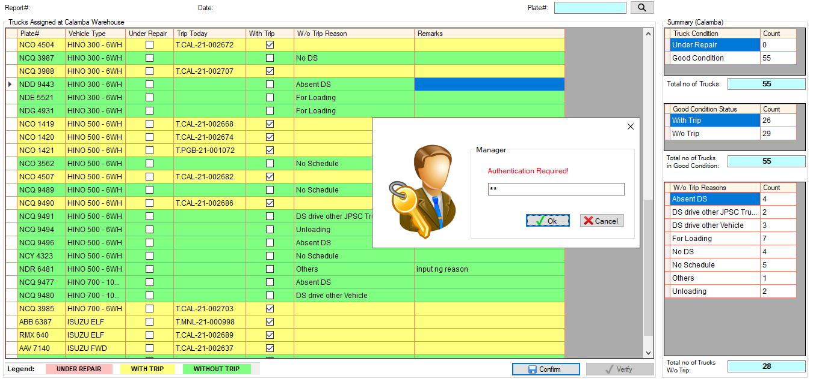

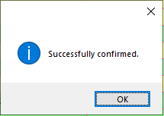

1. Once confirmed, kailangan i-verify ni logistics staff. Open Truck Status module, then click **For Checking.**

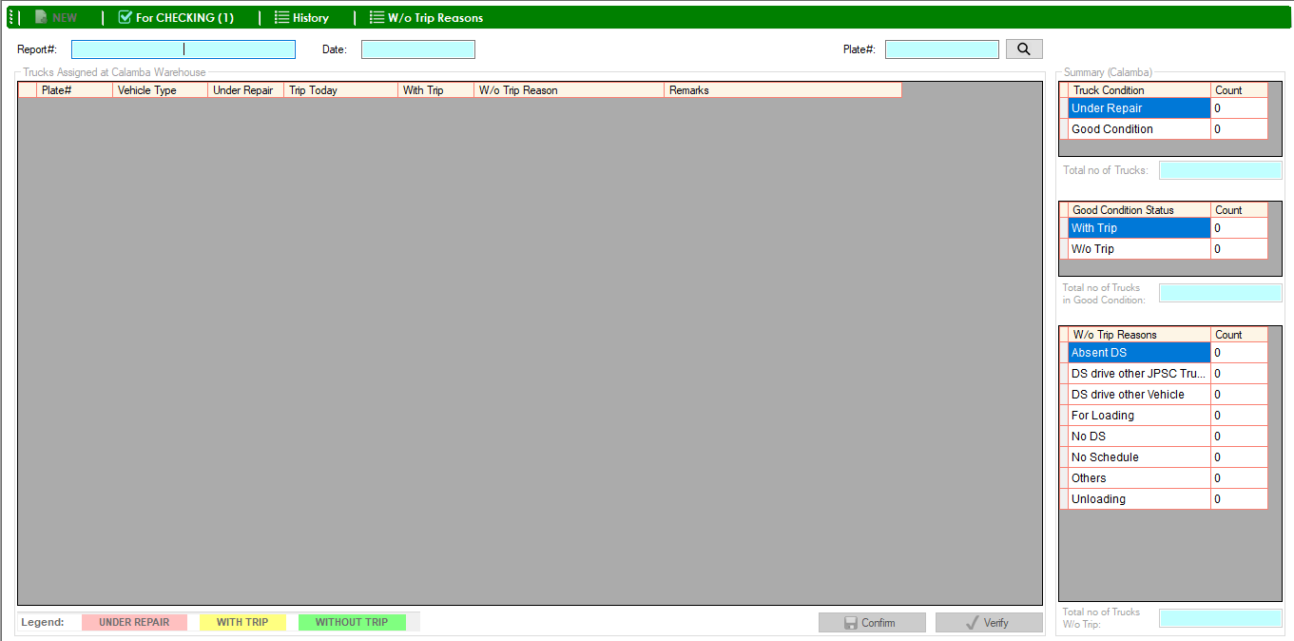

1. 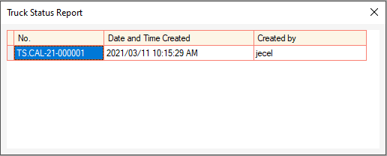Double click the report#.
2. 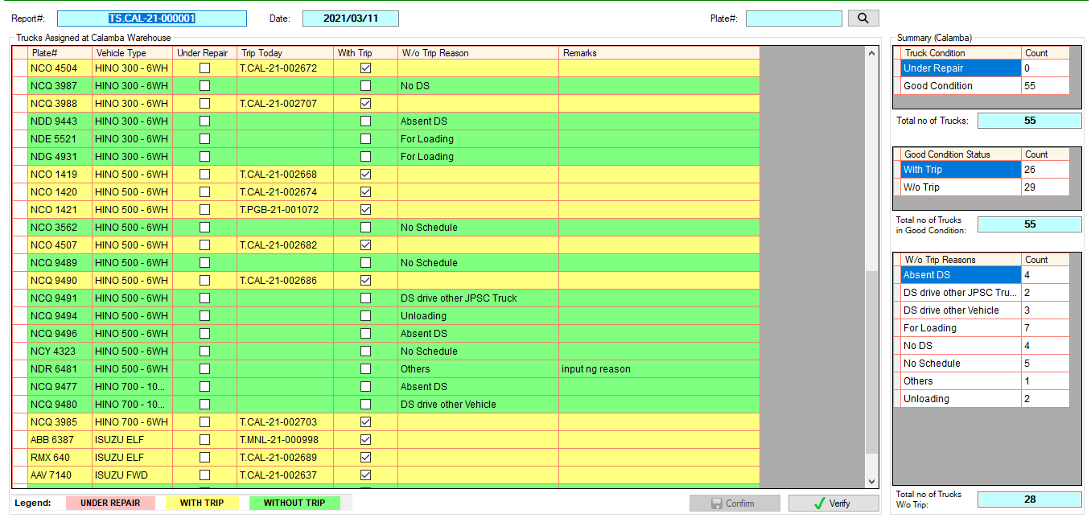Confirmed report will show.
3. 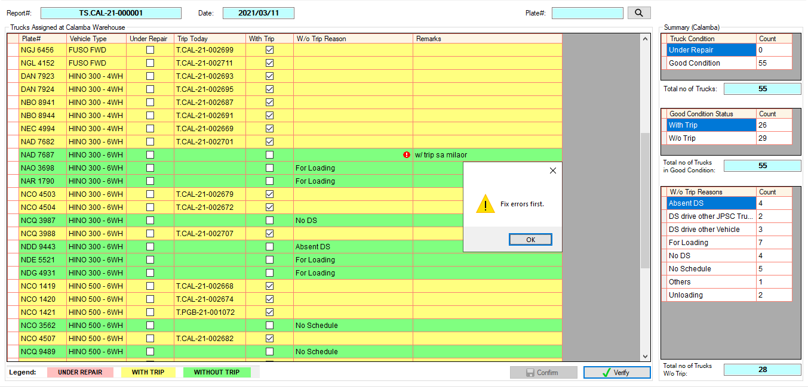Check the details, then click Verify button.
4. 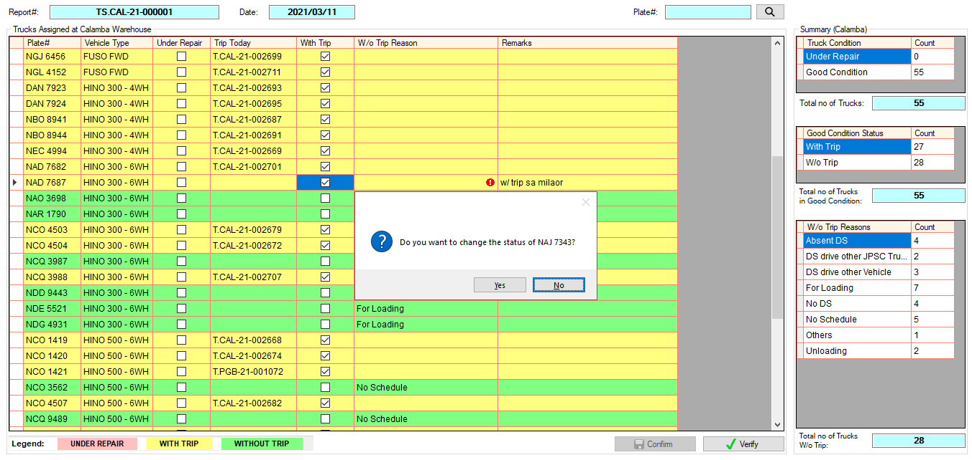Kung may plate# na walang reason, ito yung mga **(For Adjustment)** ni warehouse. Based sa example, ang remarks ay with trip sa milaor, kung nagbyahe talaga sa milaor ang truck, check the corresponding **With Trip** checkbox column.

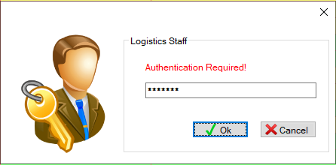

1. 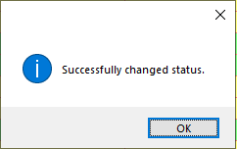Click Yes to continue. Then input password, then click Ok button.
2. 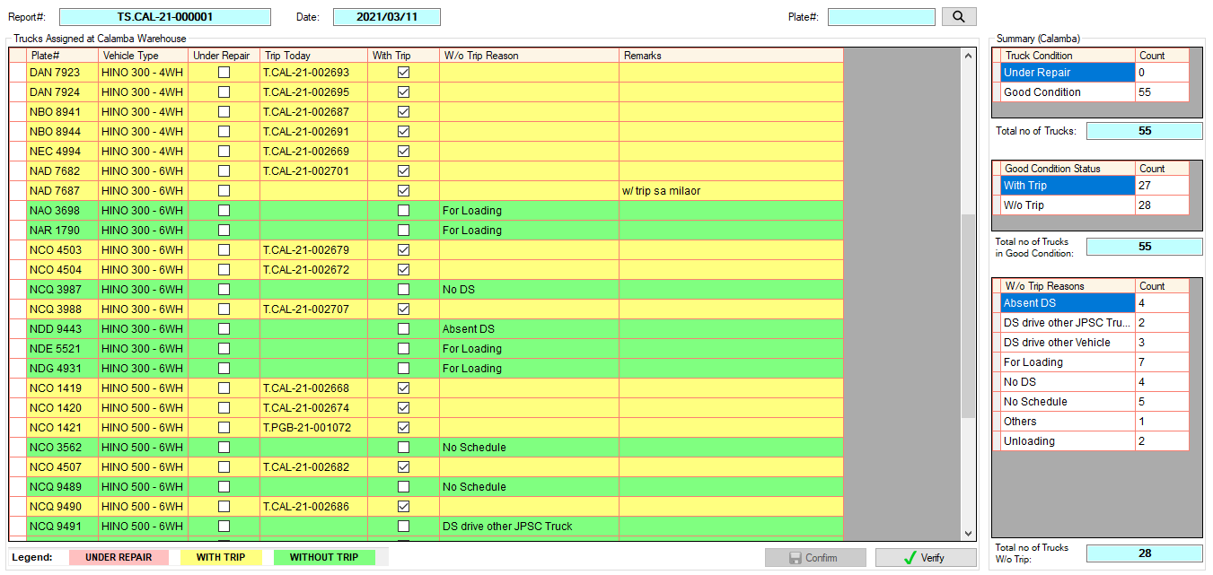Kung nacheck na at kumpleto na, click Verify button.
3. 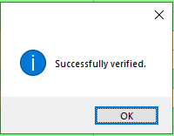Input password, then click Ok button.
4. To check previous reports, click **History**.

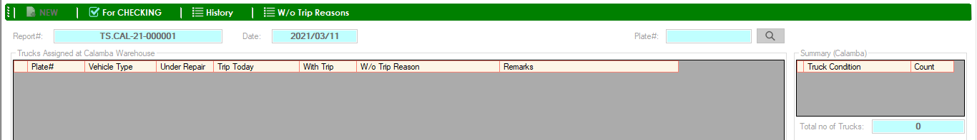

1. 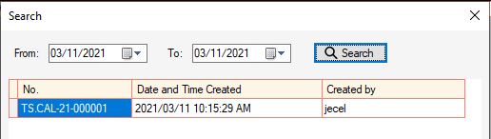Search report date, then double click the report#.
2. Verified Report will show. Summary is highlighted if the report is already verified.

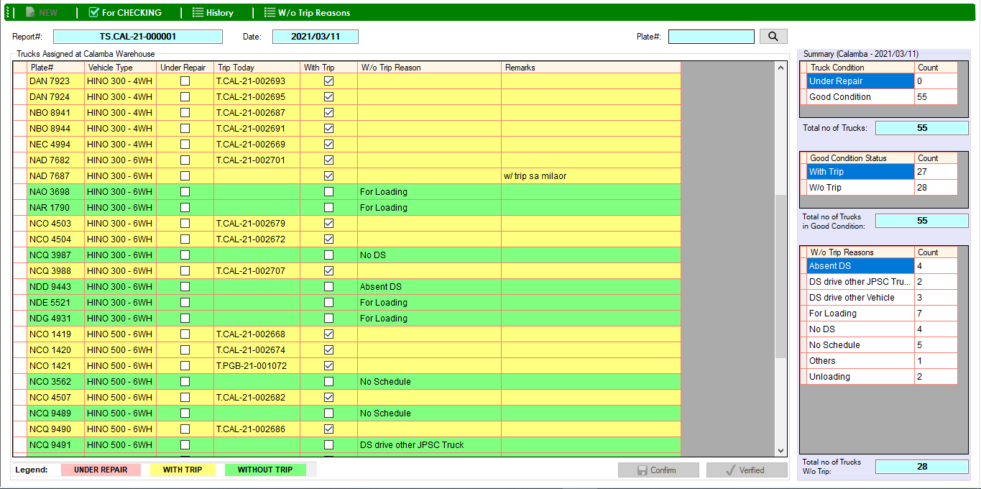

1. Click **W/o Trip Reasons** to show the list of reasons.



## Motorpool Inspection Status

* 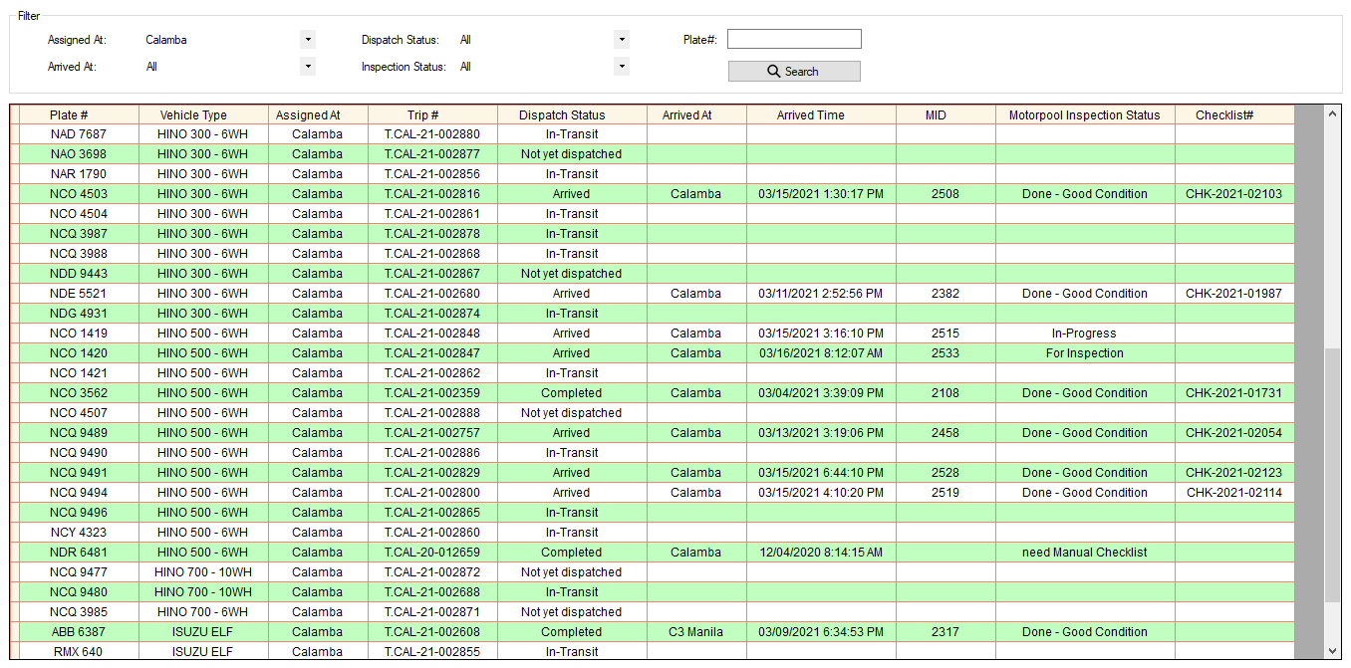connected with Motorpool System

# **ADMINISTRATOR MENU**

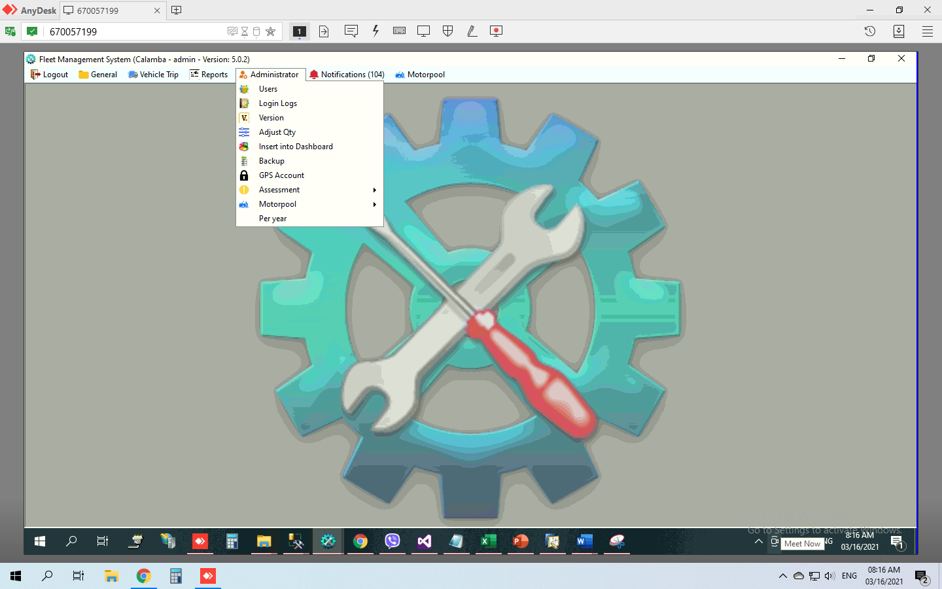

## Users

## Login Logs

## Version

* Update fleet

1. In Login form, edit the version label.

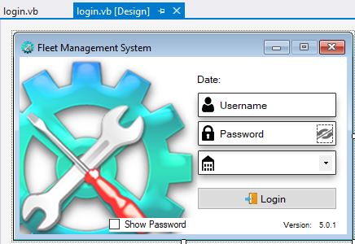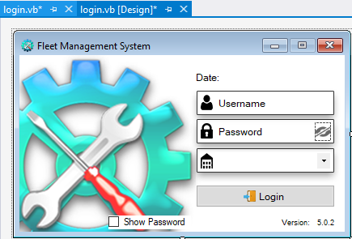

1. Create an exe file that has a default of different warehouses.

Example:

* For Calamba warehouse

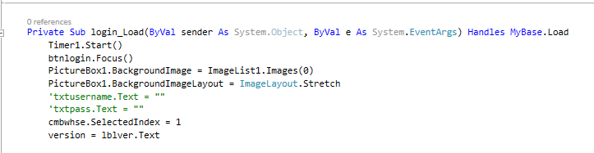

* For C3 Manila Warehouse

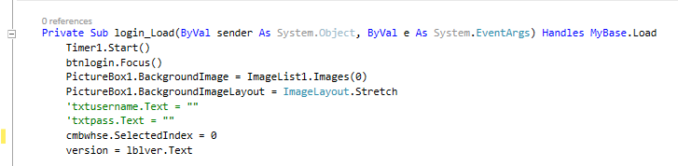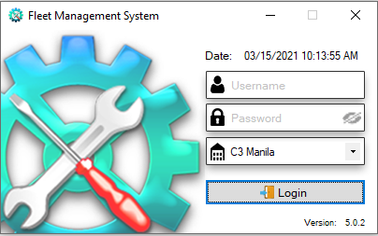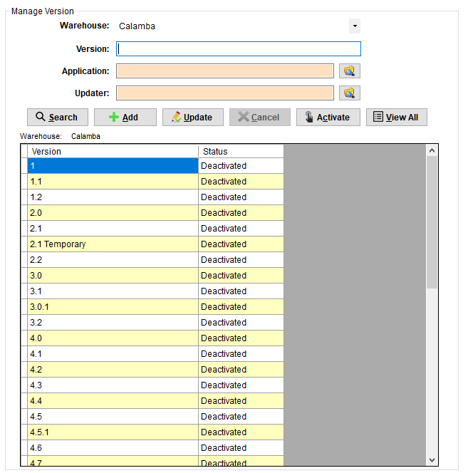

Zip File (vehicle exe and other files)

Note:

-fleet exe file name should be “vehicle”

-zip file name should be “Updated”

Version

Auto Updater exe file

Note:

-Auto Updater exe file name should be “autoupdater”

* 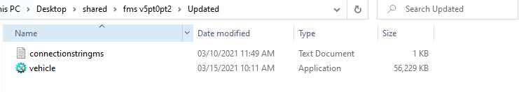Example of files inside Updated folder
* Browse Updated zip file folder

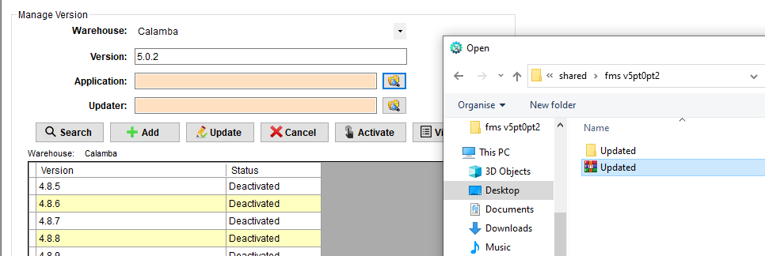

* Browse Auto Updater exe file

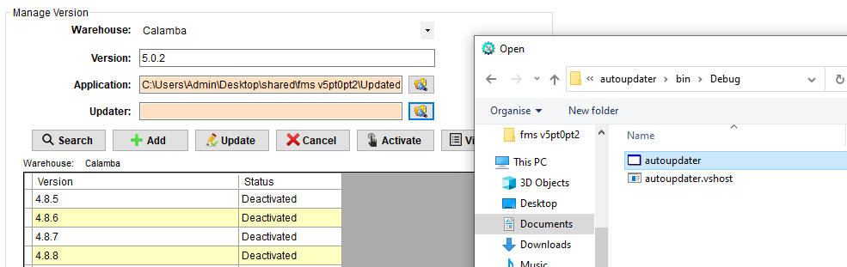

* 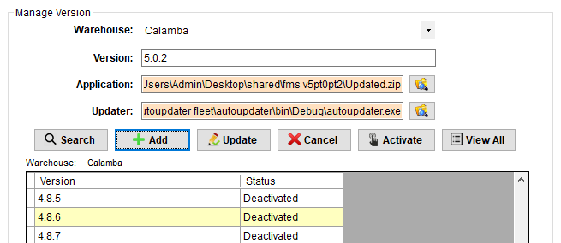Click Add button.
* 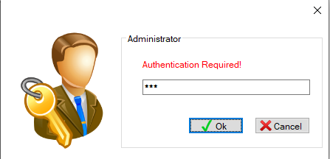Input password, then click Ok button.

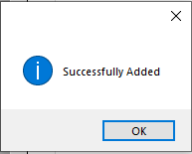

* 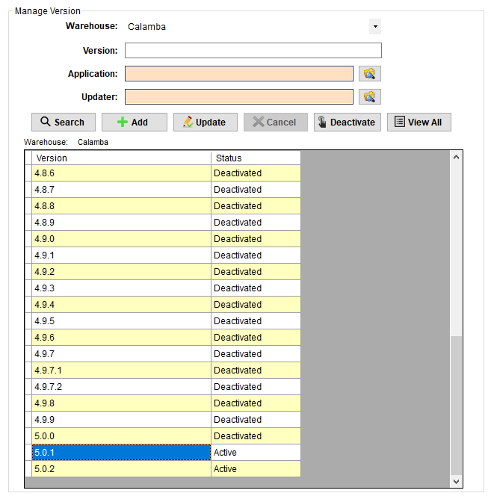Select previous version, then click Deactivate button.
* Input password, then click Ok button.

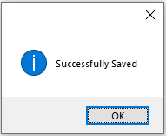

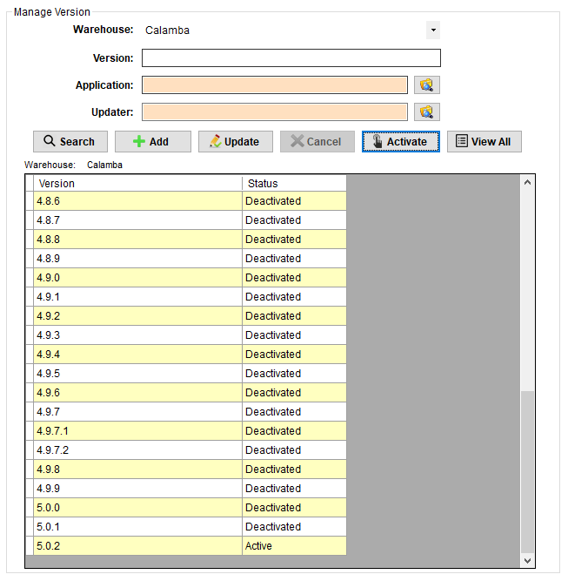

* Logout



* Then, Login again.

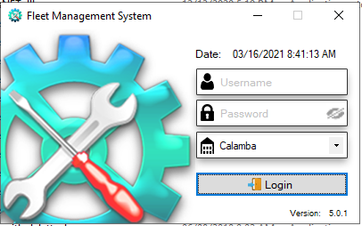

Previous Version

* 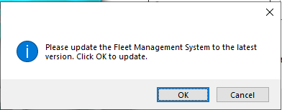Click OK to update.
* Wait until Login form shows.

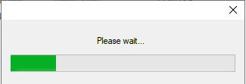

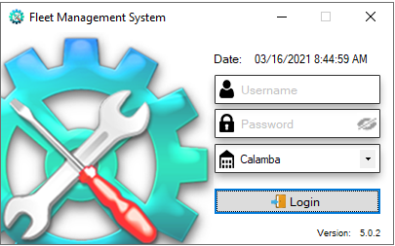

Updated Version

## Adjust Qty

* 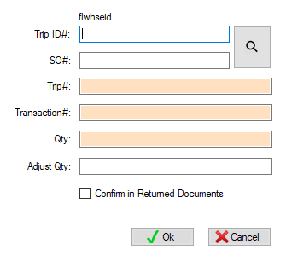For Dashboard only

## Insert into Dashboard

* To generate trips for warehouses that have no fleet yet.

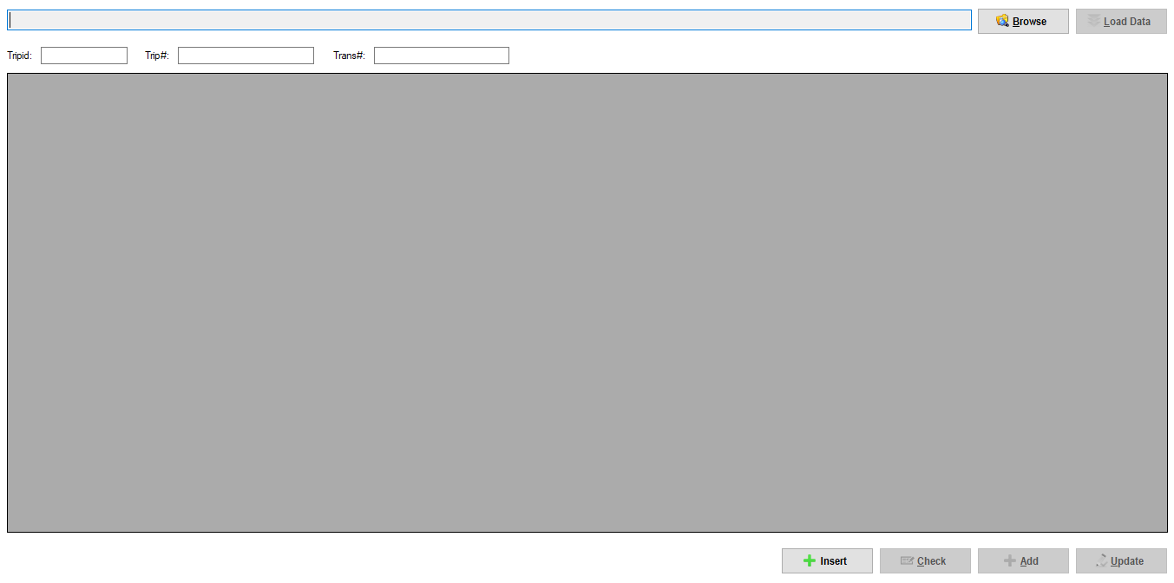

## Backup

* (Di na ginagamit)

## GPS Account

* 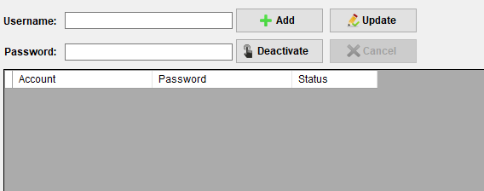To get HASH in GPS API

## Assessment Category

## Motorpool

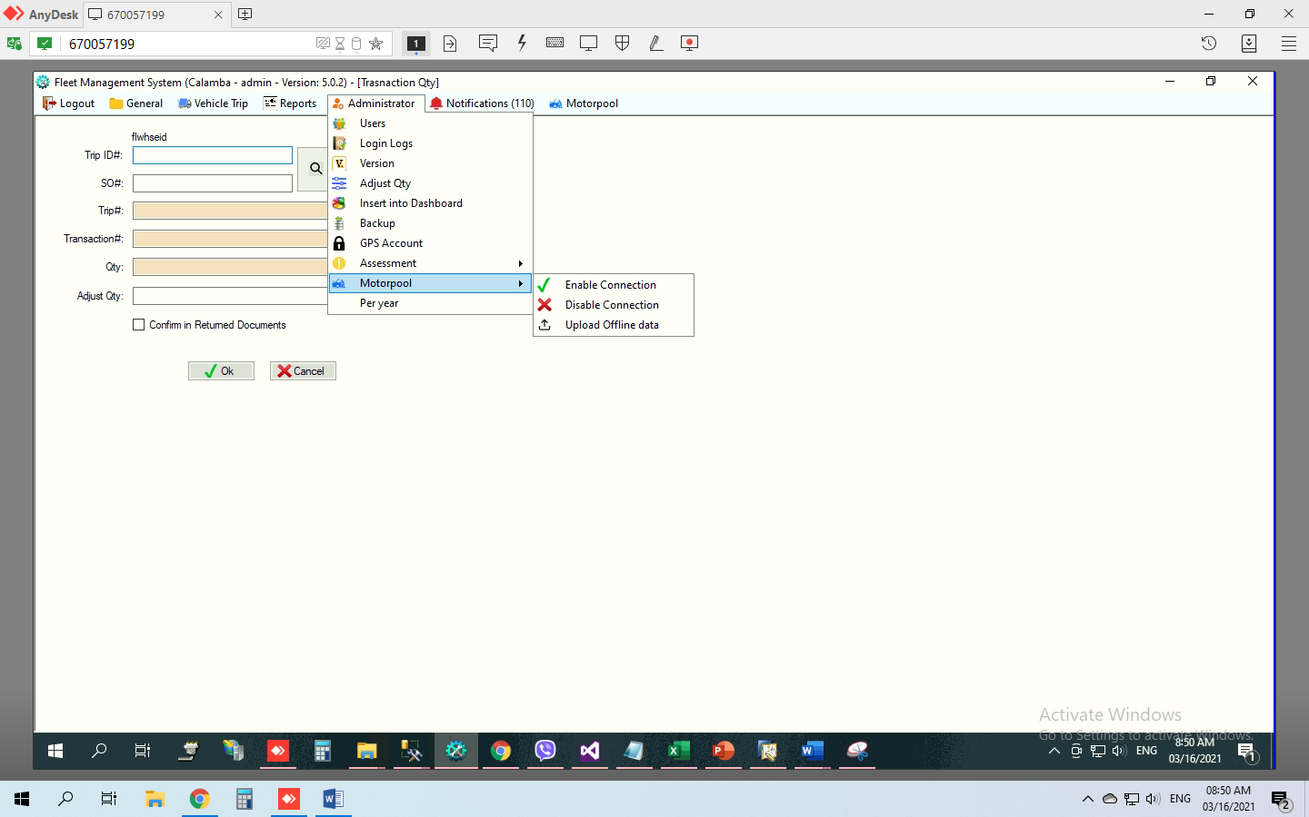

* If Motorpool system mobile app is online, and fleet management system network is connected to Motorpool system, click Enable Connection.
* If Fleet Management System is offline or Motorpool system mobile app is offline, click Disable Connection to disconnect Motorpool mobile app and then use the Motorpool Back up module in fleet instead.
* Click Upload Offline data to insert data from Motorpool Back up module in fleet to Motorpool system mobile app.

# **NOTIFICATIONS MENU**

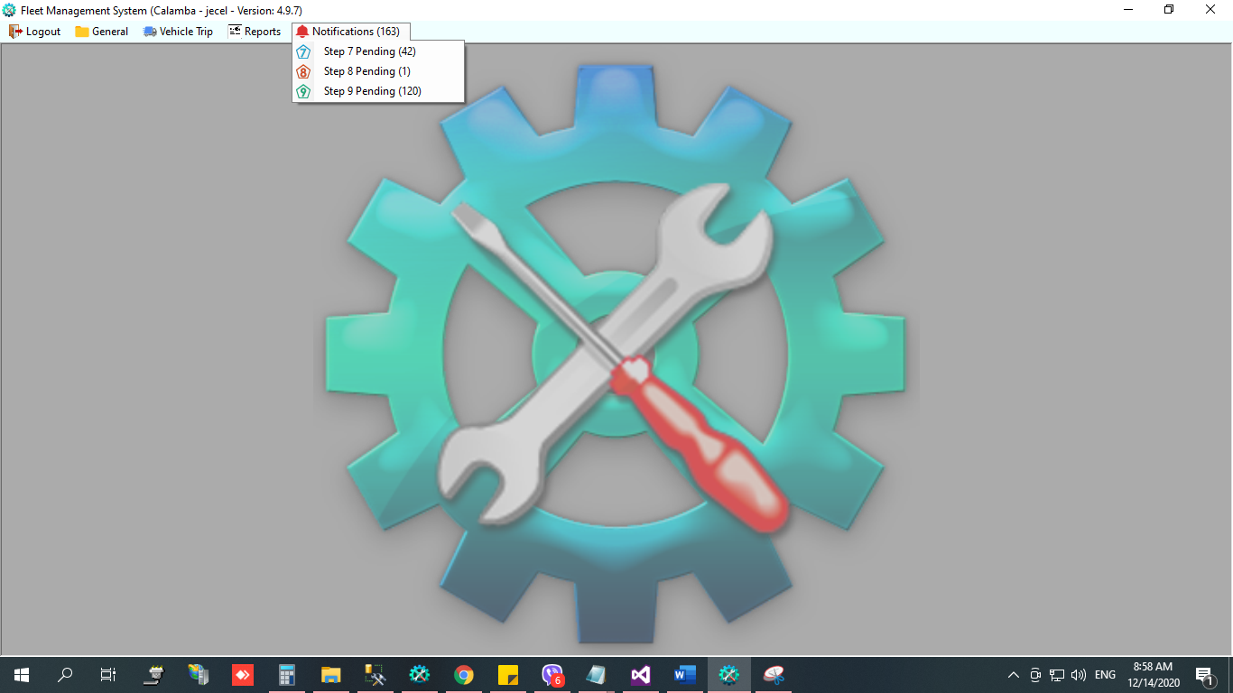

### Step 7

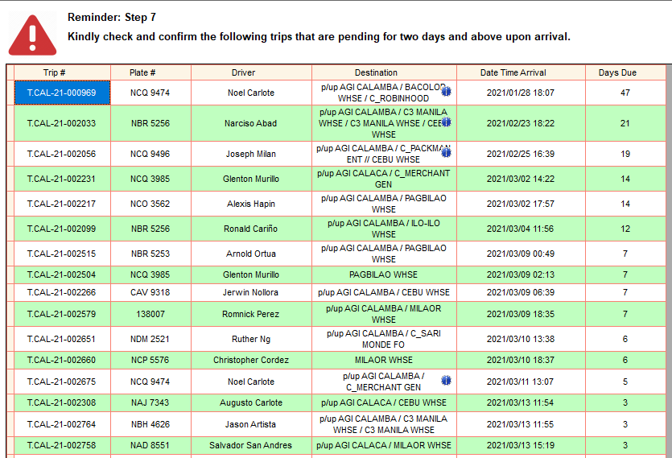

With Delivery via Shipping Lines, pwede na i-close pag lumabas dito sa Step 7 Pending dahil nasend na ng warehouse sa viber thread and receiving copy.

### Step 8

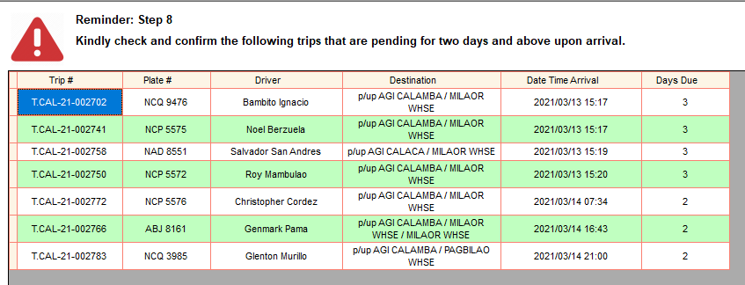

### Step 9

* 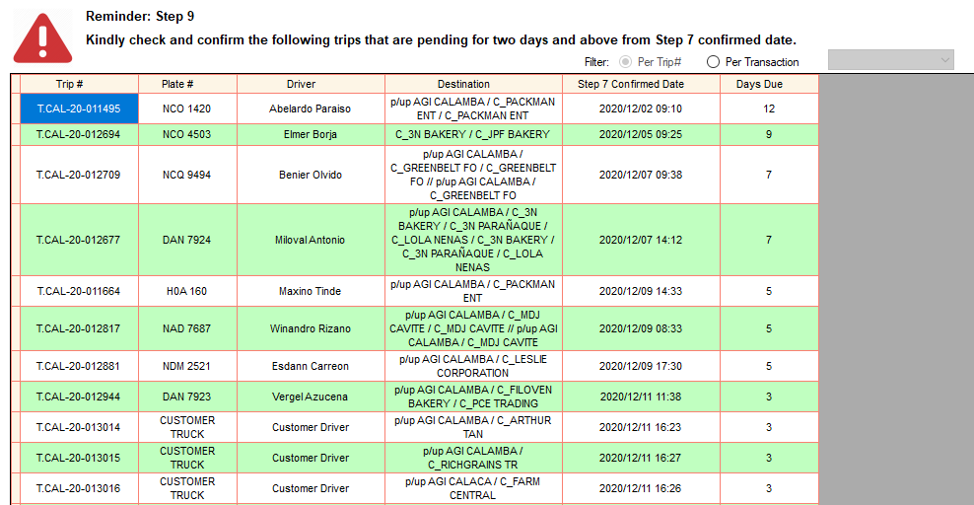Per Trip
* 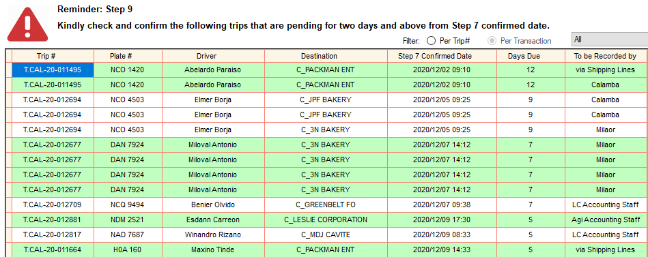Per Transaction

### Temporary POI

* 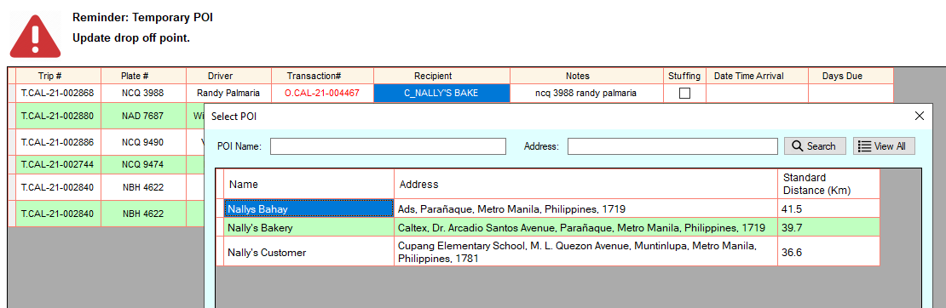To update, right click then select Update Drop off.
* Double click POI

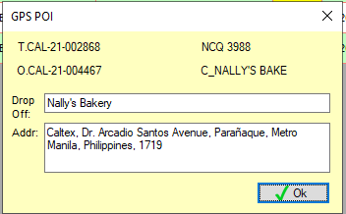

* Click Ok button to continue.

# **MOTORPOOL MENU**

(Makikita lang ang list pero di makikita yung details dahil pang backup lang ito sa motorpool app)

1. For Inspection – Mga truck na hindi pa naiinspect
2. In Progress – Mga truck na iniinspect na
3. Under Repair – Mga truck na need i-repair
4. Fleet Motorpool Logs – Magkakaroon lang ng logs kung sa fleet nag process ng motorpool at hindi sa mobile app. Gagamitin lang ang fleet motorpool pang back up kung sakaling hindi gumagana ang mobile app.
5. Not yet Arrived – Mga truck na hindi pa na arrival sa fleet kaya hindi makikita sa list ng For Inspection.
6. Available Trucks – Mga truck na tapos na iinspect pero wala pang schedule sa fleet.
7. App Completed Checklist – List ng mga completed checklist gamit ang mobile app.

